ISA 95.00.05 ed4 WD02

Enterprise - Control System Integration
Part 5: Business to Manufacturing Transactions
ISA 95.00.05 ed4 WD02
March 2018
This document is a draft that represents work being done by an ISA Standards Committee leading to the development of an ISA Standard. ISA grants permission to anyone to reproduce and distribute copies of this draft ISA standard, in whole or in part, but only for the following purposes and only as long as the recipient is not charged any fee for the copy (nor may the copy be included as part of a package with other materials or presentations for which a fee is charged):
- Review of and comment on the draft standard;
- Provide to others for review and comment;
- Promotion of the standard; or
- Informing and educating others about the standard.
In addition, all copies must reproduce a copyright notice as follows:
© Copyright 2017 ISA. All rights reserved. Reproduced and distributed with permission of ISA.
ISA reserves all other rights to the draft standard. Any other reproduction or distribution without the prior written consent of ISA is prohibited.
The reader is cautioned that this document has not been approved and cannot be presumed to reflect the position of ISA or any other committee, society, or group. Although every effort has been made to ensure accuracy, neither ISA, members of the S&P Department, nor their employers shall be held liable for errors or limitations.


ANSI/ISA Draft 95.00.05-2018, Enterprise-Control System Integration, Part 5: Business-to-Manufacturing Transactions
ISBN: 978-0-876640-35-7

Copyright © 2018 by ISA. All rights reserved. Not for resale. Printed in the United States of America.

ISA
67 Alexander Drive
P. O. Box 12277
Research Triangle Park, NC 27709 USA

NOTE Some of the work in this document is based on the work of the Open Applications Group, Inc. (OAGi). All references to the Open Applications Group, OAGi, OAGIS, and BODs remains the property of the Open Applications Group and its members. The Open Applications Group’s OAGIS is a royalty-free standard and the license grants any user to build products and base derivative works on OAGIS, as long as the intellectual property is acknowledged to belong to OAGi and its members. For more information on the Open Applications Group and OAGIS, go to www.openapplications.org.

PREFACE

This preface, as well as all footnotes and annexes, is included for information purposes and is not part of ANSI/ISA 95.00.05-2017.
This document has been prepared as part of the service of ISA, the International Society or Automation, toward a goal of uniformity in the field of instrumentation. To be of real value, this document should not be static but should be subject to periodic review. Toward this end, the Society welcomes all comments and criticisms and asks that they be addressed to the Secretary, Standards and Practices Board; ISA; 67 Alexander Drive; P. O. Box 12277; Research Triangle Park, NC 27709; Telephone (919) 549-8411; Fax (919) 549-8288; E-mail: standards@isa.org.
The ISA Standards and Practices Department is aware of the growing need for attention to the metric system of units in general, and the International System of Units (SI) in particular, in the preparation of instrumentation standards. The Department is further aware of the benefits to USA users of ISA standards of incorporating suitable references to the SI (and the metric system) in their business and professional dealings with other countries. Toward this end, this Department will endeavor to introduce SI-acceptable metric units in all new and revised standards, recommended practices, and technical reports to the greatest extent possible. Standard for Use of the International System of Units (SI): The Modern Metric System, published by the American Society for Testing & Materials as IEEE/ASTM SI 10-97, and future revisions, will be the reference guide for definitions, symbols, abbreviations, and conversion factors.
It is the policy of ISA to encourage and welcome the participation of all concerned individuals and interests in the development of ISA standards, recommended practices, and technical reports. Participation in the ISA standards-making process by an individual in no way constitutes endorsement by the employer of that individual, of ISA, or of any of the standards, recommended practices, and technical reports that ISA develops.
CAUTION - ISA ADHERES TO THE POLICY OF THE AMERICAN NATIONAL STANDARDS INSTITUTE WITH REGARD TO PATENTS. IF ISA IS INFORMED OF AN EXISTING PATENT THAT IS REQUIRED FOR USE OF THE STANDARD, IT WILL REQUIRE THE OWNER OF THE PATENT TO EITHER GRANT A ROYALTY-FREE LICENSE FOR USE OF THE PATENT BY USERS COMPLYING WITH THE STANDARD OR A LICENSE ON REASONABLE TERMS AND CONDITIONS THAT ARE FREE FROM UNFAIR DISCRIMINATION.
EVEN IF ISA IS UNAWARE OF ANY PATENT COVERING THIS STANDARD, THE USER IS CAUTIONED THAT IMPLEMENTATION OF THE STANDARD MAY REQUIRE USE OF TECHNIQUES, PROCESSES, OR MATERIALS COVERED BY PATENT RIGHTS. ISA TAKES NO POSITION ON THE EXISTENCE OR VALIDITY OF ANY PATENT RIGHTS THAT MAY BE INVOLVED IN IMPLEMENTING THE STANDARD. ISA IS NOT RESPONSIBLE FOR IDENTIFYING ALL PATENTS THAT MAY REQUIRE A LICENSE BEFORE IMPLEMENTATION OF THE STANDARD OR FOR INVESTIGATING THE VALIDITY OR SCOPE OF ANY PATENTS BROUGHT TO ITS ATTENTION. THE USER SHOULD CAREFULLY INVESTIGATE RELEVANT PATENTS BEFORE USING THE STANDARD FOR THE USER’S INTENDED APPLICATION.
HOWEVER, ISA ASKS THAT ANYONE REVIEWING THIS STANDARD WHO IS AWARE OF ANY PATENTS THAT MAY IMPACT IMPLEMENTATION OF THE STANDARD NOTIFY THE ISA STANDARDS AND PRACTICES DEPARTMENT OF THE PATENT AND ITS OWNER.
ADDITIONALLY, THE USE OF THIS STANDARD MAY INVOLVE HAZARDOUS MATERIALS, OPERATIONS OR EQUIPMENT. THE STANDARD CANNOT ANTICIPATE ALL POSSIBLE APPLICATIONS OR ADDRESS ALL POSSIBLE SAFETY ISSUES ASSOCIATED WITH USE IN HAZARDOUS CONDITIONS. THE USER OF THIS STANDARD MUST EXERCISE SOUND PROFESSIONAL JUDGMENT CONCERNING ITS USE AND APPLICABILITY UNDER THE USER’S PARTICULAR CIRCUMSTANCES. THE USER MUST ALSO CONSIDER THE APPLICABILITY OF ANY GOVERNMENTAL REGULATORY LIMITATIONS AND ESTABLISHED SAFETY AND HEALTH PRACTICES BEFORE IMPLEMENTING THIS STANDARD.
THE USER OF THIS DOCUMENT SHOULD BE AWARE THAT THIS DOCUMENT MAY BE IMPACTED BY ELECTRONIC SECURITY ISSUES. THE COMMITTEE HAS NOT YET ADDRESSED THE POTENTIAL ISSUES IN THIS VERSION.

CONTENTS

FOREWORD 13
INTRODUCTION 14
1 Scope 15
2 Normative references 15
3 Definitions, abbreviations, and conventions 16
3.1 Terms and definitions 16
3.2 Abbreviations 16
3.3 Conventions 17
4 Transaction messages and verbs 17
4.1 Introduction 17
4.2 Transaction models 17
4.3 Message structure 19
4.3.1 General Structure 19
4.3.2 Application identification area 20
4.3.3 Data Area 21
4.3.4 Message nouns 21
4.3.5 Wildcard 21
5 Message verbs 22
5.1 Verbs and transaction models 22
5.2 GET verb 24
5.3 SHOW verb 25
5.4 PROCESS verb 25
5.5 ACKNOWLEDGE verb 26
1.1 CHANGE verb 27
5.6 CANCEL verb 27
5.7 CONFIRM verb 28
5.8 RESPOND verb 29
5.9 SYNC verb 29
5.10 SYNC ADD verb 30
5.11 SYNC CHANGE verb 30
5.12 SYNC DELETE verb 30
5.13 NOTIFY verb 31
5.14 Verb actions and the use of IDs 31
6 Message nouns 32
6.1 Introduction 32
6.2 Defined message contents 32
6.2.1 Object References 32
6.2.2 Hierarchy Scope 32
6.2.3 Equipment 32
6.2.4 Equipment Capability Test Specification 32
6.2.5 Equipment Class 32
6.2.6 Job List 32
6.2.7 Job Response 33
6.2.8 Job Response List 33
6.2.9 Material Class 33
6.2.10 Material Definition 33
6.2.11 Material Lot 33
6.2.12 Material Sublot 34
6.2.13 Material Test Specification 34
6.2.14 Operational Location 34
6.2.15 Operational Location Class 34
6.2.16 Operations Capability 34
6.2.17 Operations Definition 34
6.2.18 Operations Schedule 35
6.2.19 Operations Performance 35
6.2.20 Person 35
6.2.21 Personnel Class 35
6.2.22 Physical Asset 36
6.2.23 Physical Asset Class 36
6.2.24 Physical Asset Capability Test Specification 36
6.2.25 Process Segment 36
6.2.26 Operations Event 36
6.2.27 Operations Event Definition 36
6.2.28 Operations Event Class 36
6.2.29 Resource Relationship Network 37
6.2.30 Resource Relationship Network Connection Type 37
6.2.31 Qualification Test Specification 37
6.2.32 Transaction Profile 37
6.2.33 Work Alert Definition 37
6.2.34 Work Alert 37
6.2.35 Work Calendar Definition 37
6.2.36 Work Calendar 38
6.2.37 Work Capability 38
6.2.38 Work Directive 38
6.2.39 Work Master 38
6.2.40 Work Performance 39
6.2.41 Work Record 39
6.2.42 Work Schedule 39
6.2.43 Workflow Specification 39
6.2.44 Workflow Specification Type 40
6.3 Hierarchy Scope Model 40
6.3.1 Hierarchy scope model elements 40
6.3.2 Hierarchy scope verbs 40
6.3.3 Hierarchy scope verb actions 40
6.4 Personnel model 41
6.4.1 Personnel model elements 41
6.4.2 Personnel class verbs 42
6.4.3 Personnel class verb actions 42
6.4.4 Person verbs 44
6.4.5 Person verb actions 44
6.4.6 Qualification test specification verbs 46
6.4.7 Qualification test specification verb actions 46
6.5 Role based equipment model 47
6.5.1 Role based equipment model elements 47
6.5.2 Equipment class verbs 48
6.5.3 Equipment class verb actions 48
6.5.4 Equipment verbs 50
6.5.5 Equipment verb actions 50
6.5.6 Equipment capability test specification verbs 52
6.5.7 Equipment capability test specification test verb actions 52
6.6 Physical asset model 53
6.6.1 Physical asset model elements 53
6.6.2 Physical asset class verbs 54
6.6.3 Physical asset class verb actions 54
6.6.4 Physical asset verbs 56
6.6.5 Physical asset verb actions 56
6.6.6 Physical asset capability test specification verbs 58
6.6.7 Physical asset capability test specification test verb actions 58
6.7 Material model 59
6.7.1 Material model elements 59
6.7.2 Material class verbs 60
6.7.3 Material class verb actions 60
6.7.4 Material definition verbs 62
6.7.5 Material definition verb actions 62
6.7.6 Material lot verbs 64
6.7.7 Material lot verb actions 64
6.7.8 Material sublot verbs 66
6.7.9 Material sublot verb actions 66
6.7.10 Material test specification verbs 68
6.7.11 Material test specification verb actions 69
6.8 Operational location model 70
6.8.1 Operational location model elements 70
6.8.2 Operational location class verbs 70
6.8.3 Operational location class verb actions 71
6.8.4 Operational location verbs 72
6.8.5 Operational location verb actions 73
6.9 Process segment model 74
6.9.1 Process segment model elements 74
6.9.2 Process segment verbs 75
6.9.3 Process segment verb actions 75
6.10 Operations event model 76
6.10.1 Operations event model elements 76
6.10.2 Operations event class verbs 77
6.10.3 Operations event class verb actions 77
6.10.4 Operations event definition verbs 78
6.10.5 Operations event definition verb actions 78
6.10.6 Operations event verbs 78
6.10.7 Operations event verb actions 79
6.10.8 Operations capability model 79
6.10.9 Operations capability model elements 79
6.10.10 Operations capability verbs 79
6.10.11 Operations capability verb actions 80
6.11 Operations definition model 82
6.11.1 Operations definition model elements 82
6.11.2 Operations definition verbs 83
6.11.3 Operations definition verb actions 83
6.12 Operations schedule model 84
6.12.1 Operations schedule model elements 84
6.12.2 Operations schedule verbs 85
6.12.3 Operations schedule verb actions 85
6.13 Operations performance model 87
6.13.1 Operations performance model elements 87
6.13.2 Operations performance verbs 88
6.13.3 Operations performance verb actions 88
6.14 Resource relationship network model 90
6.14.1 Resource relationship network model elements 90
6.14.2 Resource relationship network verbs 91
6.14.3 Resource relationship network verb actions 91
6.14.4 Resource relationship connection type verbs 92
6.14.5 Resource relationship connection type verb actions 92
6.15 Work alerts 93
6.15.1 Work alert model elements 93
6.15.2 Work alert definition verbs 94
6.15.3 Work alert definition actions 94
6.15.4 Work alert verbs 95
6.15.5 Work alert verb actions 96
6.16 Work calendar 97
6.16.1 Work calendar elements 97
6.16.2 Work calendar definition verbs 98
6.16.3 Work calendar definition actions 98
6.16.4 Work calendar verbs 99
6.16.5 Work calendar actions 99
6.17 Work capability model 100
6.17.1 Work capability model elements 100
6.17.2 Work capability verbs 100
6.17.3 Work capability verb actions 100
6.18 Work definition model 103
6.18.1 Work definition model elements 103
6.18.2 Work master verbs 103
6.18.3 Work master verb actions 103
6.18.4 Work directive verbs 104
6.18.5 Work directive verb actions 104
6.19 Work record 105
6.19.1 Work record elements 105
6.19.2 Work record verbs 106
6.19.3 Work record verb actions 106
6.20 Work schedule model 107
6.20.1 Work schedule elements 107
6.20.2 Work schedule verbs 107
6.20.3 Work schedule verb actions 108
6.20.4 Job list verbs 108
6.20.5 Job list verb actions 108
6.21 Work performance model 110
6.21.1 Work performance elements 110
6.21.2 Work performance verbs 110
6.21.3 Work performance verb actions 110
6.21.4 Job response verbs 111
6.21.5 Job response verb actions 111
6.21.6 Job response list verbs 113
6.21.7 Job response list verb actions 113
6.22 Workflow specification model 114
6.22.1 Workflow specification elements 114
6.22.2 Workflow specification verbs 114
6.22.3 Workflow specification verb actions 114
6.22.4 Workflow specification type 115
6.22.5 Workflow specification type verbs 115
6.22.6 Workflow specification type verb actions 115
6.23 Transaction Profile 116
7 Completeness, compliance and conformance 118
7.1 Completeness 118
7.2 Compliance 118
7.2.1 Conformance 118
Annex A – (Informative) Transaction models and business scenario examples 122
A.1 Coordinating activities 122
A.2 Usage scenarios 123
A.3 Operations schedule and operations performance 123
A.3.1 Push Model 123
A.3.2 Pull model 123
A.3.3 Publish model 124
A.4 Operations schedule changes 125
A.4.1 Push model 125
A.4.2 Publish model 125
A.5 Operations schedule cancelled 126
A.5.1 Push model 126
A.5.2 Push and pull model 126
A.6 Daily operations performance 127
A.6.1 Push model 127
A.6.2 Pull model 127
A.6.3 Publish model 128
A.7 Operations schedule based on operations capability 128
A.7.1 Pull and push model 128
A.7.2 Publish and push model 129
A.8 Operations schedule changes 129
A.8.1 Push and pull model 129
A.8.2 Publish model 130
A.9 Material quantity changed 131
A.9.1 Push model 131
A.9.2 Publish and push model 131
A.9.3 Push and pull model 132
Annex B – (Informative) Questions on the use of transactions 133
Annex C – (Informative) Bibliography and References 136
Annex D – (Informative) Patterns for Verbs 137
D.1 Patterns 137
D.2 Actions for GET verb 137
D.3 Actions for PROCESS verb 138
D.4 Actions for CHANGE message 138
D.5 Actions for CANCEL message 139
D.6 Actions for SYNC message 140
D.7 Pattern for usage of NOTIFY verb 141
Annex E – (Informative) General rules for identifying nouns from object models 142
E.1 Patterns 142
E.2 Hierarchical Object Model 142
E.3 Non-hierarchical Object Model 143

Figures
Figure 1 – Typical exchanged messages in a transaction 19
Figure 3 – Typical exchanged data set 20
Figure 3 – Typical layout of an application identification area 20
Figure 4 – GET with wildcard and SHOW response 22
Figure 5 – GET and SHOW transaction 25
Figure 6 – PROCESS/ACKNOWLEDGE transaction with an acknowledge always option 26
Figure 7 – Example of acknowledge to a process message 27
Figure 8 – CHANGE/RESPOND transaction with a respond always option 27
Figure 9 – GET and SHOW transaction with a CONFIRM always 28
Figure 10 – Example of a GET message with Confirm OnError 28
Figure 11 – Confirm Message 29
Figure 12 – SYNC ADD transaction with confirmation 30
Figure 13 – SYNC DELETE transaction with no confirmation 31
Figure 14 - NOTIFY transaction 31
Figure 18 - Object grouping for hierarchy scope model 40
Figure 19 – Object grouping for the personnel model 42
Figure 20 – Object grouping for the role based equipment model 48
Figure 21 – Object grouping for the physical asset model 54
Figure 22 – Object grouping for the material model 60
Figure 23 - Object grouping for the operational location model 70
Figure 24 – Object grouping for the process segment model 75
Figure 25 - Object grouping for the operations event model 77
Figure 26 – Object grouping for the Operations capability model 79
Figure 27 – Object grouping for the operations definition model 83
Figure 28 – Object grouping for the operations schedule model 85
Figure 29 – Object grouping for the operations performance model 88
Figure 30 – Object grouping for the resource relationship network model 91
Figure 31 – Object grouping for the work alert model 94
Figure 32 – Object grouping for the work calendar model 98
Figure 33 – Object grouping for the work capability model 100
Figure 34 – Object grouping for the work definition model 103
Figure 35 – Object grouping for the work record model 106
Figure 36 – Object grouping for the work schedule model 107
Figure 37 – Object grouping for the work performance model 110
Figure 38 – Object grouping for the workflow specification model 114
Figure 39 – Transaction profile model 117
Figure 40 – Coordinating planning and operations processes 122
Figure 41 – Push model; operations schedule and operations performance 123
Figure 42 – Pull model; operations schedule and operations performance 123
Figure 40 – Publish Model; operations schedule and operations performance 124
Figure 43 - Publish notifications of Work Scheduling Operations Events 125
Figure 42 – Push Model; Operations schedule changes 125
Figure 46 – Publish model: v schedule changes 126
Figure 47 – Push model; operations schedule cancelled 126
Figure 48 – Push and pull model; schedule cancelled 127
Figure 49 – Push model; daily operations performance 127
Figure 50 – Pull model; daily operations performance 128
Figure 51 – Publish model; daily operations schedule 128
Figure 52 – Pull and push model; operations capability and operations schedule 129
Figure 53 – Publish and push model; operations capability and operations schedule 129
Figure 54 – Push and pull model; schedule changes 130
Figure 55 – Publish model; schedule changes after capability changes 131
Figure 56 – Push model; material lot added, material lot quantity changed 131
Figure 57 – Publish and push model; material quantity changes 132
Figure 58 – Push and pull model; material quantity changes 132
Figure 56 - Implementation of Notify transactions that requires a response 135
Figure 59 – Object model with composite relationships 143
Figure 60 – Example of multiple composite objects 144

Tables
Table 1 - Defined verbs 23
Table 2 – Acknowledge request options 27
Table 3 – Acknowledge element 27
Table 4 – Respond options 28
Table 5 – Confirmation request options 29
Table 6 – Respond element 31
Table 7 - Hierarchy scope verb actions 42
Table 8 – Personnel class verb actions 44
Table 9 – Person verb actions 46
Table 10 – Qualification test specification verb actions 48
Table 11 – Equipment class verb actions 50
Table 12 – Equipment verb actions 52
Table 13 – Equipment capability test specification verb actions 54
Table 14 – Physical asset class verb actions 56
Table 15 – Physical Asset verb actions 58
Table 16 – Physical asset capability test specification verb actions 60
Table 17 – Material Class verb actions 61
Table 18 – Material definition verb actions 63
Table 19 – Material lot verb actions 65
Table 20 – Material sublot verb actions 67
Table 21 – Material test verb actions 69
Table 22 – Operational location class verb actions 72
Table 23 – Operational location verb actions 74
Table 24 – Process segment verb actions 76
Table 25 – Operations event class verb actions 78
Table 26 – Operations event definition verb actions 79
Table 27 – Operations event verb actions 80
Table 28 – Operations capability verb actions 81
Table 29 – Operations capability element definitions for GET verb 82
Table 30 – Operations definition verb actions 84
Table 31 - Operations schedule verb actions 86
Table 32 – Operations schedule element definitions for GET verb 88
Table 33 – Operations Performance verb actions 89
Table 34 – Operations Performance definitions for GET verb 90
Table 35 – Resource Relationship Network verb actions 91
Table 36 – Resource Relationship Connection Type verb actions 92
Table 37 – Work alert definition additional attributes 94
Table 38 – Work alert definition verb actions 94
Table 39 – Work alert definition element definitions for GET verb 95
Table 40 – Work alert definition additional attributes 96
Table 41 – Work alert verb actions 96
Table 42 – Work alert element definitions for GET verb 97
Table 43 – Work calendar definition verb actions 98
Table 44 – Work calendar verb actions 98
Table 45 – Work capability verb actions 100
Table 46 – Work capability element definitions for GET verb 101
Table 47 – Work master verb actions 103
Table 48 – Work directive verb actions 104
Table 49 – Work record verb actions 105
Table 50 – Work Schedule verb actions 107
Table 51 – Job List verb actions 108
Table 52 – Work Schedule and Job List element definitions for GET verb 109
Table 53 – Work performance verb actions 110
Table 54 – Work performance element definitions for GET verb 111
Table 55 – Job response verb actions 111
Table 56 – Job response element definitions for GET verb 112
Table 57 – Job response list verb actions 112
Table 58 – Job response list element definitions for GET verb 113
Table 59 – Workflow Specification verb actions 114
Table 60 – Workflow Specification Type verb actions 115
Table 61 – Attributes of Transaction Profile 116
Table 62 – Attributes of Supported Action 117
Table 63 – Transaction Profile verb actions 117
Table 64 – Supported verb-noun actions 119
Table 65 – Vendor conformance example 120
Table 66 – GET message with object ID is specified 137
Table 67 – GET message with wildcard in object ID 137
Table 68 – GET message with no object ID specified 138
Table 69 – PROCESS message with Object ID specified 138
Table 70 – PROCESS message with no object ID 138
Table 71 – CHANGE message with object ID 139
Table 72 – CHANGE message with wildcard object ID 139
Table 73 – CANCEL message with object ID 139
Table 74 – CANCEL message with wildcard in object ID 140
Table 75 – SYNC message with object ID 140
Table 76 – SYNC message with wildcard in object ID 140

ENTERPRISE-CONTROL SYSTEM INTEGRATION -
Part 5: Business-to-Manufacturing Transactions

FOREWORD
ISA 95 is a multi-part series of standards that define enterprise-to-control system integration. This Part 5 standard defines the transactions to interface business and manufacturing activities per the following:
- Clause 4 is normative. It describes the transaction models and messages used.
- Clause 5 is normative. It describes the verbs used in the messages.
- Clause 6 is normative. It defines the message nouns, the structure of the nouns, the verbs used with the nouns, and the rules for the verbs.
- Clause 7 is normative. It describes the requirements for declarations about completeness, compliance and conformance to the standard.
- Annex A is informative. It contains examples of sequences of transactions used to coordinate selected business activities.
- Annex B is informative. It contains a series of questions and answers regarding the use of the standard.
- Annex C is informative. It contains references to documents used in the generation of this standard
- Annex D is informative. It defines the pattern for verbs.
- Annex E is informative. It defines the general rules used for identifying nouns from object models.
As currently envisioned, ANSI/ISA-95 consists of the following standards under the general title Enterprise-Control System Integration:
- Part 1: Models and Terminology
- Part 2: Object Model Attributes
- Part 3: Activity Models of Manufacturing Operations Management
- Part 4: Objects and attributes for manufacturing operations management
- Part 5: Business-To-Manufacturing Transactions
- Part 6: Messaging Service Model
- Part 7: Alias Service Model
- Part 8: Profiles
- Part 9: Common Operations Management Events

INTRODUCTION
This part of ISA-95 is based on the use of ISA-95 abstract models previously defined in ISA-95 Part 2 and ISA-95 Part 4 combined with verbs to define a transaction model for information exchange. It is recognized that other non-ISA-95 Part 5 transaction protocols are possible and are not deemed invalid as a result. Transactions occur at all levels within the enterprise and between enterprise partners, and are related to both required and actual activities, but the focus of this Part 5 is the interface between enterprise/business systems and manufacturing systems.
This standard defines transactions that are exchanged between Level 4 and Level 3, and within Level 3 as defined in the object models of ISA-95 Part 2 and ISA-95 Part 4. Models are introduced which provide descriptions of the transactions and explanations of the required transaction processing behaviour.
Technology specific implementations to provide this behaviour are not defined in this standard. This part of ISA-95 has the intent of providing insight into the level of work required to construct transactional exchanges.

ENTERPRISE-CONTROL SYSTEM INTEGRATION

Part 5: Business to Manufacturing Transactions

Scope
This part of ISA-95 defines transactions in terms of information exchanges between applications performing business and manufacturing activities associated with Levels 3 and 4. The exchanges are intended to enable information collection, retrieval, transfer and storage in support of Enterprise-Control system integration. This part of ISA-95 is consistent with the ISA-95.00.02 and ISA-95.00.04 object models attributes. This standard also defines transactions that specify how to exchange the objects defined in ISA-95.00.02, ISA-95.00.04 and this standard. Other uses of the transaction model are not defined in this part.
The models covered in this standard are:
- Hierarchy Scope Model
- Personnel Model
- Equipment Model
- Physical Asset Mode
- Material Model
- Process Segment Model
- Operational Location Model
- Operations Event Model
- Operations Capability Model
- Operations Definition Model
- Operations Schedule Model
- Operations Performance Model
- Resource Relationship Network Model
- Work Capability Model
- Work Definition Model
- Work Schedule Model
- Job List Model
- Work Performance Model
- Workflow Specification Model
- Work Calendar
- Work Record
- Work Alert Model

Normative references
The following normative documents contain provisions, which through reference in this text constitute provisions of this part. At the time of publication, the editions indicated were valid. All normative documents are subject to revision, and parties to agreements based on this part are encouraged to investigate the possibility of applying the most recent editions of the normative documents indicated below. Members of IEC and ISO maintain registers of currently valid normative documents.
ISO/IEC 19501-1, Information Technology – Unified Modeling Language (UML)—Part 1: Specification
ISA-95.00.01, Enterprise-control system integration – Part 1: Models and terminology
ISA-95.00.02, Enterprise-control system integration – Part 2: Object modes and attributes
ISA-95.00.03, Enterprise-control system integration – Part 3: Activity models of manufacturing operations management
ISA-95.00.04, Enterprise-control system integration – Part 4: Object modes and attributes for manufacturing operations management integration
ISO 8601, Data elements and interchange formats – Information interchange – Representation of dates and times

Definitions, abbreviations, and conventions

Terms and definitions

application
an ordered set of physical and logical system processes, performed by a set of resources that conduct a set of transactions intended to accomplish a definite objective; information provider or information user performing the activity that is involved in a transaction
EXAMPLE HMIs, Data Historians, MES and LIMs software are examples of applications.

ID
information to identify an object or a property of an object

message
structured information unit conveyed in a one-way transfer of data between one sending application to one or more receiving applications

noun
one of two parts in the content of a message and represents one or more objects, as defined in the Parts 2 and 4 object models

transaction
sequence of related messages that are exchanged among applications performing Level 3 or Level 4 activities

verb
one of two parts in the content of a message and defines the action to be performed, or the response to a request

wildcard
information to identify a collection of objects or properties of objects

Abbreviations
EDA Event Driven Architecture
ERP Enterprise Resource Planning
MEP Message Exchange Pattern
MOM Manufacturing Operations Management
OAGIS Open Applications Group Interface Standard
SYNC Synchronized data
UTC Universal Coordinated Time

Conventions
Uppercase words are used to identify the verbs in a transaction message, to differentiate them from verbs in the sentences.
EXAMPLE 1 GET for the get verb used in a transaction message.
Italics and uppercase letters are used, beyond the use defined in ISO/IEC Directives Part2, to emphasize the ISA-95 specific meaning of terms. They are used for the following cases:
- Names of objects used in exchanged data
- Parts of messages
- Verb/noun message examples
EXAMPLE 1 GET Equipment for the get verb used in with an equipment object.
Uppercase words are used to identify transaction models.
EXAMPLE 2 PUSH transaction for PROCESS, CHANGE, and CANCEL verbs

Transaction messages and verbs

Introduction
This clause defines a common set of transactions, messages and verbs that should be used between Level 4 and Level 3, and among Level 3, applications to exchange the data defined in the object models of ISA-95.00.02 and ISA-95.00.04.
A transaction shall consist of a sequence of messages, where each message shall have a structure as defined in Clause 4.3.
Messages shall contain both a noun and a verb area. The information conveyed in a message shall be contained in the noun area of a message while the actions associated with the information shall be contained in the verb area.
The role of an application initiating a transaction shall determine the set of verbs to be used in conducting the transaction. These transaction models are described in Clause 4.2.
Three different transaction models are defined:
- A PULL model where a user of data requests the data from a provider of the data.
- A PUSH model where a provider of data requests an action (processing, changing, or cancelling) on the data by another user.
- A PUBLISH model where the owner of data publishes it to users (subscribers) of the data.
NOTE 1 The phrase “owner of data” is used to identify the application that has responsibility for enforcing the consistency of data.
NOTE 2 This standard does not address the case where there may be multiple systems that can act as the owner of data. In these situations, configuration should be set up so that one master owner of the data should be designated, with other systems performing the role of data users.

Transaction models
There are three classes of actions provided by the verb set:
- query/reporting for data sharing, and
- transaction processing, and
- data synchronization and event notification.
Each is defined in a different transaction model:
- A PULL model where a user of data requests information from an information provider. This model is used for query/reporting.
Information provider applications listen for GET messages and respond with SHOW messages to complete the transaction.
Information user applications send GET messages.
  - Requests for information are sent through GET messages.
  - A GET message describes the scope of the requested information.
  - A SHOW message returns the information.
- A PUSH model where a sender of information sends new or changed information to the receiver to process requests. This model is used for transaction processing.
Receiver applications listen for PROCESS, CHANGE, or CANCEL messages.
Sender applications send PROCESS, CHANGE, and CANCEL messages..
  - New information is pushed to the receiver through a PROCESS message. Responses may be returned to the sender through an ACKNOWLEDGE message.
  - Changes to information are pushed to the receiver through a CHANGE message. Responses may be returned to the sender through a RESPOND message.
  - Information to be removed is pushed to the receiver through a CANCEL message.
- A PUBLISH model where the provider of data publishes it to users (subscribers) of the data. This model is used for both data synchronization and event notification.
The timing of the publication and scope of the published information is not defined in a message. It is determined by an out-of-band agreement between the publisher and subscriber, therefore there is no SUBSCRIBE message defined in this standard.
NOTE 1 An out-of-band agreement means that the agreement is not defined in the transaction protocol.
Example An agreement between a publisher and subscriber may be setup through configuration parameters in the applications, or an agreement may be setup dynamically through a web service agreement, or an agreement may be setup through a third party application.
  - Data Synchronization is used to inform non-owners of data that data has been added , changed, or deleted by the owner:
Subscriber applications receive SYNC messages.
Publisher applications send SYNC messages.
    - A publisher sends SYNC messages containing new, changed, or deleted information.
    - A subscriber receives SYNC messages containing new, changed, or deleted information.
  - Event Notification is used to notify of an event that occurred or that data that has been created:
Subscriber applications receive NOTIFY messages.
Publisher applications send NOTIFY messages.
    - A publisher sends NOTIFY messages containing events.
    - A publisher sends NOTIFY messages containing new information.
    - A subscriber receives NOTIFY messages containing events or new information.
Information providers (publishers) applications publish NOTIFY transactions.
Information users (subscribers) applications receive NOTIFY transactions to which they have subscribed.
There is no acknowledgement or response to a notification, if an acknowledgement response is required, it is processed as a separate notification.
NOTE 2 The notification of events allows for use of an event driven architecture (EDA) pattern. EDA is an integration architecture for a message exchange pattern promoting the dissemination of published events to subscribers in a loosely coupled environment. The event publisher only knows the event has transpired and has no knowledge of the subsequent processing subscribing may perform.
A single application may support one or more transaction models and the application may take on multiple roles (sender, receiver, provider, and user).
NOTE 3 The transactions are based on the assumption that the exchanged information (noun) is contained in a message of some form. The exact form of the messages is undefined in this specification; for example, the messages could be tab delimited files, XML files, electronic mail messages, or data in a named pipe. The exact form of the transport mechanism for the sending, receiving, listening, and publishing of messages is not defined in this specification.
NOTE 4 The transaction message models do not imply any specific architecture or mechanism for transporting the messages.
The transactions assume the ability to send an empty or nearly empty message that identifies either a specific object (typically by ID), a list of specific objects (by a list of IDs), or a class of objects (by wildcard or property value definition).
Figure 1 illustrates the exchange of messages in a typical transaction, where a message (GET Equipment) is sent from an information user with an identification of an object (Equipment), and a message (SHOW Equipment) is returned from the information provider with the object’s information (Equipment).
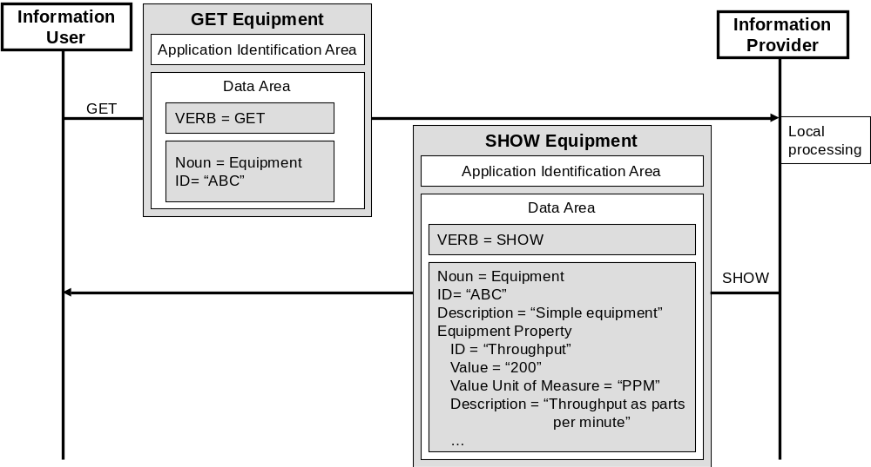
Figure 1 – Typical exchanged messages in a transaction

Message structure

General Structure
Every message shall contain the information required to identify the source of the message and the type of the message. There shall be two main areas in a message, as shown in Figure 2, an application identification area and a data area. Within the data area there shall be a verb area and a noun area.
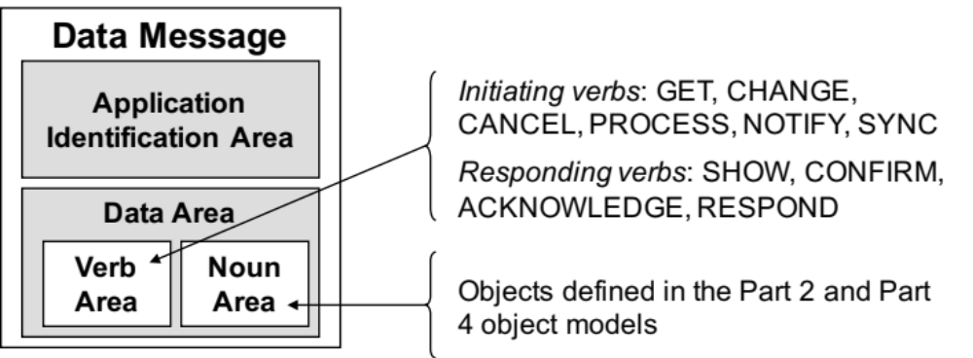
Figure 2 – Typical exchanged data set

Application identification area
The application identification area shall carry information that a receiving application uses to handle a message. The application identification area is used for the application layer of communication, such as indicating a required confirmation of message processing. This information typically includes the electronic address of the sender, an indication of the confirmation requirement, and the date and time the message was created. The application identification area may also include other information required for identification and authentication of the messages, such as a transaction ID. Figure 4 illustrates a typical layout for an application identification area.
NOTE See the OAGIS (Open Applications Group Integration Specification) 9.0 specification for a format for the application identification area. The data exchange model defined in this document is consistent with the OAGIS specification; such that an implementation of OAGIS, using the objects defined in ISA-95.00.02 and ISA-95.00.04, can conform to this part of the standard.
Dates and times shall include time information in order to unambiguously identify times, such as coordinated universal time or ISO 8601 CE (Common Era) calendar extended format. A time zone specification of the time is optional, and if missing the time shall be represented as UTC.

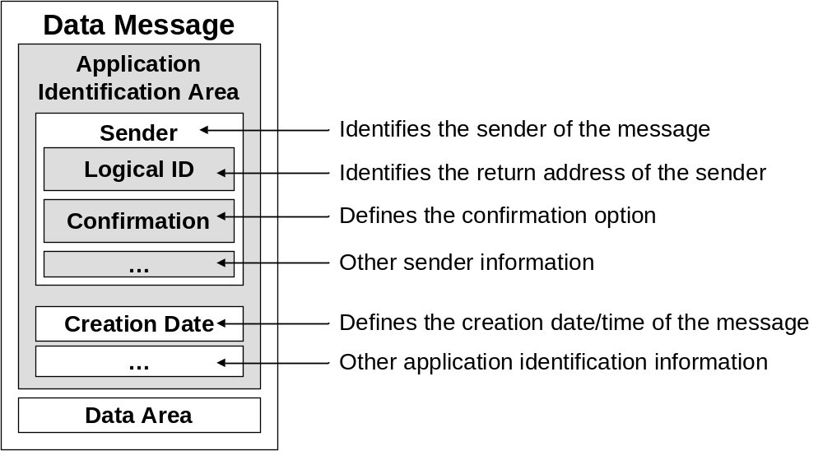
Figure 3 – Typical layout of an application identification area

Data Area
The data area in a message shall contain a verb area and a noun area.
The verb area shall contain verbs and associated elements that represent the actions to be performed by the receiving application, or the response to a request by the sending application. The verbs defined in this part of the standard are listed in Clause 5.
The noun area shall contain nouns and associated elements that represent one or more objects defined in the ISA-95.00.02 and ISA-95.00.04 object models. The nouns defined in this part of the standard are listed in Clause 6.
The verb-noun combinations define messages that are intended to have a unique and unambiguous meaning.

Message nouns
Nouns represent one or more objects from the object models defined in ISA-95.00.02 and ISA-95.00.04 that have been grouped together for use with messages.
Example A Material Definition noun is a composition of a Material Definition object instance with its Material Definition Property object instances.

Wildcard
The noun may contain a wildcard string used to identify multiple objects.
NOTE 1 Wildcards apply to the ID of a property, not to the value of the properties.
NOTE 2 Wildcards should be used with care if combined with lists of object IDs or property IDs. In the case of errors a confirmation message may not have sufficient information to determine the exact error.
NOTE 3 A common convention for specifying wildcards in text strings are as regular expressions (as defined in ISO/IEC 9945-2:2003 Information technology – Portable Operating System Interface (POSIX) – Part 2: System Interfaces). Regular expressions are widely supported in programming languages, text processing programs, advanced text editors, and some other programs. Regular expression support is part of the standard library of many programming languages, including Java and Python, is built into the syntax of others, including Perl and ECMAScript, and is supported by many commonly available libraries.
NOTE 4 Wildcards could also be implemented using limited regular expressions. In a limited regular expression a wildcard string can have the following special characters:
- “*” – Indicates zero or more characters, any character is acceptable
- Example 1 The wildcard “ABC*” would match “ABC”, “ABCD”, “ABCDEF”, “ABC@4!*“, but not “ABDDEF”
- “%” – Indicates one or more characters, any character is acceptable
- Example 2 The wildcard “ABC%” would match “ABCD”, “ABCDEF”, “ABC^4^*“, but not “ABC”
- “?” – Indicates zero or one characters at the specified position, any character is acceptable
- Example 3 The wildcard “ABC?” would match “ABCX”, “ABCD”, “ABC!“, “ABC”, but not “ABCDE” or “ABDC”
- The character following a “\” is considered a literal character, not a wildcard character.
- Example 4 An object ID of “ABC\*” defines the object ID as “ABC*”.
- Example 5 A property ID of “\\\\USM 123” defines the property ID “\\USM 123”.
NOTE 4 Two consecutive backslash characters, i.e. “\\” are interpreted to be a single backslash character “\”.
Figure 4 illustrates a GET/SHOW transaction with a wildcard specified. The provider of the information returns a list of objects matching the wildcard specification.
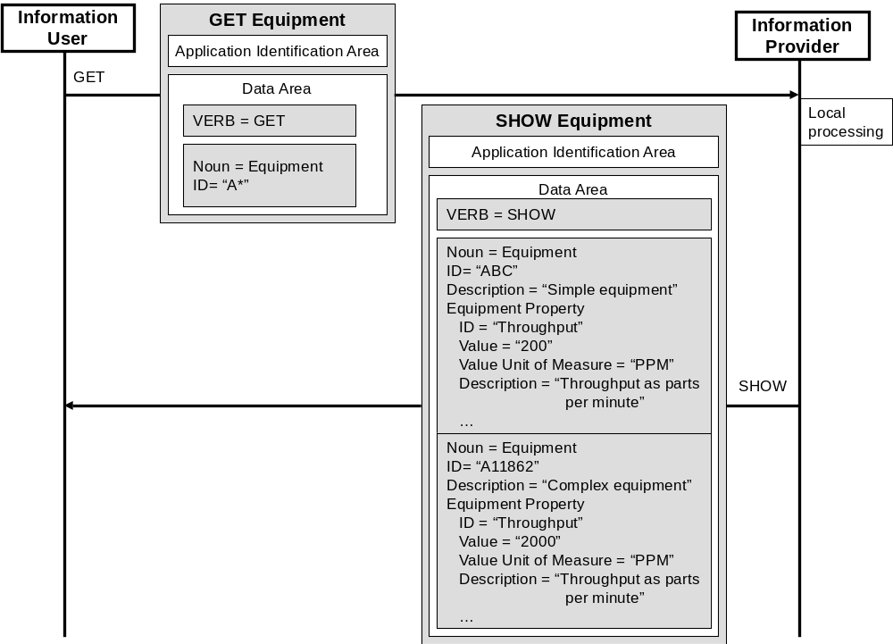
Figure 4 – GET with wildcard and SHOW response

Message verbs

Verbs and transaction models
The verb area of a message shall contain a verb, defined in this clause and listed in Table 1.
Table 1 - Defined verbs
Verb | Description | Transaction Model
ACKNOWLEDGE | Acknowledgement of a PROCESS request.  The noun may contain assigned IDs and other information to inform the sender of the PROCESS message of the IDs of any created objects.  Example 1 A PROCESS message sent with a Material Lot may return the ID assigned to the lot by the receiving system. | PUSH
CANCEL | Request to a receiver to remove information.  The specified noun’s information shall be cancelled. If contained elements IDs are specified, then only the specified contained elements for the specified noun shall be cancelled, not the noun itself.  NOTE 1 This does not indicate that the information is deleted, just that it is no longer available for GET, CHANGE and SYNC messages.  NOTE 2 Not all objects have contained elements. Examples of contained elements are properties, specifications, actuals, etc.  Example 2 A property object for a Material Class noun is a contained element. | PUSH
CHANGE | Request to a receiver to change information.  The specified attributes and contained elements of the noun shall be changed. If no IDs of contained elements are specified, only the specified attributes of the noun shall be changed.  NOTE 3 See Part 2 and Part 4 for definitions of object attributes. | PUSH
CONFIRM | Confirmation response to a request. | PUSH, PULL, PUBLISH
GET | Request to an information provider for information on one or more objects.  The information provider shall return a SHOW message containing each of the specified attributes and each of the specified contained elements of the specified nouns. If no attribute or contained element is specified in the noun area, then all attributes and/or contained elements shall be returned.  When wildcards are applied to the noun and property IDs, it shall be possible to further filter the information to be returned by specifying a value for one or more attributes of the noun. Only objects whose attributes match the specified value (out of the list of objects matching the wildcards applied to noun and property IDs) shall be returned.  Example 3 To get all the Material Lots with Status = “New”, the wildcard “*” would be specified for the Material Lot ID and the “New” value would be specified for the Status attribute. | PULL
PROCESS | Request to a receiver to process new information.  A new noun shall be added. If the specified noun already exists, only the specified contained elements shall be added. | PUSH
RESPOND | Response to a CHANGE message request.  The noun may contain proposed or alternate information that was used in place of the CHANGE noun information.  Example 4 A CHANGE message sent with an updated Material Lot status of “OK” may return a RESPOND with a different status of “OUT OF SPEC” because of business rules in the receiver of the CHANGE message. | PUSH
SHOW | Response to a GET message. | PULL
SYNC ADD | Request from the owner of the object to add information.  A new noun shall be added. If the specified noun already exists, only the specified contained elements shall be added. | PUBLISH
SYNC CHANGE | Request from the owner of the object to change information.  The specified attributes and contained elements of the noun shall be changed. If no IDs of contained elements are specified, only the specified attributes of the noun shall be changed. | PUBLISH
SYNC DELETE | Request from the owner of the object to delete information.  The specified noun shall be cancelled. If contained elements IDs are specified, then only the specified contained elements for the specified noun shall be cancelled. | PUBLISH
NOTIFY | Notification of the occurrence of an event or information creation, by an information provider (publisher) for consumption by zero or more information users (subscribers).  There is no expectation of acknowledgement or response to a notification. | PUBLISH

NOTE 1 The processes on either side of the messages are not defined in this technical specification.
NOTE 2 The mechanism to set up the one-to-one association of the PUSH model is not included in this Part. Configuration and set up are implementation specific and would be defined in conforming specifications.
NOTE 3 The mechanism to set up the one-to-one association of the PULL model is not included in this Part. Configuration and set up are implementation specific and would be defined in conforming specifications.
NOTE 4 The mechanism used for subscribing in the PUBLISH model is not included in this Part. Subscribing mechanisms are implementation specific and would be defined in conforming specifications.
NOTE 5 Contained elements are object properties or other contained elements as described in Clause 6.2.
NOTE 6 Different methods are possible to specify objects. Such methods depend on the specific noun as well as on the specific verb used, and are specified in the sections for each object type.
NOTE 7 The entity receiving the PROCESS message may perform further processing of the added information.
NOTE 8 There is no ability defined in this part of the standard to add or remove object attributes; ISA-95.00.02 and ISA-95.00.04 define the object attributes.
NOTE 9 Additional information returned in a SHOW message (as a response to a GET message) (e.g. IDs of referenced objects) is specified in the sections for each object type.
NOTE 10 Additional information changed by the CHANGE and SYNC CHANGE messages (e.g. IDs of referenced objects) is specified in the sections for each object type.
NOTE 11 Objects can be specified by specific values of their ID or by using wildcards.

GET verb
The GET verb shall be used in a GET message to communicate a request for information on an object or list of objects.
The response to the GET message is a SHOW message. Figure 6 illustrates the GET/SHOW transaction.
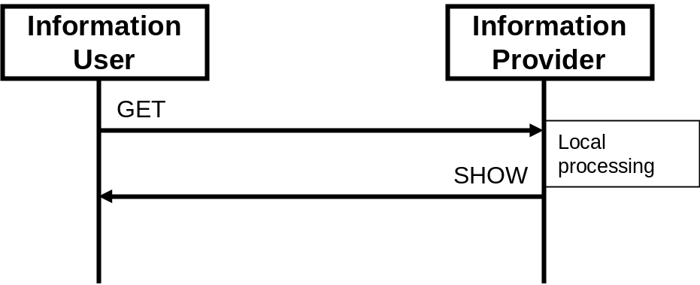
Figure 5 – GET and SHOW transaction
The GET is designed to retrieve one or more objects and any contained elements by using the ID attribute.
Within a GET message, the ID of the requested object is passed to the provider of the information. Where a single ID is not sufficient identification to identify the subset of information requested, such as when only a property of an object is needed, then the ID of the top level object, and the ID or value of the encapsulated object (the property) is passed to the provider of the data. The identifying IDs are specified in the ID sections for each object type.
When a wildcard definition is used in the ID, then the GET returns a list of objects matching the wildcard specification.
Example The GET may retrieve multiple objects such as all of the personnel classes.
NOTE A GET with a wildcard provides a very limited query capability. The transactions are not intended to provide a complete query/reporting capability as normally seen in a database system. If additional query capability is needed, then the GET/SHOW transaction can be used to create copies of all data, and then that copy can be queried locally.

SHOW verb
The SHOW verb shall be used in a SHOW message when responding to a GET message.

PROCESS verb
The PROCESS verb shall be used in a PROCESS message to request processing of the associated noun by the receiving application. A PROCESS message is sent to an entity that can process the object. In a typical exchange scenario a PROCESS message is considered to be the equivalent of a formal command.
NOTE A PROCESS verb is often the equivalent of a command to add an object, but usually the receiving entity does further processing of the information. The PROCESS verb is sent to the owner of the information. A SYNC ADD message is usually send out by the receiver of the PROCESS message, after processing, to inform any other users of the information that there has been new information added.
Example 1 The sending of a PROCESS Operations Schedule message to a site indicates that the schedule is to be executed.
Example 2 The sending of a PROCESS Equipment message indicates that a new equipment item is to be added to a master equipment database. The receiver of the PROCESS message may then send out a SYNC ADD Equipment message to indicate that the master equipment database was updated.
A PROCESS verb area contains an optional element with one of the following additional definitions: Never or Always. (See Table 2) If the optional element is not specified, then it defaults to Never.
Table 2 – Acknowledge request options
Name | Description
Never | No ACKNOWLEDGE message requested.
Always | Always send an ACKNOWLEDGE message.

ACKNOWLEDGE verb
The ACKNOWLEDGE verb shall be used in an ACKNOWLEDGE message to indicate an application’s receipt of a PROCESS request. The response to a PROCESS message is an ACKNOWLEDGE message. The ACKNOWLEDGE message may return the original or modified data. Figure 6 illustrates a PROCESS message with the acknowledge always option, and with a response ACKNOWLEDGE message.
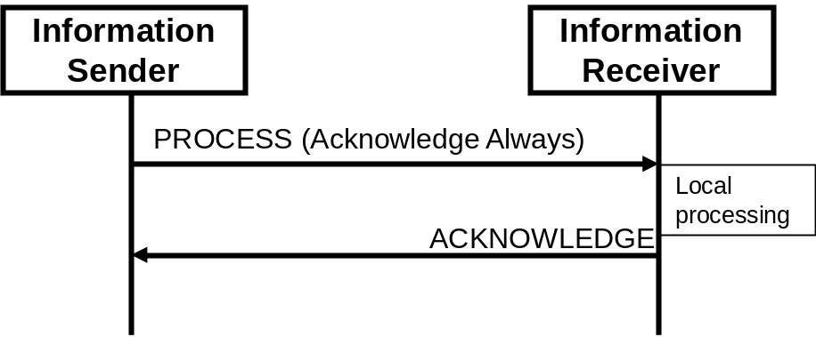
Figure 6 – PROCESS/ACKNOWLEDGE transaction with an acknowledge always option
Example 1 Sending of an ACKNOWLEDGE Operations Schedule message, where a PROCESS Operations Schedule message has been received and the corresponding business application acknowledges the receipt of the Operations Schedule and responds with an acceptance.
An ACKNOWLEDGE verb area contains an element with one of the following additional definitions: Accepted, Rejected, or Modified. (See Table 3)
Table 3 – Acknowledge element
Acknowledge Element Value | Definition
ACCEPTED | The information was accepted by the receiver of the information and was processed according to the business rules of the receiver.
REJECTED | The information was rejected by the receiver of the information and was not processed by the receiver. The message data area shall contain an identification of the reason for rejection.
MODIFIED | The information was accepted by the receiver of the information but was modified for correct processing, the modified data shall be returned with the ACKNOWLEDGE. The message data area shall contain an identification of the type of modification.

Example 2 Figure 7 shows a message sequence from a scheduling system to an execution system. The initial PROCESS message with an operations schedule is received and an ACKNOWLEDGE message with a MODIFIED flag was returned with a new proposed schedule. The scheduling system re-generates a schedule and resends to the execution system. The execution system accepts the operations schedule and returns an ACKNOWLEDGE message with an ACCEPTED flag.
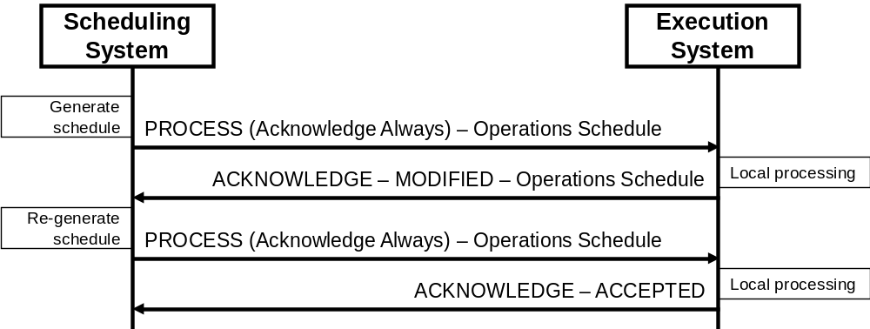
Figure 7 – Example of acknowledge to a process message

CHANGE verb
The CHANGE verb shall be used in a CHANGE message when the sender of the message is sending a request for the data to be changed. The noun area contains the new data. Figure 8 illustrates a CHANGE message with a respond always option and with a RESPOND message.
Example Sending of a CHANGE Person message, where the personnel information, such as a qualification test, is changed by a system that is not the owner of the personnel model data.
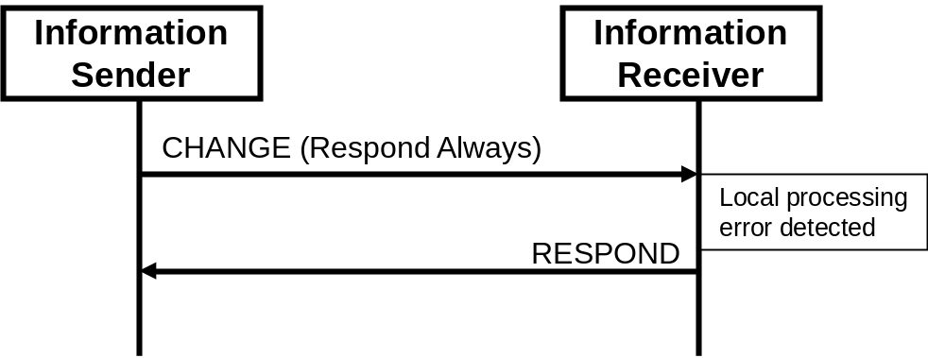
Figure 8 – CHANGE/RESPOND transaction with a respond always option
A CHANGE verb area contains an optional element with one of the following additional definitions: Never or Always. (See Table 4) If the optional element is not specified, then it defaults to Never.
Table 4 – Respond options
Name | Description
Never | No RESPOND message requested.
Always | Always send a RESPOND message.

CANCEL verb
The CANCEL verb shall be used in a CANCEL message when the sender of the CANCEL message is sending a request for the data to be cancelled.
Example Sending of a CANCEL Material Lot message, where an application indicates that a material lot is no longer valid (or available), but the application that is sending the CANCEL message is not the owner of the material model data.
NOTE Because the CANCEL is not sent by the owner of the data, the data are not necessarily deleted. The sender is indicating that the sender no longer needs the data.

CONFIRM verb
A CONFIRM verb shall be used in a CONFIRM message for confirmation of receipt and processing of any message other than the CONFIRM, RESPOND, or ACKNOWLEDGE messages. See Figure 11 for an example of confirmation with detected errors.
Figure 9 illustrates a transaction with a GET message followed by a SHOW message and a CONFIRM message (because of the “Confirm Always” option specified with the GET message).
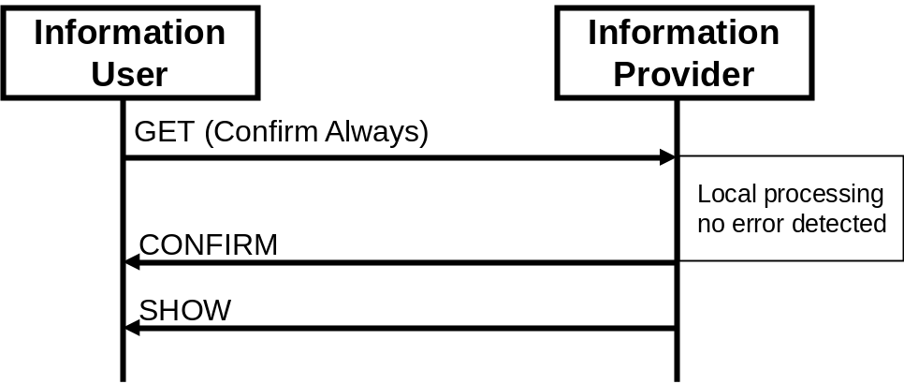
Figure 9 – GET and SHOW transaction with a CONFIRM always
NOTE The order of arrival of the CONFIRM message, SHOW message, and any other response message is not defined in this standard.
Confirmation is an option controlled by the sending business application. It is a request to the receiving application to send back a confirmation message to the sender of the initiating message. If the optional element is not specified, then it defaults to Never.
A confirmation request, specified in the application identification area, has the values defined in Table 5.
Table 5 – Confirmation request options
Name | Description
Never | No confirmation requested.
OnError | Send back a confirmation only if an error has occurred.
Always | Always send a confirmation regardless of the local processing.

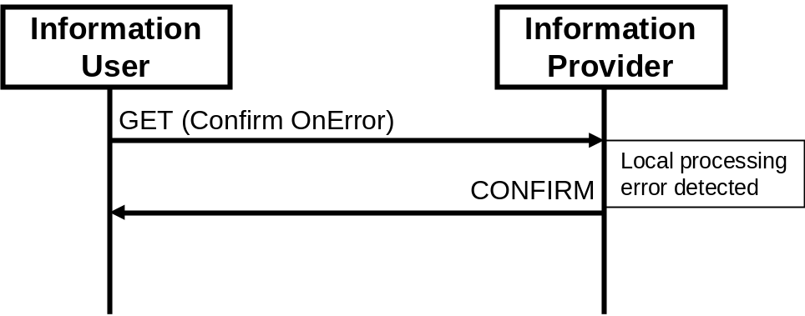
Figure 10 – Example of a GET message with Confirm OnError
NOTE The order of arrival of the CONFIRM message and any other response message is not defined in this standard.
The CONFIRM message:
- Identifies the initiating message being confirmed.
- Indicates the status of the processing of the message.
- Includes a description of the error if the status indicates a processing error if requested.
If an error occurs in the processing of the initiating message by the receiving application and the sender set the confirmation element to either OnError or Always, then the receiving application shall provide a CONFIRM message.
Error handling at the application layer is through the confirmation element in the application identification area. Specific error codes or error text are not defined in this part and are implementation specific.
The application error handling is in addition to any communication layer error handling that may be provided by the infrastructure framework, web service, or middleware.
Additional error description, code, or text associated with objects in the noun area may be contained in the noun area, as shown in Figure 11.
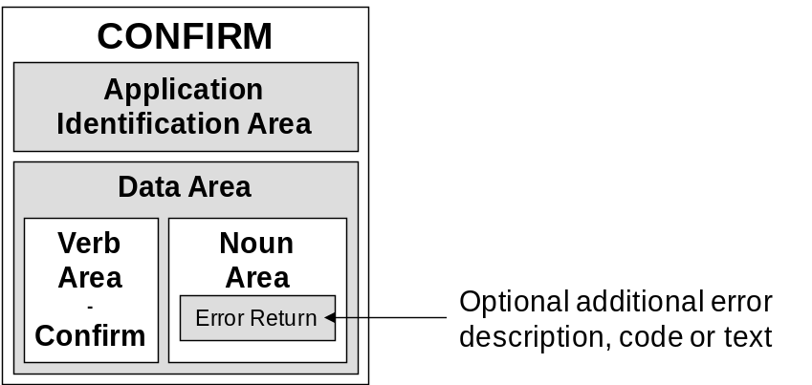
Figure 11 – Confirm Message

RESPOND verb
The RESPOND verb shall be used in a RESPOND message to signify the application receipt and processing of a CHANGE message. The RESPOND message is used when responding to a CHANGE message. The RESPOND message may return the original or modified data.
A RESPOND verb area contains an element with one of the following additional definitions: Accepted, Rejected, or Modified. (See Table 6)
Table 6 – Respond element
Respond element value | Definition
ACCEPTED | The information was accepted by the receiver of the information and was changed according to the business rules of the receiver.
REJECTED | The information was rejected by the receiver of the information and was not changed by the receiver. The message data area shall contain an identification of the reason for rejection.
MODIFIED | The information was accepted by the receiver of the information but was modified for correct processing and the modified data were returned with the RESPOND. The message data area shall contain an identification of the type of modification.

SYNC verb
The SYNC verb shall be used in a SYNC message when the owner of the data is publishing the information or change in information to subscribers.
NOTE 1 SYNC is short for synchronize, and implies synchronized or aligned data; it does not mean synchronous communications
NOTE 2 There should only be one application that sends SYNC messages for any specific element of information.
Example 1 A human resources system may provide personnel capability information; however, a training system may provide the Qualification Test Specification information pertaining to the personnel capability object.
The owner of the information sends the SYNC message.
The SYNC message shall contain one of the following modifiers in the verb area: ADD, CHANGE, or DELETE.
Example 2 This verb is commonly used when mass changes are necessary, such as when an ERP publishes item master to multiple MES systems, or when a publish and subscribe mechanism is used as a company’s integration architecture.

SYNC ADD verb
A SYNC ADD verb shall be sent by the owner of the information and indicates that the owner of the information has added new information. The SYNC ADD message shall include the object instances added and the values of all attributes of these objects. The specific elements to be added are defined in Clause 6. See Figure 12 for an example of a SYNC ADD with a CONFIRM response.

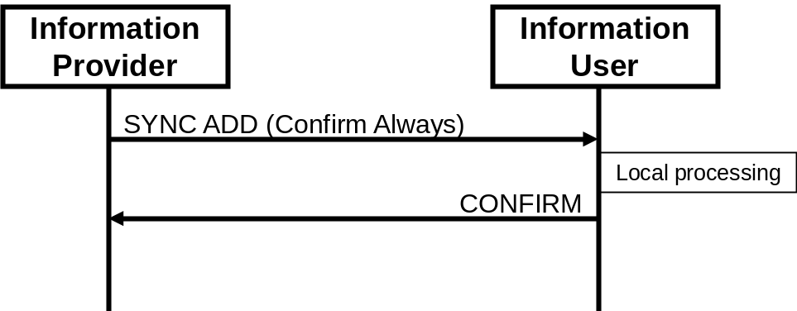
Figure 12 – SYNC ADD transaction with confirmation
Example A SYNC ADD on a Material Test Specification noun indicates the definition of a new Material Test Specification object.

SYNC CHANGE verb
A SYNC CHANGE verb is sent by the owner of the information and is used to disseminate information on changed objects to subscribed users. The SYNC CHANGE message shall include the object instances changed with the values of the attributes changed. The specific elements to be changed are defined in Clause 6.
Example A SYNC CHANGE message with a MATERIAL CLASS object indicates a change in the material class or a property of the material class and the new value.

SYNC DELETE verb
A SYNC DELETE verb is sent by the owner of the information and indicates that the provider of the information has deleted the information. The SYNC DELETE message shall include the object instances deleted.
See Figure 13 for an example of a SYNC DELETE with no response. The specific elements to be deleted are defined in Clause 6.
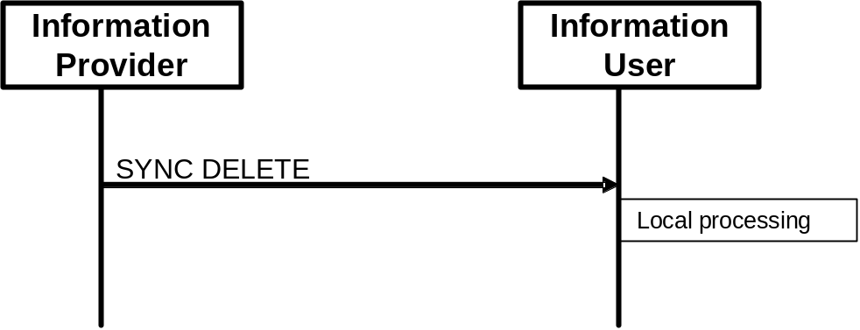
Figure 13 – SYNC DELETE transaction with no confirmation
NOTE A SYNC DELETE message only indicates that the provider has deleted the information from publication. The information may still be archived or retained in accordance with business policies, but just not available for further publishing. The information user has the responsibility to determine the correct action, such as retaining or archiving their information.

NOTIFY verb
The NOTIFY verb shall be used in a NOTIFY message when an information provider publishes notification of the occurrence of an event or data creation. The noun area contains the event data, as illustrated in Figure 14.
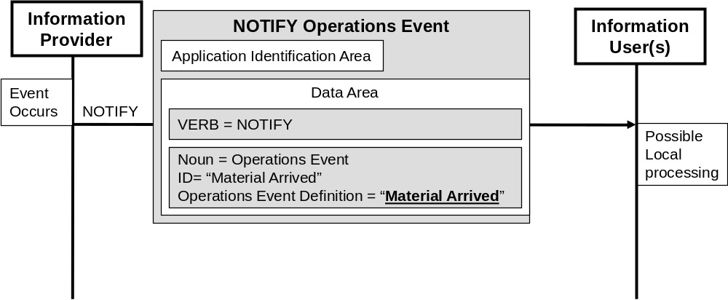
Figure 14 - NOTIFY transaction
The NOTIFY verb does not support acknowledgment or response to a notification. If an implementation requires acknowledgement or response to an event notification, then the responses should be processed as separate event notifications.
NOTE The NOTIFY transaction publication is disconnected from the consumption of the transaction by subscribers. There may be zero or many information users subscribed to receive notifications.
Example Generation of notifications by information providers typically involve the following functions:
- Monitoring of activities from an enterprise or manufacturing operations management system.
- Identification when the trigger condition for the notification is met, indicating that an event has occurred or information is created.
- Assembly of NOTIFY message for notification of the event occurrence or data creation.
- Publication of the NOTIFY message.

Verb actions and the use of IDs
The verbs GET, CHANGE, CANCEL, PROCESS, and SYNC, have different meaning and responses based on the values of ID attributes in the noun object. The specific rules for each verb/noun combination are defined in Clause 6. IDs may be specified, not specified, or contain wildcard values. The action is each case is defined in the noun’s verb action clause. Where there are multiple IDs in a noun/object, each row in the noun’s verb action table defines one valid combination of ID values.

Message nouns

Introduction
This clause defines the contents of the noun area in a message that shall be used by verbs to identify information exchanged.

Defined message contents

Object References
An object may be included in a message either to communicate information about that object or to communicate a reference to a preexisting object. Where a message is communicated containing an object only with its ID (and the ID is recognized as a preexisting object), this shall constitute a reference to a preexisting object with the given ID rather than information describing that object.

Hierarchy Scope
The Hierarchy Scope noun contains the following object as defined in ISA-95.00.02:
- Hierarchy Scope

Equipment
The Equipment noun can contain the following objects as defined in ISA-95.00.02:
- Equipment
- Equipment Property
- Equipment Capability Test Result
- Equipment Asset Mapping

Equipment Capability Test Specification
The Equipment Capability Test Specification noun contains the following object as defined in ISA-95.00.02:
- Equipment Capability Test Specification

Equipment Class
The Equipment Class noun can contain the following objects as defined in ISA-95.00.02:
- Equipment Class
- Equipment Class Property

Job List
The Job List noun can contain the following objects as defined in ISA-95.00.04:
- Job Order
- Job List
- Job Order Parameter
- Personnel Requirement
- Equipment Requirement
- Physical Asset Requirement
- Material Requirement
- Personnel Requirement Property
- Equipment Requirement Property
- Physical Asset Requirement Property
- Material Requirement Property

Job Response
The Job Response noun contains the following objects as defined in ISA-95.00.04:
- Job Response
- Job Response Data
- Personnel Actual
- Equipment Actual
- Physical Asset Actual
- Material Actual
- Personnel Actual Property
- Equipment Actual Property
- Physical Asset Actual Property
- Material Actual Property

Job Response List
The Job Response List noun contains the following objects as defined in ISA-95.00.04:
- Job Response List
- Job Response
- Job Response Data
- Personnel Actual
- Equipment Actual
- Physical Asset Actual
- Material Actual
- Personnel Actual Property
- Equipment Actual Property
- Physical Asset Actual Property
- Material Actual Property

Material Class
The Material Class noun can contain the following objects as defined in ISA-95.00.02:
- Material Class
- Material Class Property

Material Definition
The Material Definition noun can contain the following objects as defined in ISA-95.00.02:
- Material Definition
- Material Definition Property

Material Lot
The Material Lot noun can contain the following objects as defined in ISA-95.00.02:
- Material Lot
- Material Lot Property
- Material Test Result

Material Sublot
The Material Sublot noun can contain the following objects as defined in ISA-95.00.02:
- Material Sublot
- Material Lot Property
- Material Test Result
Example Sublot specific properties may be unique RFIDs (Radio Frequency ID) for each sublot or maximum temperature indicators for each sublot.

Material Test Specification
The Material Test Specification noun can contain the following object as defined in ISA-95.00.02:
- Material Test Specification

Operational Location
The Operational Location noun contains the following objects as defined in ISA-95.00.02:
- Operational Location
- Operational Location Property

Operational Location Class
The Operational Location Class noun contains the following objects as defined in ISA-95.00.02:
- Operational Location Class
- Operational Location Class Property

Operations Capability
The Operations Capability noun can contain the following objects as defined in ISA-95.00.02:
- Operations Capability
- Process Segment Capability
- Personnel Capability
- Equipment Capability
- Physical Asset Capability
- Material Capability
- Personnel Capability Property
- Equipment Capability Property
- Physical Asset Capability Property
- Material Capability Property

Operations Definition
The Operations Definition noun can contain the following objects as defined in ISA-95.00.02:
- Operations Definition
- Operations Segment
- Operations Segment Dependency
- Operations Material Bill
- Operations Material Bill Item
- Parameter Specification
- Personnel Specification
- Equipment Specification
- Physical Asset Specification
- Material Specification
- Personnel Specification Property
- Equipment Specification Property
- Physical Asset Specification Property
- Material Specification Property

Operations Schedule
The Operations Schedule noun can contain the following objects as defined in ISA-95.00.02:
- Operations Schedule
- Operations Request
- Segment Requirement
- Requested Segment Response
- Segment Parameter
- Personnel Requirement
- Equipment Requirement
- Physical Asset Requirement
- Material Requirement
- Personnel Requirement Property
- Equipment Requirement Property
- Physical Asset Requirement Property
- Material Requirement Property

Operations Performance
The Operations Performance noun can contain the following objects as defined in ISA-95.00.02:
- Operations Performance
- Operations Response
- Segment Response
- Segment Data
- Personnel Actual
- Equipment Actual
- Physical Asset Actual
- Material Actual
- Personnel Actual Property
- Equipment Actual Property
- Physical Asset Actual Property
- Material Actual Property

Person
The Person noun can contain the following objects as defined in ISA-95.00.02:
- Person
- Person Property
- Qualification Test Result

Personnel Class
The Personnel Class noun can contain the following objects as defined in ISA-95.00.02:
- Personnel Class
- Personnel Class Property

Physical Asset
The Physical Asset noun can contain the following objects as defined in ISA-95.00.02:
- Physical Asset
- Physical Asset Property
- Physical Asset Capability Test Result
- Equipment Asset Mapping

Physical Asset Class
The Physical Asset Class noun can contain the following objects as defined in ISA-95.00.02:
- Physical Asset Class
- Physical Asset Class Property

Physical Asset Capability Test Specification
The Physical Asset Capability Test Specification noun contains the following object as defined in ISA-95.00.02:
- Physical Asset Capability Test Specification

Process Segment
The Process Segment noun can contain the following objects as defined in ISA-95.00.02:
- Process Segment
- Process Segment Parameter
- Personnel Segment Specification
- Equipment Segment Specification
- Physical Asset Segment Specification
- Material Segment Specification
- Process Segment Dependency
- Personnel Segment Specification Property
- Equipment Segment Specification Property
- Physical Asset Segment Specification Property
- Material Segment Specification Property

Operations Event
The Operations Event noun can contain the following objects as defined in ISA-95.00.02:
- Operations Event
- Operations Event Property
- Operations Event Record

Operations Event Definition
The Operations Event Definition noun can contain the following objects as defined in ISA-95.00.02:
- Operations Event Definition
- Operations Event Definition Property
- Operations Event Definition Record Specification

Operations Event Class
The Operations Event Class noun can contain the following objects as defined in ISA-95.00.02:
- Operations Event Class
- Operations Event Class Property
- Operations Event Class Record Specification

Resource Relationship Network
The Resource Relationship Network noun can contain the following objects as defined in ISA-95.00.04:
- Resource Relationship Network
- Resource Network Connection
- Resource Network Connection Property
- To Resource Reference
- To Resource Reference Property
- From Resource Reference
- From Resource Reference Property

Resource Relationship Network Connection Type
The Resource Relationship Network Connection Type noun can contain the following objects as defined in ISA-95.00.04:
- Resource Network Connection Type
- Resource Network Connection Type Property

Qualification Test Specification
The Qualification Test Specification noun contains the following object as defined in ISA-95.00.02:
- Qualification Test Specification

Transaction Profile
The message contents of a transaction profile returns all supported verb/noun combinations, if the combination is supported as a receiver, if it is supported as a sender, and if wildcards are supported. See Clause 6.22 and Clause 7 for the definition of the object and compliance information.
NOTE The transaction profile is a method to interactively determine what verbs and nouns are supported by an application.

Work Alert Definition
The Work Alert Definition noun can contain the following objects as defined in ISA-95.00.04:
- Work Alert Definition
- Work Alert Definition Property

Work Alert
The Work Alert noun can contain the following objects as defined in ISA-95.00.04:
- Work Alert
- Work Alert Property

Work Calendar Definition
The Work Calendar Definition noun can contain the following objects in ISA-95.00.04:
- Work Calendar Definition
- Work Calendar Definition Entry
- Work Calendar Definition Property

Work Calendar
The Work Calendar noun can contain the following objects in ISA-95.00.04:
- Work Calendar
- Work Calendar Entry
- Work Calendar Property

Work Capability
The Work Capability noun contains the following objects as defined in ISA-95.00.04:
- Work Capability
- Work Master Capability
- Personnel Capability
- Equipment Capability
- Physical Asset Capability
- Material Capability
- Personnel Capability Property
- Equipment Capability Property
- Physical Asset Capability Property
- Material Capability Property

Work Directive
The Work Directive noun contains the following objects as defined in ISA-95.00.04:
- Work Directive
- Workflow Specification
- Parameter Specification
- Personnel Specification
- Equipment Specification
- Physical Asset Specification
- Material Specification
- Personnel Specification Property
- Equipment Specification Property
- Physical Asset Specification Property
- Material Specification Property

Work Master
The Work Master noun contains the following objects as defined in ISA-95.00.04:
- Work Master
- Workflow Specification
- Parameter Specification
- Personnel Specification
- Equipment Specification
- Physical Asset Specification
- Material Specification
- Personnel Specification Property
- Equipment Specification Property
- Physical Asset Specification Property
- Material Specification Property

Work Performance
The Work Performance noun contains the following objects as defined in ISA-95.00.04:
- Work Performance
- Work Response
- Job Response
- Job Response Data
- Personnel Actual
- Equipment Actual
- Physical Asset Actual
- Material Actual
- Personnel Actual Property
- Equipment Actual Property
- Physical Asset Actual Property
- Material Actual Property

Work Record
The Work Record noun contains the following objects as defined in ISA-95.00.04:
- - Work Record
- - All subobjects in a Work Record as defined in ISA-95.00.04

Work Schedule
The Work Schedule noun contains the following objects as defined in ISA-95.00.04:
- Work Schedule
- Work Request
- Job Order Parameter
- Personnel Requirement
- Equipment Requirement
- Physical Asset Requirement
- Material Requirement
- Personnel Requirement Property
- Equipment Requirement Property
- Physical Asset Requirement Property
- Material Requirement Property

Workflow Specification
The Workflow Specification noun contains the following objects as defined in ISA-95.00.04:
- Workflow Specification
- Workflow Specification Node
- Workflow Specification Node Property
- Workflow Specification Connection
- Workflow Specification Connection Property

Workflow Specification Type
The Workflow Specification Type noun contains the following objects as defined in ISA-95.00.04:
- Workflow Specification Type
- Workflow Specification Node Type
- Workflow Specification Node Type Property
- Workflow Specification Connection Type
- Workflow Specification Connection Type Property

Hierarchy Scope Model

Hierarchy scope model elements
The message definitions assume that information may be accessed from one starting point, hierarchy scope, as identified by the dotted collection in Figure 15.
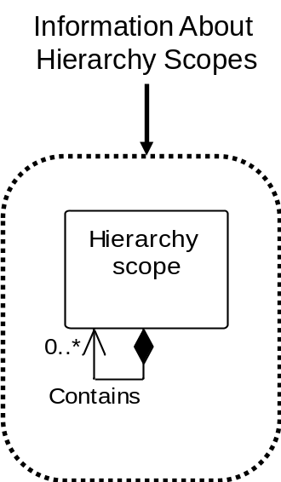
Figure 15 - Object grouping for hierarchy scope model
Example Messages include Get Hierarchy Scope, Show Hierarchy Scope and Process Hierarchy Scope

Hierarchy scope verbs
All verbs shall be valid for a hierarchy scope noun.

Hierarchy scope verb actions
The actions performed on hierarchy scope objects are defined in Table 7.
Table 7 - Hierarchy scope verb actions
Value of Hierarchy Scope ID | Verb action on noun
IDs specified | GET: Shall define a request that the receiver is to return, in a SHOW message, all attributes about the Hierarchy Scopes.  PROCESS: Shall define a request that the receiver is to add Hierarchy Scopes. The message defines suggested IDs for the Hierarchy Scopes. The receiver adds the Hierarchy Scopes and assigns IDs. The assigned IDs shall be returned in the ACKNOWLEDGE message.  CHANGE: Shall define a request that the receiver is to change the specified attributes of the Hierarchy Scopes. A RESPOND message may be used to communicate agreement, disagreement, or changes made to the CHANGE message data.  CANCEL: Shall define a request that the receiver is to cancel the specified Hierarchy Scopes.  SYNC ADD: Shall define a request that the receiver is to add the specified Hierarchy Scopes.  SYNC CHANGE: Shall define a request that the receiver is to change the specified attributes of the Hierarchy Scopes.  SYNC DELETE: Shall define a request that the receiver is to delete the specified Hierarchy Scopes.  NOTIFY: Shall define the creation of a new hierarchy scope.
<not specified> | GET: Error.  PROCESS: Error.  CHANGE: Error.  CANCEL: Error.  SYNC ADD: Error.  SYNC CHANGE: Error.  SYNC DELETE: Error.  NOTIFY: Error.
Wildcard specified | GET: Shall define a request that the receiver is to return, in a SHOW message, all attributes of all Hierarchy Scopes identified by the ID wildcard.  Example To return all Hierarchy Scopes, specify a “*” as the wildcard.  PROCESS: Error.  CHANGE: Error.  CANCEL: Shall define a request that the receiver is to cancel all Hierarchy Scopes matching the wildcard.  SYNC ADD: Error.  SYNC CHANGE: Error.  SYNC DELETE: Shall define a request that the receiver is to delete all Hierarchy Scopes matching the wildcard.  NOTIFY: Error.

Test specification model
The message definitions assume that test information may be accessed from one starting point, test specification, as identified by the dotted collections in Figure 16. Test Specification is defined for the <<interface>> classes defined in ISA 95.00.02 in the Operations Test Model, and for Personnel Class, Person, Equipment Class, Equipment, Physical Asset Class, Physical Asset, Material Class, Material Definition, Material Lot, and Material Sublot.
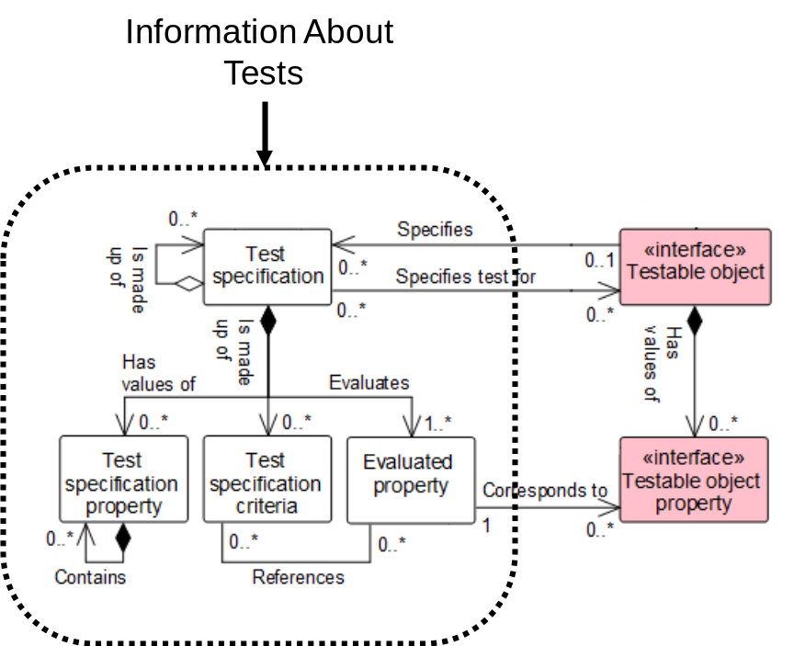
Figure 16 – Object Grouping for Test Specification

Test specification verbs
All verbs shall be valid for a test specification noun.

Test specification verb actions
The actions performed on a Test specification noun are defined in Table 10.
Table 10 – Test specification verb actions
Value of Test ID | Verb action on noun
IDs specified | GET: Shall define a request that the receiver is to return, in a SHOW message, all attributes of the Test Specifications, the IDs of Testable Objects referenced by the test, and the IDs of all Testable Object Properties referenced by the test.  PROCESS: Shall define a request that the receiver is to add Test Specifications. The message defines suggested IDs for the Test Specifications, values for the attributes and IDs of Testable Object Properties referenced by the Test Specification. The receiver adds the Test Specifications and assigns IDs. The assigned IDs shall be returned in the ACKNOWLEDGE message.  CHANGE: Shall define a request that the receiver is to change the specified attributes of the Test Specifications and IDs of Testable Object Properties referenced. A RESPOND message may be used to communicate agreement, disagreement, or changes made to the CHANGE message data.  CANCEL: Shall define a request that the receiver is to cancel the specified Test Specifications.  SYNC ADD: Shall define a request that the receiver is to add the specified Test Specifications and IDs of Testable Object Properties referenced.  SYNC CHANGE: Shall define a request that the receiver is to change the specified attributes of the Test Specifications and IDs of testable Object Properties referenced.  SYNC DELETE: Shall define a request that the receiver is to delete the specified Test Specifications.  NOTIFY: Shall define the creation of a new Test Specification.
<not specified> | GET: Error.  PROCESS: Error.  CHANGE: Error.  CANCEL: Error.  SYNC ADD: Error.  SYNC CHANGE: Error.  SYNC DELETE: Error.  NOTIFY: Error.
Wildcard specified | GET: Shall define a request that the receiver is to return, in a SHOW message, all attributes of all Test Specifications identified by the wildcard, the IDs of testable Object Properties referenced by the tests.  Example To return all Test Specifications, specify a “*” as the wildcard.  PROCESS: Error.  CHANGE: Shall define a request that the receiver is to change the specified attributes of all Test Specifications matching the wildcard ID and IDs of Testable Object Properties referenced. A RESPOND message may be used to communicate agreement, disagreement, or changes made to the CHANGE message data.  CANCEL: Shall define a request that the receiver is to cancel all Test Specifications matching the wildcard ID.  SYNC ADD: Error.  SYNC CHANGE: Shall define a request that the receiver is to change the specified attributes of all Test Specifications matching the wildcard ID and IDs of Testable Object Properties referenced.  SYNC DELETE: Shall define a request that the receiver is to delete all Test Specifications matching the wildcard ID.  NOTIFY: Error.

Personnel model

Personnel model elements
The message definitions assume that information may be accessed from any of three starting points: personnel class, person, or test specification, as identified by the dotted collections in Figure 17. Personnel class and person implement the testable object <<interface>> class (See ISA 95.00.02 on the Operations Test Model). Personnel class property and person property implement the testable object property <<interface>> class. See clause 6.4 for the test specification transaction definitions.
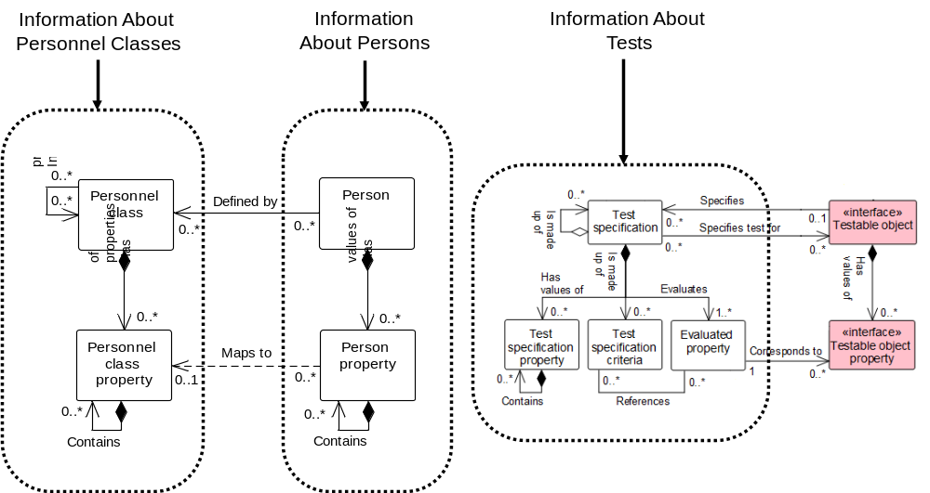
Figure 17 – Object grouping for the personnel model
Example Messages may be: GET Personnel Class, GET Person, GET Qualification Test Specification

Personnel class verbs
All verbs shall be valid for a personnel class noun.
A personnel class message contains information about personnel classes, or personnel classes and their personnel class properties. The returned information does not contain the person objects associated with the personnel class, but does contain the IDs of the persons belonging to the class.

Personnel class verb actions
Table 8 defines verb actions and the use of IDs and values for the personnel class.
Table 8 – Personnel class verb actions
Value of Personnel  Class ID | Value of Personnel Class Property ID | Personnel Class Property Value | Verb action on noun
IDs specified | not specified | not specified | GET: Shall define a request that the receiver is to return, in a SHOW message, all attributes about the specified Personnel Classes, all properties and their attributes, and the list of Person IDs of the Personnel Classes.  PROCESS: Shall define a request that the receiver is to add Personnel Classes. The IDs define suggested IDs for the Personnel Classes. The receiver adds the Personnel Classes and assigns IDs. The assigned IDs shall be returned in the ACKNOWLEDGE message.  CHANGE: The specified attributes of the specified Personnel Classes shall be changed.  CANCEL: Shall define a request that the receiver is to cancel the specified Personnel Classes.  SYNC ADD: Shall define a request that the receiver is to add the specified Personnel Classes.  SYNC CHANGE: The specified attributes of the specified Personnel Classes shall be changed.  SYNC DELETE: Shall define a request that the receiver is to delete the specified Personnel Classes.  NOTIFY: Shall define the creation of a new Personnel Class.
IDs specified | IDs specified | not specified | GET: Shall define a request that the receiver is to return, in a SHOW message, all attributes about the specified Personnel Classes, all of the specified Personnel Class properties, and the list of Person IDs of the Personnel Classes.  PROCESS: Shall define a request that the receiver is to add Personnel Classes. The ID defines suggested IDs for the Personnel Classes and list of properties. The receiver adds the Personnel Classes and properties and assigns IDs. The assigned IDs shall be returned in the ACKNOWLEDGE message.  CHANGE: Error (no property values are specified).  CANCEL: Shall define a request that the receiver is to cancel the specified properties for the specified Personnel Classes.  SYNC ADD: Shall define a request that the receiver is to add the Personnel Classes and list of Personnel Class Properties.  SYNC CHANGE: Error (no property values are specified).  SYNC DELETE: Shall define a request that the receiver is to delete the specified list of Personnel Class properties.  NOTIFY: Shall define the creation of a new Personnel Class.
IDs specified | IDs specified | Property Value Specified | GET: Shall define a request that the receiver is to return, in a SHOW message, all attributes about the specified Personnel Classes where the Personnel Class Property value matches the specified property value, all of the specified Personnel Class properties, and the list of Person IDs.  PROCESS: Shall define a request that the receiver is to add Personnel Classes. The IDs define suggested IDs for the Personnel Classes and properties, and values for the properties. The receiver adds the Personnel Classes and properties and assigns IDs. The assigned IDs shall be returned in the ACKNOWLEDGE message.  CHANGE: Shall define a request that the receiver is to change the values of the specified properties for the specified Personnel Classes to the property values specified. A RESPOND message may be used to communicate agreement, disagreement, or changes made to the CHANGE message data.  CANCEL: Shall define a request that the receiver is to cancel the specified properties of the Personnel Classes that have the specified property value.  SYNC ADD: Shall define a request that the receiver is to add the specified Personnel Classes, list of properties and property values.  SYNC CHANGE: Shall define a request that the receiver is to change the values of the specified list of properties for the specified Personnel Classes to the specified values.  SYNC DELETE: Shall define a request that the receiver is to delete the specified list of Personnel Class Properties of the specified Personnel Classes that have the specified property values.  NOTIFY: Shall define the creation of a new Personnel Class.
Wildcard specified | not specified | not specified | GET: Shall define a request that the receiver is to return, in a SHOW message, all attributes and properties about the Personnel Classes that match the wildcard and the list of Person IDs of each Personnel Class.  Example 1 To return all Personnel Classes, specify a “*” as the wildcard.  PROCESS: Error.  CHANGE: Error (no property values are specified).  CANCEL: Shall define a request that the receiver is to cancel all Personnel Classes matching the wildcard.  SYNC ADD: Error.  SYNC CHANGE: Error (no property values are specified).  SYNC DELETE: Shall define a request that the receiver is to delete all Personnel Classes matching the wildcard.  NOTIFY: Error.
Wildcard specified | Wildcard specified | not specified | GET: Shall define a request that the receiver is to return, in a SHOW message, all attributes of the Personnel Classes that match the wildcard, and for each class return all Personnel Class Properties that match the property wildcards, and the list of Person IDs of to the class.  Example 2 To return a single property, specify the single Personnel Class Property ID in the property wildcard.  Example 3 To return all Personnel Class properties, specify a “*” as the property wildcard.  Example 4 To return a single Personnel Class, specify the Personnel Class ID in the wildcard.  Example 5 To return all Personnel Classes, specify a “*” as the wildcard.  PROCESS: Error.  CHANGE: Error (no property values are specified).  CANCEL: Shall define a request that the receiver is to cancel all properties matching the property wildcard of all Personnel Classes that match the wildcard.  SYNC ADD: Error.  SYNC CHANGE: Error (no property values are specified).  SYNC DELETE: Shall define a request that the receiver is to delete all properties that match the property wildcard of all Personnel Classes that match the wildcard.  NOTIFY: Error.

Person verbs
All verbs shall be valid for a person noun.
NOTE This contains information about persons and their person properties. The returned information does not contain the personnel class objects associated with the person, but does contain the IDs of the personnel classes the person belongs to.

Person verb actions
The actions performed on a person noun are defined in Table 9.
Table 9 – Person verb actions
Value of Person  ID | Value of Person Property ID | Person Property Value | Verb action on noun
IDs specified | not specified | not specified | GET: Shall define a request that the receiver is to return, in a SHOW message, all attributes about the specified Persons, all properties and their attributes, and the list of Personnel Class IDs of the Persons.  PROCESS: Shall define a request that the receiver is to add Persons. The message defines suggested IDs for the Persons. The receiver adds the Persons and assigns IDs. The assigned IDs shall be returned in the ACKNOWLEDGE message.  CHANGE: The specified attributes of the specified Persons shall be changed.  CANCEL: Shall define a request that the receiver is to cancel the specified Persons.  SYNC ADD: Shall define a request that the receiver is to add the specified Persons.  SYNC CHANGE: The specified attributes of the specified Persons shall be changed.  SYNC DELETE: Shall define a request that the receiver is to delete the specified Persons.  NOTIFY: Shall define the creation of a new Person.
IDs specified | IDs specified | not specified | GET: Shall define a request that the receiver is to return, in a SHOW message, all attributes about the specified Persons, all of the specified Person properties, and the list of Personnel Class IDs of the Persons.  PROCESS: Shall define a request that the receiver is to add Persons. The ID defines suggested IDs for the Persons and list of properties. The receiver adds the Persons and properties and assigns IDs. The assigned IDs shall be returned in the ACKNOWLEDGE message.  CHANGE: Error (no property values are specified).  CANCEL: Shall define a request that the receiver is to cancel the specified properties for the specified Persons.  SYNC ADD: Shall define a request that the receiver is to add the Persons and list of Person Properties.  SYNC CHANGE: Error (no property values are specified).  SYNC DELETE: Shall define a request that the receiver is to delete the specified list of Person Properties.  NOTIFY: Shall define the creation of a new Person.
IDs specified | IDs specified | Property Value Specified | GET: Shall define a request that the receiver is to return, in a SHOW message, all attributes about the specified Persons where the Person Property value matches the specified property value, all of the specified Person properties, and the list of Personnel Class IDs.  PROCESS: Shall define a request that the receiver is to add Persons. The ID defines suggested IDs for the Persons and properties, and values for the properties. The receiver adds the Persons and properties and assigns IDs. The assigned IDs shall be returned in the ACKNOWLEDGE message.  CHANGE: Shall define a request that the receiver is to change the values of the specified properties for the specified Persons to the specified values. A RESPOND message may be used to communicate agreement, disagreement, or changes made to the CHANGE message data.  CANCEL: Shall define a request that the receiver is to cancel the specified properties of the Persons that have the specified property value.  SYNC ADD: Shall define a request that the receiver is to add the specified Persons, list of properties and property values.  SYNC CHANGE: Shall define a request that the receiver is to change the values of the specified list of properties for the specified Persons to the specified values.  SYNC DELETE: Shall define a request that the receiver is to delete the specified list of Person Properties of the specified Persons that have the specified property value.  NOTIFY: Shall define the creation of a new Person.
Wildcard specified | not specified | not specified | GET: Shall define a request that the receiver is to return, in a SHOW message, all attributes and properties about the Persons that match the wildcard and the list of Personnel Class IDs of each Person.  Example 1 To return all Persons, specify a “*” as the wildcard.  PROCESS: Error.  CHANGE: Error (no property values are specified).  CANCEL: Shall define a request that the receiver is to cancel all Persons matching the wildcard.  SYNC ADD: Error.  SYNC CHANGE: Error (no property values are specified).  SYNC DELETE: Shall define a request that the receiver is to delete all Persons matching the wildcard.  NOTIFY: Error.
Wildcard specified | Wildcard specified | not specified | GET: Shall define a request that the receiver is to return, in a SHOW message, all attributes of the Persons that match the wildcard, and for each Person return all Person Properties that match the property wildcards, and the list of Personnel Class IDs of to the Person.  Example 2 To return a single property, specify the property in the property wildcard.  Example 3 To return all properties, specify a “*” as the property wildcard.  Example 4 To return a single Person, specify the Person ID in the wildcard.  Example 5 To return all Persons, specify a “*” as the wildcard.  PROCESS: Error.  CHANGE: Error (no property values are specified).  CANCEL: Shall define a request that the receiver is to cancel all properties matching the property wildcard of all Persons that match the wildcard.  SYNC ADD: Error.  SYNC CHANGE: Error (no property values are specified).  SYNC DELETE: Shall define a request that the receiver is to delete all properties that match the property wildcard of all Persons that match the wildcard.  NOTIFY: Error.

Role based equipment model

Role based equipment model elements
The message definitions assume that information may be accessed from any of three starting points: equipment class, equipment, or test specification, as identified by the dotted collections in Figure 18. Equipment class and equipment implement the testable object <<interface>> class (See ISA 95.00.02 on the Operations Test Model). Equipment class property and equipment property implement the testable object property <<interface>> class. See clause 6.4 for the test specification transaction definitions.

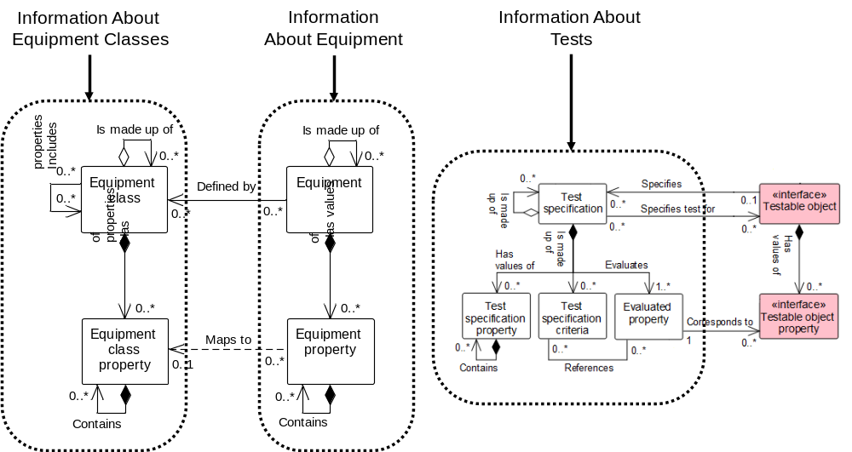
Figure 18 – Object grouping for the role based equipment model
Example Messages may be: GET Equipment Class, GET Equipment, GET Equipment Capability Test

Equipment class verbs
All verbs shall be valid for an equipment class noun.
NOTE This contains information about equipment classes, or equipment classes and their equipment class properties. The returned information does not contain the equipment objects associated with the equipment class, but only the IDs of the equipment belonging to the class.

Equipment class verb actions
The actions performed on equipment class objects are defined in Table 11.
Table 11 – Equipment class verb actions
Value of Equipment  Class ID | Value of Equipment Class Property ID | Equipment Class Property Value | Verb action on noun
IDs specified | not specified | not specified | GET: Shall define a request that the receiver is to return, in a SHOW message, all attributes about the specified Equipment Classes, all properties and their attributes, and the IDs of Equipment that are members of each Equipment Class.  PROCESS: Shall define a request that the receiver is to add Equipment Classes. The message defines suggested IDs for the Equipment Classes. The receiver adds the Equipment Classes and assigns IDs. The assigned IDs shall be returned in the ACKNOWLEDGE message.  CHANGE: The specified attributes of the specified Equipment Classes shall be changed.  CANCEL: Shall define a request that the receiver is to cancel the specified Equipment Classes.  SYNC ADD: Shall define a request that the receiver is to add the specified Equipment Classes.  SYNC CHANGE: The specified attributes of the specified Equipment Classes shall be changed.  SYNC DELETE: Shall define a request that the receiver is to delete the specified Equipment Classes.  NOTIFY: Shall define the creation of a new Equipment Class.
IDs specified | IDs specified | not specified | GET: Shall define a request that the receiver is to return, in a SHOW message, all attributes about the specified Equipment Classes, all of the specified Equipment Class Properties, and the IDs of Equipment that are members of each Equipment Class.  PROCESS: Shall define a request that the receiver is to add Equipment Classes. The message defines suggested IDs for the Equipment Classes and properties. The receiver adds the Equipment Classes and properties and assigns IDs. The assigned IDs shall be returned in the ACKNOWLEDGE message.  CHANGE: Error (no property values are specified).  CANCEL: Shall define a request that the receiver is to cancel the specified properties for the specified Equipment Classes.  SYNC ADD: Shall define a request that the receiver is to add the Equipment Classes and list of Equipment Class Properties.  SYNC CHANGE: Error (no property values are specified).  SYNC DELETE: Shall define a request that the receiver is to delete the specified list of Equipment Class Properties.  NOTIFY: Shall define the creation of a new Equipment Class.
IDs specified | IDs specified | Property Value Specified | GET: Shall define a request that the receiver is to return, in a SHOW message, all attributes about the specified Equipment Classes where the Equipment Class Property value matches the specified property value, all of the specified Equipment Class Properties, and the IDs of Equipment that are members of each Equipment Class.  PROCESS: Shall define a request that the receiver is to add Equipment Classes. The message defines suggested IDs for the Equipment Classes and properties, and values for the properties. The receiver adds the Equipment Classes and properties and assigns IDs. The assigned IDs shall be returned in the ACKNOWLEDGE message.  CHANGE: Shall define a request that the receiver is to change the values of the specified properties for the specified Equipment Classes to the specified values. A RESPOND message may be used to communicate agreement, disagreement, or changes made to the CHANGE message data.  CANCEL: Shall define a request that the receiver is to cancel the specified properties of the Equipment Classes that have the specified property value.  SYNC ADD: Shall define a request that the receiver is to add the specified Equipment Classes, list of properties and property values.  SYNC CHANGE: Shall define a request that the receiver is to change the values of the specified list of properties for the specified Equipment Classes to the specified values.  SYNC DELETE: Shall define a request that the receiver is to delete the specified list of Equipment Class Properties of the specified Equipment Classes that have the specified property value.  NOTIFY: Shall define the creation of a new Equipment Class.
Wildcard specified | not specified | not specified | GET: Shall define a request that the receiver is to return, in a SHOW message, all attributes and properties about the Equipment Classes that match the wildcard ID and the IDs of Equipment that are members of each Equipment Class.  Example 1 To return all Equipment Classes, specify a “*” as the wildcard.  PROCESS: Error.  CHANGE: Error (no property values are specified).  CANCEL: Shall define a request that the receiver is to cancel all Equipment Classes matching the wildcard ID.  SYNC ADD: Error.  SYNC CHANGE: Error (no property values are specified).  SYNC DELETE: Shall define a request that the receiver is to delete all Equipment Classes matching the wildcard ID.  NOTIFY: Error.
Wildcard specified | Wildcard specified | not specified | GET: Shall define a request that the receiver is to return, in a SHOW message, all attributes of the Equipment Classes that match the wildcard IDs, and for each class return all Equipment Class Properties that match the property wildcards, and the IDs of Equipment that are members of each Equipment Class.  Example 2 To return a single property, specify the Equipment Class Property ID in the property wildcard.  Example 3 To return all Equipment Class Properties, specify a “*” as the property wildcard.  Example 4 To return a single Equipment Class, specify the ID in the wildcard ID.  Example 5 To return all Equipment Classes, specify a “*” as the wildcard.  PROCESS: Error.  CHANGE: Error (no property values are specified).  CANCEL: Shall define a request that the receiver is to cancel all Equipment Class Properties matching the property wildcard of all Equipment Classes that match the wildcard.  SYNC ADD: Error.  SYNC CHANGE: Error (no property values are specified).  SYNC DELETE: Shall define a request that the receiver is to delete all Equipment Class Properties matching the property wildcard of all Equipment Classes that match the wildcard.  NOTIFY: Error.

Equipment verbs
All verbs shall be valid for an equipment noun.
NOTE This contains information about equipment and the equipment properties. The returned information does not contain the equipment class objects associated with the equipment, but only the IDs of the equipment classes the equipment belongs to.

Equipment verb actions
The actions performed on an equipment noun are defined in Table 12.
Table 12 – Equipment verb actions
Value of Equipment  ID | Value of Equipment Property ID | Equipment Property Value | Verb action on noun
IDs specified | not specified | not specified | GET: Shall define a request that the receiver is to return, in a SHOW message, all attributes about the specified Equipment, all properties and their attributes, all Equipment Asset Mappings and the IDs of the Equipment Classes of the Equipment.  PROCESS: Shall define a request that the receiver is to add Equipment. The ID defines a suggested ID for the Equipment. The receiver adds the Equipment and assigns IDs. The assigned IDs shall be returned in the ACKNOWLEDGE message.  CHANGE: The specified attributes of the specified Equipment and/or the Equipment Asset Mappings shall be changed.  CANCEL: Shall define a request that the receiver is to cancel the specified Equipment.  SYNC ADD: Shall define a request that the receiver is to add the specified Equipment.  SYNC CHANGE: The specified attributes of the specified Equipment shall be changed.  SYNC DELETE: Shall define a request that the receiver is to delete the specified Equipment.  NOTIFY: Shall define the creation of a new Equipment.
IDs specified | IDs specified | not specified | GET: Shall define a request that the receiver is to return, in a SHOW message, all attributes about the specified Equipment, all of the specified Equipment Properties, and the IDs of Equipment Classes of the Equipment.  PROCESS: Shall define a request that the receiver is to add Equipment. The ID defines suggested IDs for the Equipment and properties. The receiver adds the Equipment and properties and assigns IDs. The assigned IDs shall be returned in the ACKNOWLEDGE message.  CHANGE: Error (no property values are specified).  CANCEL: Shall define a request that the receiver is to cancel the specified properties for the specified Equipment.  SYNC ADD: Shall define a request that the receiver is to add the Equipment and list of Equipment Properties.  SYNC CHANGE: Error (no property values are specified).  SYNC DELETE: Shall define a request that the receiver is to delete the specified list of Equipment Properties.  NOTIFY: Shall define the creation of a new Equipment.
IDs specified | IDs specified | Property Value Specified | GET: Shall define a request that the receiver is to return, in a SHOW message, all attributes about the specified Equipment where the Equipment Property value matches the specified property value, all of the specified Equipment Properties, and the IDs of Equipment Classes.  PROCESS: Shall define a request that the receiver is to add Equipment. The message defines suggested IDs for the Equipment and properties, and values for the properties. The receiver adds the Equipment and properties and assigns IDs. The assigned IDs shall be returned in the ACKNOWLEDGE message.  CHANGE: Shall define a request that the receiver is to change the values of the specified properties for the specified Equipment to the specified values. A RESPOND message may be used to communicate agreement, disagreement, or changes made to the CHANGE message data.  CANCEL: Shall define a request that the receiver is to cancel the specified properties of the Equipment that have the specified property value.  SYNC ADD: Shall define a request that the receiver is to add the specified Equipment, list of properties and property values.  SYNC CHANGE: Shall define a request that the receiver is to change the values of the specified list of properties for the specified Equipment to the specified values.  SYNC DELETE: Shall define a request that the receiver is to delete the specified list of Equipment Properties of the specified Equipment that have the specified property value.  NOTIFY: Shall define the creation of a new Equipment.
Wildcard specified | not specified | not specified | GET: Shall define a request that the receiver is to return, in a SHOW message, all attributes and properties about the Equipment that matches the ID wildcard and the IDs of Equipment Classes of each Equipment and all Equipment Asset Mappings.  Example 1 To return all Equipment, specify a “*” as the wildcard.  PROCESS: Error.  CHANGE: Error (no property values are specified).  CANCEL: Shall define a request that the receiver is to cancel all Equipment matching the ID wildcard.  SYNC ADD: Error.  SYNC CHANGE: Error (no property values are specified).  SYNC DELETE: Shall define a request that the receiver is to delete all Equipment matching the ID wildcard.  NOTIFY: Error.
Wildcard specified | Wildcard specified | not specified | GET: Shall define a request that the receiver is to return, in a SHOW message, all attributes of the Equipment that matches the ID wildcard, and for each class return all Equipment Properties that match the property ID wildcards, and the IDs of Equipment Classes of to the Equipment.  Example 2 To return a single property, specify the Equipment Property ID in the property ID wildcard.  Example 3 To return all Equipment properties, specify a “*” as the property ID wildcard.  Example 4 To return a single Equipment, specify the Equipment ID in the ID wildcard.  Example 5 To return all Equipment, specify a “*” as the ID wildcard.  PROCESS: Error.  CHANGE: Error (no property values are specified).  CANCEL: Shall define a request that the receiver is to cancel all properties matching the Equipment Property ID wildcard of all Equipment that matches the ID wildcard.  SYNC ADD: Error.  SYNC CHANGE: Error (no property values are specified).  SYNC DELETE: Shall define a request that the receiver is to delete all properties that match the Equipment Property ID wildcard of all Equipment that match the ID wildcard.  NOTIFY: Error.

Physical asset model

Physical asset model elements
The message definitions assume that information may be accessed from any of three starting points: physical asset class, physical asset, or physical asset capability test, as identified by the dotted collections in Figure 19. Physical class and physical asset implement the testable object <<interface>> class (See ISA 95.00.02 on the Operations Test Model). Physical asset class property and physical asset property implement the testable object property <<interface>> class. See clause 6.4 for the test specification transaction definitions.
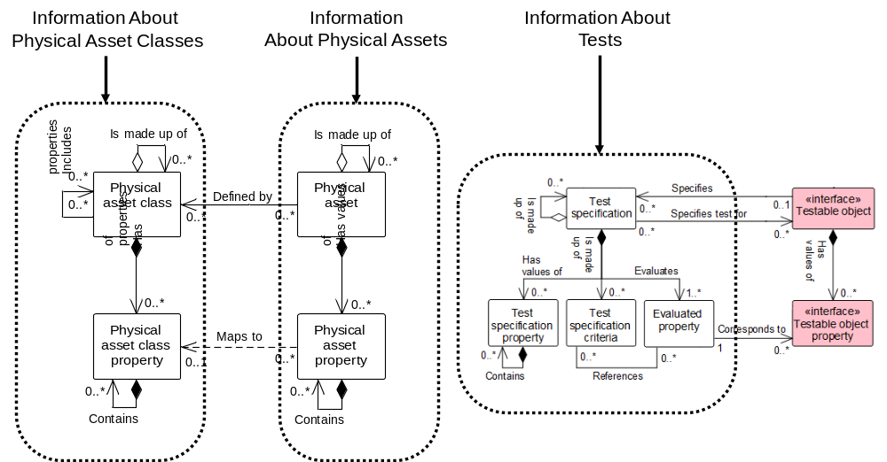
Figure 19 – Object grouping for the physical asset model
Example Messages may be: GET Physical Asset Class, GET Physical Asset, GET Physical Asset Capability Test

Physical asset class verbs
All verbs shall be valid for a physical asset class noun.
NOTE This contains information about physical asset classes, or physical asset classes and their physical asset class properties. The returned information does not contain the physical asset objects associated with the physical asset class, but only the IDs of the physical asset belonging to the class.

Physical asset class verb actions
The actions performed on physical asset class objects are defined in Table 13.
Table 13 – Physical asset class verb actions
Physical Asset  Class ID | Physical Asset Class Property ID | Physical Asset Class Property Value | Verb action on noun
IDs specified | not specified | not specified | GET: Shall define a request that the receiver is to return, in a SHOW message, all attributes about the specified Physical asset Classes, all properties and their attributes, and the IDs of Physical asset that are members of each Physical asset Class.  PROCESS: Shall define a request that the receiver is to add Physical asset Classes. The message defines suggested IDs for the Physical asset Classes. The receiver adds the Physical asset Classes and assigns IDs. The assigned IDs shall be returned in the ACKNOWLEDGE message.  CHANGE: The specified attributes of the specified Physical asset Classes shall be changed.  CANCEL: Shall define a request that the receiver is to cancel the specified Physical asset Classes.  SYNC ADD: Shall define a request that the receiver is to add the specified Physical asset Classes.  SYNC CHANGE: The specified attributes of the specified Physical asset Classes shall be changed.  SYNC DELETE: Shall define a request that the receiver is to delete the specified Physical asset Classes.  NOTIFY: Shall define the creation of a new Physical asset Class.
IDs specified | IDs specified | not specified | GET: Shall define a request that the receiver is to return, in a SHOW message, all attributes about the specified Physical asset Classes, all of the specified Physical asset Class Properties, and the IDs of Physical asset that are members of each Physical asset Class.  PROCESS: Shall define a request that the receiver is to add Physical asset Classes. The message defines suggested IDs for the Physical asset Classes and properties. The receiver adds the Physical asset Classes and properties and assigns IDs. The assigned IDs shall be returned in the ACKNOWLEDGE message.  CHANGE: Error (no property values are specified).  CANCEL: Shall define a request that the receiver is to cancel the specified properties for the specified Physical asset Classes.  SYNC ADD: Shall define a request that the receiver is to add the Physical asset Classes and list of Physical asset Class Properties.  SYNC CHANGE: Error (no property values are specified).  SYNC DELETE: Shall define a request that the receiver is to delete the specified list of Physical asset Class Properties.  NOTIFY: Shall define the creation of a new Physical asset Class.
IDs specified | IDs specified | Property Value Specified | GET: Shall define a request that the receiver is to return, in a SHOW message, all attributes about the specified Physical asset Classes where the Physical asset Class Property value matches the specified property value, all of the specified Physical asset Class Properties, and the IDs of Physical asset that are members of each Physical asset Class.  PROCESS: Shall define a request that the receiver is to add Physical asset Classes. The message defines suggested IDs for the Physical asset Classes and properties, and values for the properties. The receiver adds the Physical asset Classes and properties and assigns IDs. The assigned IDs shall be returned in the ACKNOWLEDGE message.  CHANGE: Shall define a request that the receiver is to change the values of the specified properties for the specified Physical asset Classes to the specified values. A RESPOND message may be used to communicate agreement, disagreement, or changes made to the CHANGE message data.  CANCEL: Shall define a request that the receiver is to cancel the specified properties of the Physical asset Classes that have the specified property value.  SYNC ADD: Shall define a request that the receiver is to add the specified Physical asset Classes, list of properties and property values.  SYNC CHANGE: Shall define a request that the receiver is to change the values of the specified list of properties for the specified Physical asset Classes to the specified values.  SYNC DELETE: Shall define a request that the receiver is to delete the specified list of Physical asset Class Properties of the specified Physical asset Classes that have the specified property value.  NOTIFY: Shall define the creation of a new Physical asset Class.
Wildcard specified | not specified | not specified | GET: Shall define a request that the receiver is to return, in a SHOW message, all attributes and properties about the Physical asset Classes that match the wildcard ID and the IDs of Physical asset that are members of each Physical asset Class.  Example 1 To return all Physical asset Classes, specify a “*” as the wildcard.  PROCESS: Error.  CHANGE: Error (no property values are specified).  CANCEL: Shall define a request that the receiver is to cancel all Physical asset Classes matching the wildcard ID.  SYNC ADD: Error.  SYNC CHANGE: Error (no property values are specified).  SYNC DELETE: Shall define a request that the receiver is to delete all Physical asset Classes matching the wildcard ID.  NOTIFY: Error.
Wildcard specified | Wildcard specified | not specified | GET: Shall define a request that the receiver is to return, in a SHOW message, all attributes of the Physical Asset Classes that match the wildcard IDs, and for each class return all Physical Asset Class Properties that match the property ID wildcards, and the IDs of Physical Asset that are members of each Physical Asset Class.  Example 2 To return a single property, specify the Physical Asset Class Property ID in the property ID wildcard.  Example 3 To return all Physical Asset Class Properties, specify a “*” as the property ID wildcard.  Example 4 To return a single Physical Asset Class, specify the ID in the wildcard ID.  Example 5 To return all Physical Asset Classes, specify a “*” as the ID wildcard.  PROCESS: Error.  CHANGE: Error (no property values are specified).  CANCEL: Shall define a request that the receiver is to cancel all Physical Asset Class Properties matching the property ID wildcard of all Physical Asset Classes that match the ID wildcard.  SYNC ADD: Error.  SYNC CHANGE: Error (no property values are specified).  SYNC DELETE: Shall define a request that the receiver is to delete all Physical Asset Class Properties matching the property ID wildcard of all Physical Asset Classes that match the ID wildcard.  NOTIFY: Error.

Physical asset verbs
All verbs shall be valid for a physical asset noun.
NOTE This contains information about physical asset and the physical asset properties. The returned information does not contain the physical asset class objects associated with the physical asset, but only the IDs of the physical asset classes the physical asset belongs to.

Physical asset verb actions
The actions performed on a physical asset noun are defined in Table 14.
Table 14 – Physical Asset verb actions
Physical Asset  ID | Physical Asset Property ID | Physical Asset Property Value | Verb action on noun
IDs specified | not specified | not specified | GET: Shall define a request that the receiver is to return, in a SHOW message, all attributes about the specified Physical Asset, all properties and their attributes, all Equipment Asset Mappings, and the IDs of the Physical Asset Classes of the Physical Asset.  PROCESS: Shall define a request that the receiver is to add Physical Asset. The ID defines a suggested ID for the Physical Asset. The receiver adds the Physical Asset and assigns IDs. The assigned IDs shall be returned in the ACKNOWLEDGE message.  CHANGE: The specified attributes of the specified Physical Asset and/or the Equipment Asset Mappings shall be changed.  CANCEL: Shall define a request that the receiver is to cancel the specified Physical Asset.  SYNC ADD: Shall define a request that the receiver is to add the specified Physical Asset.  SYNC CHANGE: The specified attributes of the specified Physical Asset shall be changed.  SYNC DELETE: Shall define a request that the receiver is to delete the specified Physical Asset.  NOTIFY: Shall define the creation of a new Physical Asset.
IDs specified | IDs specified | not specified | GET: Shall define a request that the receiver is to return, in a SHOW message, all attributes about the specified Physical Asset, all of the specified Physical Asset Properties, and the IDs of Physical Asset Classes of the Physical Asset.  PROCESS: Shall define a request that the receiver is to add Physical Asset. The ID defines suggested IDs for the Physical Asset and properties. The receiver adds the Physical Asset and properties and assigns IDs. The assigned IDs shall be returned in the ACKNOWLEDGE message.  CHANGE: Error (no property values are specified).  CANCEL: Shall define a request that the receiver is to cancel the specified properties for the specified Physical Asset.  SYNC ADD: Shall define a request that the receiver is to add the Physical Asset and list of Physical Asset Properties.  SYNC CHANGE: Error (no property values are specified).  SYNC DELETE: Shall define a request that the receiver is to delete the specified list of Physical Asset Properties.  NOTIFY: Shall define the creation of a new Physical Asset.
IDs specified | IDs specified | Property Value Specified | GET: Shall define a request that the receiver is to return, in a SHOW message, all attributes about the specified Physical Asset where the Physical Asset Property value matches the specified property value, all of the specified Physical Asset Properties, and the IDs of Physical Asset Classes.  PROCESS: Shall define a request that the receiver is to add Physical Asset. The message defines suggested IDs for the Physical Asset and properties, and values for the properties. The receiver adds the Physical Asset and properties and assigns IDs. The assigned IDs shall be returned in the ACKNOWLEDGE message.  CHANGE: Shall define a request that the receiver is to change the values of the specified properties for the specified Physical Asset to the specified values. A RESPOND message may be used to communicate agreement, disagreement, or changes made to the CHANGE message data.  CANCEL: Shall define a request that the receiver is to cancel the specified properties of the Physical Asset that have the specified property value.  SYNC ADD: Shall define a request that the receiver is to add the specified Physical Asset, list of properties and property values.  SYNC CHANGE: Shall define a request that the receiver is to change the values of the specified list of properties for the specified Physical Asset to the specified values.  SYNC DELETE: Shall define a request that the receiver is to delete the specified list of Physical Asset Properties of the specified Physical Asset that have the specified property value.  NOTIFY: Shall define the creation of a new Physical Asset.
Wildcard specified | not specified | not specified | GET: Shall define a request that the receiver is to return, in a SHOW message, all attributes and properties about the Physical Asset that matches the ID wildcard and the IDs of Physical Asset Classes of each Physical Asset and all Equipment Asset Mappings.  Example 1 To return all Physical Asset, specify a “*” as the wildcard.  PROCESS: Error.  CHANGE: Error (no property values are specified).  CANCEL: Shall define a request that the receiver is to cancel all Physical Asset matching the ID wildcard.  SYNC ADD: Error.  SYNC CHANGE: Error (no property values are specified).  SYNC DELETE: Shall define a request that the receiver is to delete all Physical Asset matching the ID wildcard.  NOTIFY: Error.
Wildcard specified | Wildcard specified | not specified | GET: Shall define a request that the receiver is to return, in a SHOW message, all attributes of the Physical Asset that matches the ID wildcard, and for each class return all Physical Asset Properties that match the property ID wildcards, and the IDs of Physical Asset Classes of to the Physical Asset.  Example 2 To return a single property, specify the Physical Asset Property ID in the property ID wildcard.  Example 3 To return all Physical Asset properties, specify a “*” as the property ID wildcard.  Example 4 To return a single Physical Asset, specify the Physical Asset ID in the ID wildcard.  Example 5 To return all Physical Asset, specify a “*” as the ID wildcard.  PROCESS: Error.  CHANGE: Error (no property values are specified).  CANCEL: Shall define a request that the receiver is to cancel all properties matching the Physical Asset Property ID wildcard of all Physical Asset that matches the ID wildcard.  SYNC ADD: Error.  SYNC CHANGE: Error (no property values are specified).  SYNC DELETE: Shall define a request that the receiver is to delete all properties that match the Physical Asset Property ID wildcard of all Physical Asset that match the ID wildcard.  NOTIFY: Error.

Material model

Material model elements
The message definitions assume that information may be accessed from any of five starting points: material class, material definition, material lot, material sublot, or material test specifications, as identified by the dotted collections in Figure 20. Material class, material definition, material lot and material sublot implement the testable object <<interface>> class (See ISA 95.00.02 on the Operations Test Model). Material class property, material definition property, and material lot property implement the testable object property <<interface>> class. See clause 6.4 for the test specification transaction definitions.
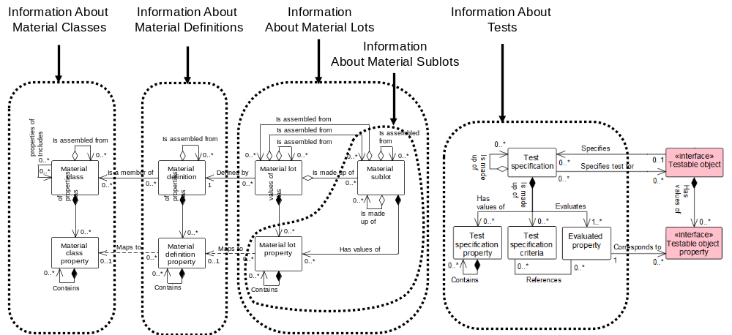
Figure 20 – Object grouping for the material model
Example Messages may be GET Material Class, GET Material Lot, GET Material Test Result

Material class verbs
All verbs shall be valid for a material class noun.
NOTE This contains information about material classes, or material classes and their material class properties. The returned information does not contain the material definitions associated with the material class, but only the IDs of the material definitions belonging to the class.

Material class verb actions
The actions performed on material class objects are defined in Table 15.
Table 15 – Material Class verb actions
Material  Class ID | Material Class Property ID | Material Class Property Value | Verb action on noun
IDs specified | not specified | not specified | GET: Shall define a request that the receiver is to return, in a SHOW message, all attributes about the specified Material Classes, all properties and their attributes, and the IDs of Material Definitions of the Material Class.  PROCESS: Shall define a request that the receiver is to add Material Classes. The ID defines suggested IDs for the Material Classes. The receiver adds the Material Classes and assigns IDs. The assigned IDs shall be returned in the ACKNOWLEDGE message.  CHANGE: The specified attributes of the specified Material Classes shall be changed.  CANCEL: Shall define a request that the receiver is to cancel the specified Material Classes.  SYNC ADD: Shall define a request that the receiver is to add the specified Material Classes.  SYNC CHANGE: The specified attributes of the specified Material Classes shall be changed.  SYNC DELETE: Shall define a request that the receiver is to delete the specified Material Classes.  NOTIFY: Shall define the creation of a new Material Class.
IDs specified | IDs specified | not specified | GET: Shall define a request that the receiver is to return, in a SHOW message, all attributes about the specified Material Classes, all of the specified Material Class Properties, and the IDs of Material Definitions of the Material Class.  PROCESS: Shall define a request that the receiver is to add Material Classes. The message defines suggested IDs for the Material Classes and list of properties. The receiver adds the Material Classes and properties and assigns IDs. The assigned IDs shall be returned in the ACKNOWLEDGE message.  CHANGE: Error (no property values are specified).  CANCEL: Shall define a request that the receiver is to cancel the specified properties for the specified Material Classes.  SYNC ADD: Shall define a request that the receiver is to add the Material Classes and list of Material Class Properties.  SYNC CHANGE: Error (no property values are specified).  SYNC DELETE: Shall define a request that the receiver is to delete the specified list of Material Class Properties for the specified Material Classes.  NOTIFY: Shall define the creation of a new Material Class.
IDs specified | IDs specified | Property Value Specified | GET: Shall define a request that the receiver is to return, in a SHOW message, all attributes about the specified Material Classes where the Material Class Property value matches the specified property value, all of the specified Material Class Properties, and the IDs of Material Definitions of the Material Class.  PROCESS: Shall define a request that the receiver is to add Material Classes. The message defines suggested IDs for the Material Classes and properties, and values for the properties. The receiver adds the Material Classes and properties and assigns IDs. The assigned IDs shall be returned in the ACKNOWLEDGE message.  CHANGE: Shall define a request that the receiver is to change the values of the specified properties for the specified Material Classes to the specified values. A RESPOND message may be used to communicate agreement, disagreement, or changes made to the CHANGE message data.  CANCEL: Shall define a request that the receiver is to cancel the specified properties of the Material Classes that have the specified property value.  SYNC ADD: Shall define a request that the receiver is to add the specified Material Classes, list of properties and property values.  SYNC CHANGE: Shall define a request that the receiver is to change the values of the specified list of properties for the specified Material Classes to the specified values.  SYNC DELETE: Shall define a request that the receiver is to delete the specified list of Material Class Properties of the specified Material Classes that have the specified property value.  NOTIFY: Shall define the creation of a new Material Class.
Wildcard specified | not specified | not specified | GET: Shall define a request that the receiver is to return, in a SHOW message, all attributes and properties about the Material Classes that match the wildcard and the IDs of Material Definitions of the Material Class.  Example 1 To return all Material Classes, specify a “*” as the wildcard.  PROCESS: Error.  CHANGE: Error (no property values are specified).  CANCEL: Shall define a request that the receiver is to cancel all Material Classes matching the wildcard.  SYNC ADD: Error.  SYNC CHANGE: Error (no property values are specified).  NOTIFY: Error.  SYNC DELETE: Shall define a request that the receiver is to delete all Material Classes matching the wildcard.
Wildcard specified | Wildcard specified | not specified | GET: Shall define a request that the receiver is to return, in a SHOW message, all attributes of the Material Classes that match the wildcard, and for each class return all Material Class Properties that match the property wildcards, and the IDs of Material Definitions of the Material Class.  Example 2 To return a single property, specify the MATERIAL CLASS property ID in the property wildcard.  Example 3 To return all Material Class Properties, specify a “*” as the property wildcard.  Example 4 To return a single Material Class, specify the Material Class ID in the wildcard.  Example 5 To return all Material Classes, specify a “*” as the wildcard.  PROCESS: Error.  CHANGE: Error (no property values are specified).  CANCEL: Shall define a request that the receiver is to cancel all properties matching the Material Class Property wildcard of all Material Classes that match the wildcard.  SYNC ADD: Error.  SYNC CHANGE: Error (no property values are specified).  SYNC DELETE: Shall define a request that the receiver is to delete all properties that match the Material Class Property wildcard of all Material Classes that match the wildcard.  NOTIFY: Error.

Material definition verbs
All verbs shall be valid for a material definition noun.
NOTE This contains information about material definitions, or material definitions and their material definitions properties. The returned information does not contain the material lots associated with the material definition, but only the IDs of the material lots.

Material definition verb actions
The actions performed on the material definition objects are defined in Table 16.
Table 16 – Material definition verb actions
Material  Definition ID | Material  Definition Property ID | Material  Definition Property Value | Verb action on noun
IDs specified | not specified | not specified | GET: Shall define a request that the receiver is to return, in a SHOW message, all attributes about the specified Material Definitions, all properties and their attributes, the IDs of Material Lots of the Material Definitions, and the IDS of Material Classes of the Material Definitions.  PROCESS: Shall define a request that the receiver is to add Material Definitions. The message defines suggested IDs for the Material Definitions. The receiver adds the Material Definitions and assigns IDs. The assigned IDs shall be returned in the ACKNOWLEDGE message.  CHANGE: The specified attributes of the specified Material Definitions shall be changed.  CANCEL: Shall define a request that the receiver is to cancel the specified Material Definitions.  SYNC ADD: Shall define a request that the receiver is to add the specified Material Definitions.  SYNC CHANGE: The specified attributes of the specified Material Definitions shall be changed.  SYNC DELETE: Shall define a request that the receiver is to delete the specified Material Definitions.  NOTIFY: Shall define the creation of a new Material Definition.
IDs specified | IDs specified | not specified | GET: Shall define a request that the receiver is to return, in a SHOW message, all attributes about the specified Material Definitions, all of the specified Material Definition Properties, the IDs of Material Lots of the Material Definitions, and the IDs of Material Classes of the Material Definitions.  PROCESS: Shall define a request that the receiver is to add Material Definitions. The message defines suggested IDs for the Material Definitions and properties. The receiver adds Material Definitions and properties and assigns IDs. The assigned IDs shall be returned in the ACKNOWLEDGE message.  CHANGE: Error (no property values are specified).  CANCEL: Shall define a request that the receiver is to cancel the specified properties for the specified Material Definitions.  SYNC ADD: Shall define a request that the receiver is to add the Material Definitions and list Material Definition Properties.  SYNC CHANGE: Error (no property values are specified).  SYNC DELETE: Shall define a request that the receiver is to delete the specified list of Material Definition Properties.  NOTIFY: Shall define the creation of a new Material Definition.
IDs specified | IDs specified | Property Value Specified | GET: Shall define a request that the receiver is to return, in a SHOW message, all attributes about the specified Material Definitions where the Material Definition Property value matches the specified property value, all of the specified Material Definition Properties, and the IDs of Material Lots of the Material Definitions and IDs of Material Classes.  PROCESS: Shall define a request that the receiver is to add Material Definitions. The message defines suggested IDs for the Material Definitions and properties, and values for the properties. The receiver adds the Material Definitions and properties and assigns IDs. The assigned IDs shall be returned in the ACKNOWLEDGE message.  CHANGE: Shall define a request that the receiver is to change the values of the specified properties for the specified Material Definitions to the specified values. A RESPOND message may be used to communicate agreement, disagreement, or changes made to the CHANGE message data.  CANCEL: Shall define a request that the receiver is to cancel the specified properties of the Material Definitions that have the specified property value.  SYNC ADD: Shall define a request that the receiver is to add the specified Material Definitions, list of properties and property values.  SYNC CHANGE: Shall define a request that the receiver is to change the values of the specified list of properties for the specified Material Definitions to the specified values.  SYNC DELETE: Shall define a request that the receiver is to delete the specified list of Material Definition Properties of the specified Material Definitions that have the specified property value.  NOTIFY: Shall define the creation of a new Material Definition.
Wildcard specified | not specified | not specified | GET: Shall define a request that the receiver is to return, in a SHOW message, all attributes and properties about the Material Definitions that match the wildcard, the IDs of Material Lots of the Material Definitions, and the IDs of Material Classes of each Material Definition.  Example 1 To return all Material Definitions, specify a “*” as the wildcard.  PROCESS: Error.  CHANGE: Error (no property values are specified).  CANCEL: Shall define a request that the receiver is to cancel all Material Definitions matching the wildcard.  SYNC ADD: Error.  SYNC CHANGE: Error (no property values are specified).  SYNC DELETE: Shall define a request that the receiver is to delete all Material Definitions matching the wildcard.  NOTIFY: Error.
Wildcard specified | Wildcard specified | not specified | GET: Shall define a request that the receiver is to return, in a SHOW message, all attributes of the Material Definitions IONS that match the wildcard, and for each class return the IDs of Material Lots of the Material Definitions and all Material Definition Properties that match the property wildcards, and the IDs of Material Classes of to the Material Definitions.  Example 2 To return a single property, specify the Material Definition Property ID in the property wildcard.  Example 3 To return all Material Definition Properties, specify a “*” as the property wildcard.  Example 4 To return a Material Definition, specify the Material Definition ID in the wildcard.  Example 5 To return all Material Definitions, specify a “*” as the wildcard.  PROCESS: Error.  CHANGE: Error (no property values are specified).  CANCEL: Shall define a request that the receiver is to cancel all Material Definition Properties matching the property wildcard of all Material Definitions that match the wildcard.  SYNC ADD: Error.  SYNC CHANGE: Error (no property values are specified).  SYNC DELETE: Shall define a request that the receiver is to delete all Material Definition properties that match the property wildcard of all Material Definitions that match the wildcard.  NOTIFY: Error.

Material lot verbs
All verbs shall be valid for a material lot noun.

Material lot verb actions
The actions performed on a material lot noun are defined in Table 17.
Table 17 – Material lot verb actions
Material Lot  ID | Material Lot Property ID | Material Lot Property Value | Verb action on noun
IDs specified | not specified | not specified | GET: Shall define a request that the receiver is to return, in a SHOW message, all attributes about the specified Material Lots, all properties and their attributes, the IDs of Material Sublots of the Material Lots, the ID of the Material Definition of the Material Lots, and the list of Material Test Results associated with the properties.  PROCESS: Shall define a request that the receiver is to add Material Lots. The message defines suggested IDs for the Material Lots. The receiver adds the Material Lots and assigns IDs. The assigned IDs shall be returned in the ACKNOWLEDGE message.  CHANGE: The specified attributes of the specified Material Lots shall be changed.  CANCEL: Shall define a request that the receiver is to cancel the specified Material Lots.  SYNC ADD: Shall define a request that the receiver is to add the specified Material Lots.  SYNC CHANGE: The specified attributes of the specified Material Lots shall be changed.  SYNC DELETE: Shall define a request that the receiver is to delete the specified Material Lots.  NOTIFY: Shall define the creation of a new Material Lots.
IDs specified | IDs specified | not specified | GET: Shall define a request that the receiver is to return, in a SHOW message, all attributes about the specified Material Lots, all of the specified Material Lot Properties, the IDs of Material Sublots of the Material Lots, the ID of the Material Definition of the Material Lot, and the list of Material Test Results associated with the properties.  PROCESS: Shall define a request that the receiver is to add Material Lots. The message defines suggested IDs for the Material Lots and list of properties. The receiver adds the Material Lots and properties and assigns IDs. The assigned IDs shall be returned in the ACKNOWLEDGE message.  CHANGE: Error (no property values are specified).  CANCEL: Shall define a request that the receiver is to cancel the specified properties for the specified Material Lots.  SYNC ADD: Shall define a request that the receiver is to add the Material Lots and list of Material Lot Properties.  SYNC CHANGE: Error (no property values are specified).  SYNC DELETE: Shall define a request that the receiver is to delete the specified list of Material Lot Properties.  NOTIFY: Shall define the creation of a new Material Lots.
IDs specified | IDs specified | Property Value Specified | GET: Shall define a request that the receiver is to return, in a SHOW message, all attributes about the specified Material Lots where the Material Lot Property value matches the specified property value, all of the specified Material Lot Properties, the IDs of Material Sublots of the Material Lots, the ID of the Material Definition, and the list of Material Test Results associated with the properties.  PROCESS: Shall define a request that the receiver is to add Material Lots. The message defines suggested IDs for the Material Lots and properties, and values for the properties. The receiver adds the Material Lots and properties and assigns IDs. The assigned IDs shall be returned in the ACKNOWLEDGE message.  CHANGE: Shall define a request that the receiver is to change the values of the specified properties for the specified Material Lots to the specified values. A RESPOND message may be used to communicate agreement, disagreement, or changes made to the CHANGE message data.  CANCEL: Shall define a request that the receiver is to cancel the specified properties of the Material Lots that have the specified property value.  SYNC ADD: Shall define a request that the receiver is to add the specified Material Lots, list of properties and property values.  SYNC CHANGE: Shall define a request that the receiver is to change the values of the specified list of properties for the specified Material Lots to the specified values.  SYNC DELETE: Shall define a request that the receiver is to delete the specified list of Material Lot Properties of the specified Material Lots that have the specified property value.  NOTIFY: Shall define the creation of a new Material Lots.
Wildcard specified | not specified | not specified | GET: Shall define a request that the receiver is to return, in a SHOW message, all attributes and properties about the Material Lots that match the wildcard the IDs of Material Sublots of the Material Lots, the ID of the Material Definition of each Material Lot, and the list of Material Test Results associated with the properties.  Example 1 To return all Material Lots, specify a “*” as the wildcard.  PROCESS: Error.  CHANGE: Error (no property values are specified).  CANCEL: Shall define a request that the receiver is to cancel all Material Lots matching the wildcard.  SYNC ADD: Error.  SYNC CHANGE: Error (no property values are specified).  SYNC DELETE: Shall define a request that the receiver is to delete all Material Lots matching the wildcard.  NOTIFY: Error.
Wildcard specified | Wildcard specified | not specified | GET: Shall define a request that the receiver is to return, in a SHOW message, all attributes of the Material Lots that match the wildcard, and for each Material Lot return all Material Lot Properties that match the property wildcards, the IDs of Material Sublots of the Material Lots, the ID of the Material Definition of to the Material Lot, and the list of Material Test Results associated with the properties.  Example 2 To return a single property, specify the Material Lot Property ID in the property wildcard.  Example 3 To return all Material Lot Properties, specify a “*” as the property wildcard.  Example 4 To return a single Material Lot, specify the Material Lot ID in the wildcard.  Example 5 To return all Material Lots, specify a “*” as the wildcard.  PROCESS: Error.  CHANGE: Error (no property values are specified).  CANCEL: Shall define a request that the receiver is to cancel all Material Lot Properties matching the wildcard of all MATERIAL LOTS that match the MATERIAL LOT wildcard.  SYNC ADD: Error.  SYNC CHANGE: Error (no property values are specified).  SYNC DELETE: Shall define a request that the receiver is to delete all properties that match the MATERIAL LOT property wildcard of all MATERIAL LOTS that match the MATERIAL LOT wildcard.  NOTIFY: Error.

Material sublot verbs
All verbs shall be valid for a material sublot noun.

Material sublot verb actions
The actions performed on a material sublot are defined in Table 18.
Table 18 – Material sublot verb actions
Material Sublot  ID | Material Sublot Property ID | Material Sublot Property Value | Verb action on noun
IDs specified | not specified | not specified | GET: Shall define a request that the receiver is to return, in a SHOW message, all attributes about the specified Material Sublots, all properties and their attributes, the IDs of Material Sublots of the Material Sublot, the ID of the Material Definition of the Material Sublot, and the list of Material Test Results associated with the properties.  PROCESS: Shall define a request that the receiver is to add Material Sublots. The message defines suggested IDs for the Material Sublots. The receiver adds the Material Sublots and assigns IDs. The assigned IDs shall be returned in the ACKNOWLEDGE message.  CHANGE: The specified attributes of the specified Material Sublots shall be changed.  CANCEL: Shall define a request that the receiver is to cancel the specified Material Sublots.  SYNC ADD: Shall define a request that the receiver is to add the specified Material Sublots.  SYNC CHANGE: The specified attributes of the specified Material Sublots shall be changed.  SYNC DELETE: Shall define a request that the receiver is to delete the specified Material Sublots.  NOTIFY: Shall define the creation of a new Material Sublot.
IDs specified | IDs specified | not specified | GET: Shall define a request that the receiver is to return, in a SHOW message, all attributes about the specified Material Sublots, all of the specified Material Sublot Properties, the IDs of Material Sublots of the Material Sublot, the ID of the Material Definition of the Material Sublot, and the list of Material Test Results associated with the properties.  PROCESS: Shall define a request that the receiver is to add Material Sublots. The message defines suggested IDs for the Material Sublots and properties. The receiver adds the Material Sublots and properties and assigns IDs. The assigned IDs shall be returned in the ACKNOWLEDGE message.  CHANGE: Error (no property values are specified).  CANCEL: Shall define a request that the receiver is to cancel the specified properties for the specified Material Sublots.  SYNC ADD: Shall define a request that the receiver is to add the Material Sublots and list of Material Sublot Properties.  SYNC CHANGE: Error (no property values are specified).  SYNC DELETE: Shall define a request that the receiver is to delete the specified list of Material Sublot Properties.  NOTIFY: Shall define the creation of a new Material Sublot.
IDs specified | IDs specified | Property Value Specified | GET: Shall define a request that the receiver is to return, in a SHOW message, all attributes about the specified Material Sublots where the Material Sublot Property value matches the specified property value, all of the specified Material Sublot Properties, the IDs of Material Sublots of the Material Sublot, the ID of the Material Definition, and the list of Material Test Results associated with the properties.  PROCESS: Shall define a request that the receiver is to add Material Sublots. The message defines suggested IDs for the Material Sublots and properties, and values for the properties. The receiver adds the Material Sublots and properties and assigns IDs. The assigned IDs shall be returned in the ACKNOWLEDGE message.  CHANGE: Shall define a request that the receiver is to change the values of the specified properties for the specified Material Sublots to the specified values. A RESPOND message may be used to communicate agreement, disagreement, or changes made to the CHANGE message data.  CANCEL: Shall define a request that the receiver is to cancel the specified properties of the Material Sublots that have the specified property value.  SYNC ADD: Shall define a request that the receiver is to add the specified Material Sublots, list of properties and property values.  SYNC CHANGE: Shall define a request that the receiver is to change the values of the specified list of properties for the specified Material Sublots to the specified values.  SYNC DELETE: Shall define a request that the receiver is to delete the specified list of Material Sublot Properties of the specified Material Sublots that have the specified property value.  NOTIFY: Shall define the creation of a new Material Sublot.
Wildcard specified | not specified | not specified | GET: Shall define a request that the receiver is to return, in a SHOW message, all attributes and properties about the Material Sublots that match the wildcard, the IDs of Material Sublots of the Material Sublot, the ID of the Material Definition of each Material Sublot, and the list of Material Test Results associated with the properties.  Example 1 To return all Material Sublots, specify a “*” as the wildcard.  PROCESS: Error.  CHANGE: Error (no property values are specified).  CANCEL: Shall define a request that the receiver is to cancel all Material Sublots matching the wildcard.  SYNC ADD: Error.  SYNC CHANGE: Error (no property values are specified).  SYNC DELETE: Shall define a request that the receiver is to delete all Material Sublots matching the wildcard.  NOTIFY: Error.
Wildcard specified | Wildcard specified | not specified | GET: Shall define a request that the receiver is to return, in a SHOW message, all attributes of the Material Sublots that match the wildcard, and for each sublot return all Material Sublot Properties that match the property wildcards, the ID of the Material Definition of to the Material Sublot, and the list of Material Test Results associated with the properties.  Example 2 To return a single property, specify the Material Sublot Property ID in the property wildcard.  Example 3 To return all Material Sublot Properties, specify a “*” as the property wildcard.  Example 4 To return a single Material Sublot, specify the Material Sublot ID in the wildcard.  Example 5 To return all Material Sublots, specify a “*” as the wildcard.  PROCESS: Error.  CHANGE: Error (no property values are specified).  CANCEL: Shall define a request that the receiver is to cancel all Material Sublot Properties matching the property wildcard of all Material Sublots that match the wildcard.  SYNC ADD: Error.  SYNC CHANGE: Error (no property values are specified).  SYNC DELETE: Shall define a request that the receiver is to delete all Material Sublot Properties that match the property wildcard of all Material Sublots that match the wildcard.  NOTIFY: Error.

Operational location model

Operational location model elements
The message definitions assume that operational location information may be accessed from either of two starting points: operational location class or operational location, as identified by the dotted collections in Figure 21.
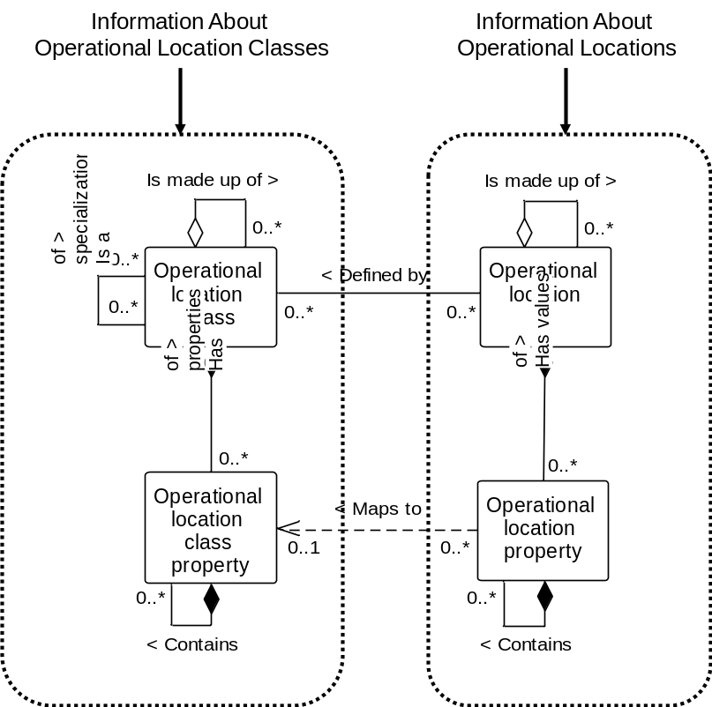
Figure 21 - Object grouping for the operational location model
Example Messages include Get Operational Location Class, Show Operational Location Class and Process Operational Location

Operational location class verbs
All verbs shall be valid for an operational location class noun.
Note This contains information about operational location classes, or operational location classes and their operational location class properties. The returned information does not contain any details of, or reference to, the operational locations belonging to the operational location class.

Operational location class verb actions
The actions performed on operational location class objects are defined in Table 22.
Table 22 – Operational location class verb actions
Operational Location Class ID | Operational Location Class Property ID | Operational Location Class Property Value | Verb action on noun
IDs specified | not specified | not specified | GET: Shall define a request that the receiver is to return, in a SHOW message, all attributes about the specified Operational Location Classes and all properties and their attributes.  PROCESS: Shall define a request that the receiver is to add Operational Location Classes. The ID defines suggested IDs for the Operational Location Classes. The receiver adds the Operational Location Classes and assigns IDs. The assigned IDs shall be returned in the ACKNOWLEDGE message.  CHANGE: The specified attributes of the specified Operational Location Classes shall be changed.  CANCEL: Shall define a request that the receiver is to cancel the specified Operational Location Classes.  SYNC ADD: Shall define a request that the receiver is to add the specified Operational Location Classes.  SYNC CHANGE: The specified attributes of the specified Operational Location Classes shall be changed.  SYNC DELETE: Shall define a request that the receiver is to delete the specified Operational Location Classes.  NOTIFY: Shall define the creation of a new Operational Location Class.
IDs specified | IDs specified | not specified | GET: Shall define a request that the receiver is to return, in a SHOW message, all attributes about the specified Operational Location Classes and all the specified Operational Location Class Properties.  PROCESS: Shall define a request that the receiver is to add Operational Location Classes. The message defines suggested IDs for the Operational Location Classes and list of properties. The receiver adds the Operational Location Classes and properties and assigns IDs. The assigned IDs shall be returned in the ACKNOWLEDGE message.  CHANGE: Error (no property values are specified).  CANCEL: Shall define a request that the receiver is to cancel the specified properties for the specified Operational Location Classes.  SYNC ADD: Shall define a request that the receiver is to add the Operational Location Classes and list of Operational Location Class Properties.  SYNC CHANGE: Error (no property values are specified).  SYNC DELETE: Shall define a request that the receiver is to delete the specified list of Operational Location Class Properties for the specified Operational Location Classes.  NOTIFY: Shall define the creation of a new Operational Location Class.
IDs specified | IDs specified | Property Value Specified | GET: Shall define a request that the receiver is to return, in a SHOW message, all attributes about the specified Operational Location Classes where the Operational Location Class Property value matches the specified property value and all the specified Operational Location Class Properties.  PROCESS: Shall define a request that the receiver is to add Operational Location Classes. The message defines suggested IDs for the Operational Location Classes and properties, and values for the properties. The receiver adds the Operational Location Classes and properties and assigns IDs. The assigned IDs shall be returned in the ACKNOWLEDGE message.  CHANGE: Shall define a request that the receiver is to change the values of the specified properties for the specified Operational Location Classes to the specified values. A RESPOND message may be used to communicate agreement, disagreement, or changes made to the CHANGE message data.  CANCEL: Shall define a request that the receiver is to cancel the specified properties of the Operational Location Classes that have the specified property value.  SYNC ADD: Shall define a request that the receiver is to add the specified Operational Location Classes, list of properties and property values.  SYNC CHANGE: Shall define a request that the receiver is to change the values of the specified list of properties for the specified Operational Location Classes to the specified values.  SYNC DELETE: Shall define a request that the receiver is to delete the specified list of Operational Location Class Properties of the specified Operational Location Classes that have the specified property value.  NOTIFY: Shall define the creation of a new Operational Location Class.
Wildcard specified | not specified | not specified | GET: Shall define a request that the receiver is to return, in a SHOW message, all attributes and properties about the Operational Location Classes that match the wildcard.  Example 1 To return all Operational Location Classes, specify a “*” as the wildcard.  PROCESS: Error.  CHANGE: Error (no property values are specified).  CANCEL: Shall define a request that the receiver is to cancel all Operational Location Classes matching the wildcard.  SYNC ADD: Error.  SYNC CHANGE: Error (no property values are specified).  SYNC DELETE: Shall define a request that the receiver is to delete all Operational Location Classes matching the wildcard.  NOTIFY: Error.
Wildcard specified | Wildcard specified | not specified | GET: Shall define a request that the receiver is to return, in a SHOW message, all attributes of the Operational Location Classes that match the wildcard, and for each class return all Operational Location Class Properties that match the property wildcards.  Example 2 To return a single property, specify the OPERATIONAL LOCATION CLASS property ID in the property wildcard.  Example 3 To return all Operational Location Class Properties, specify a “*” as the property wildcard.  Example 4 To return a single Operational Location Class, specify the Operational Location Class ID in the wildcard.  Example 5 To return all Operational Location Classes, specify a “*” as the wildcard.  PROCESS: Error.  CHANGE: Error (no property values are specified).  CANCEL: Shall define a request that the receiver is to cancel all properties matching the Operational Location Class Property wildcard of all Operational Location Classes that match the wildcard.  SYNC ADD: Error.  SYNC CHANGE: Error (no property values are specified).  SYNC DELETE: Shall define a request that the receiver is to delete all properties that match the Operational Location Class Property wildcard of all Operational Location Classes that match the wildcard.  NOTIFY: Error.

Operational location verbs
All verbs shall be valid for an operational location noun.
Note This contains information about operational locations, or operational locations and their operational location properties. The returned information does not contain the operational location classes associated with the operational locations, but only the ID’s of the operational location classes to which the operational locations belong.

Operational location verb actions
The actions performed on operational location objects are defined in Table 23.
Table 23 – Operational location verb actions
Operational Location ID | Operational Location Property ID | Operational Location Property Value | Verb action on noun
IDs specified | not specified | not specified | GET: Shall define a request that the receiver is to return, in a SHOW message, all attributes about the specified Operational Locations, all properties and their attributes, and the ID’s of the Operational Location Classes of the Operational Locations.  PROCESS: Shall define a request that the receiver is to add Operational Locations. The ID defines suggested IDs for the Operational Locations. The receiver adds the Operational Locations and assigns IDs. The assigned IDs shall be returned in the ACKNOWLEDGE message.  CHANGE: The specified attributes of the specified Operational Locations shall be changed.  CANCEL: Shall define a request that the receiver is to cancel the specified Operational Locations.  SYNC ADD: Shall define a request that the receiver is to add the specified Operational Locations.  SYNC CHANGE: The specified attributes of the specified Operational Locations shall be changed.  SYNC DELETE: Shall define a request that the receiver is to delete the specified Operational Locations.  NOTIFY: Shall define the creation of a new Operational Location.
IDs specified | IDs specified | not specified | GET: Shall define a request that the receiver is to return, in a SHOW message, all attributes about the specified Operational Locations, all properties and their attributes, and the ID’s of the Operational Location Classes of the Operational Locations.  PROCESS: Shall define a request that the receiver is to add Operational Locations. The message defines suggested IDs for the Operational Location and list of properties. The receiver adds the Operational Locations and properties and assigns IDs. The assigned IDs shall be returned in the ACKNOWLEDGE message.  CHANGE: Error (no property values are specified).  CANCEL: Shall define a request that the receiver is to cancel the specified properties for the specified Operational Locations.  SYNC ADD: Shall define a request that the receiver is to add the Operational Locations and list of Operational Location Properties.  SYNC CHANGE: Error (no property values are specified).  SYNC DELETE: Shall define a request that the receiver is to delete the specified list of Operational Location Properties for the specified Operational Locations.  NOTIFY: Shall define the creation of a new Operational Location.
IDs specified | IDs specified | Property Value Specified | GET: Shall define a request that the receiver is to return, in a SHOW message, all attributes about the specified Operational Locations where the Operational Location Property value matches the specified property value, all the specified Operational Location Properties and the ID’s of the Operational Location Classes of the Operational Locations.  PROCESS: Shall define a request that the receiver is to add Operational Locations. The message defines suggested IDs for the Operational Locations and properties, and values for the properties. The receiver adds the Operational Locations and properties and assigns IDs. The assigned IDs shall be returned in the ACKNOWLEDGE message.  CHANGE: Shall define a request that the receiver is to change the values of the specified properties for the specified Operational Locations to the specified values. A RESPOND message may be used to communicate agreement, disagreement, or changes made to the CHANGE message data.  CANCEL: Shall define a request that the receiver is to cancel the specified properties of the Operational Locations that have the specified property value.  SYNC ADD: Shall define a request that the receiver is to add the specified Operational Locations, list of properties and property values.  SYNC CHANGE: Shall define a request that the receiver is to change the values of the specified list of properties for the specified Operational Location to the specified values.  SYNC DELETE: Shall define a request that the receiver is to delete the specified list of Operational Location Properties of the specified Operational Locations that have the specified property value.  NOTIFY: Shall define the creation of a new Operational Location.
Wildcard specified | not specified | not specified | GET: Shall define a request that the receiver is to return, in a SHOW message, all attributes and properties about the Operational Locations that match the wildcard and the ID’s of the Operational Location Classes of the Operational Locations.  Example 1 To return all Operational Locations, specify a “*” as the wildcard.  PROCESS: Error.  CHANGE: Error (no property values are specified).  CANCEL: Shall define a request that the receiver is to cancel all Operational Location matching the wildcard.  SYNC ADD: Error.  SYNC CHANGE: Error (no property values are specified).  SYNC DELETE: Shall define a request that the receiver is to delete all Operational Locations matching the wildcard.  NOTIFY: Error.
Wildcard specified | Wildcard specified | not specified | GET: Shall define a request that the receiver is to return, in a SHOW message, all attributes of the Operational Locations that match the wildcard, and for each Operational Location return all Operational Location Properties that match the property wildcard and the ID’s of the Operational Location Classes of the Operational Locations.  Example 2 To return a single property, specify the Operational Location Property ID in the property wildcard.  Example 3 To return all Operational Location Properties, specify a “*” as the property wildcard.  Example 4 To return a single Operational Location, specify the Operational Location ID in the wildcard.  Example 5 To return all Operational Locations, specify a “*” as the wildcard.  PROCESS: Error.  CHANGE: Error (no property values are specified).  CANCEL: Shall define a request that the receiver is to cancel all properties matching the Operational Location Property wildcard of all Operational Locations that match the wildcard.  SYNC ADD: Error.  SYNC CHANGE: Error (no property values are specified).  SYNC DELETE: Shall define a request that the receiver is to delete all properties that match the Operational Location Property wildcard of all Operational Locations that match the wildcard.  NOTIFY: Error.

Process segment model

Process segment model elements
The message definitions assume that process segment information may be accessed from one starting point; a process segment, as identified by the dotted collection in Figure 22.
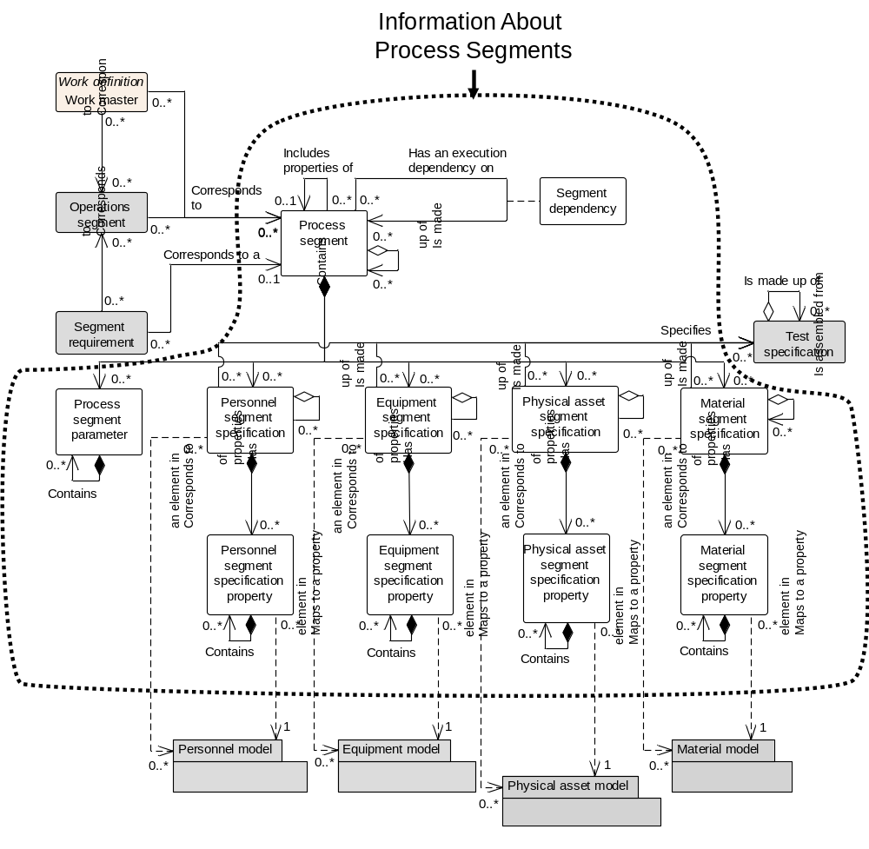
Figure 22 – Object grouping for the process segment model

Process segment verbs
All verbs shall be valid for a process segment noun. The object grouping for process segment is illustrated in Figure 24.
NOTE 1 A process segment is a logical grouping of personnel resources, equipment resources, and material required to carry out an operations step. A process segment usually defines the needed classes of personnel, equipment, and material, but it may define specific resources, such as specific equipment needed. A process segment may define the quantity of the resource needed.
NOTE 2 The process segment model is hierarchical with process segments containing process segments and personnel specification, equipment specification, and material specification information.

Process segment verb actions
The actions performed on a process segment noun are defined in Table 24.
Table 24 – Process segment verb actions
Process Segment ID | Verb action on noun
IDs specified | GET: Shall define a request that the receiver is to return, in a SHOW message, all attributes, parameters, specifications and properties about the Process Segments.  PROCESS: Shall define a request that the receiver is to add Process Segments. The message defines suggested IDs for the Process Segments, values for the attributes, parameters, specifications and properties. The receiver adds the Process Segments and assigns IDs. The assigned IDs shall be returned in the ACKNOWLEDGE message.  CHANGE: Shall define a request that the receiver is to change the specified attributes, parameters, specifications, and properties of the Process Segments. A RESPOND message may be used to communicate agreement, disagreement, or changes made to the CHANGE message data.  CANCEL: Shall define a request that the receiver is to cancel the specified Process Segments. If contained elements IDs are specified, then only the specified contained elements for the specified Process Segments are to be cancelled, not the Process Segments.  SYNC ADD: Shall define a request that the receiver is to add the specified Process Segments, attributes, parameters, specifications and properties.  SYNC CHANGE: Shall define a request that the receiver is to change the specified attributes, parameters, specifications, and/or properties of the Process Segments.  SYNC DELETE: Shall define a request that the receiver is to delete the specified Process Segments.  NOTIFY: Shall define the creation of a new Process Segment.
<not specified> | GET: Error.  PROCESS: Error.  CHANGE: Error.  CANCEL: Error.  SYNC ADD: Error.  SYNC CHANGE: Error.  SYNC DELETE: Error.  NOTIFY: Error.
Wildcard specified | GET: Shall define a request that the receiver is to return, in a SHOW message, all attributes, parameters, specifications, and properties about all Process Segments identified by the wildcard.  Example To return all Process Segments, specify a “*” as the wildcard.  PROCESS: Error.  CHANGE: Shall define a request that the receiver is to change all specified attributes, parameters, specifications, and properties of all Process Segments matching the wildcard. A RESPOND message may be used to communicate agreement, disagreement, or changes made to the CHANGE message data.  CANCEL: Shall define a request that the receiver is to cancel all Process Segments matching the wildcard.  SYNC ADD: Error.  SYNC CHANGE: Shall define a request that the receiver is to change all specified attributes, parameters, specifications, and properties of all Process Segments matching the wildcard.  SYNC DELETE: Shall define a request that the receiver is to delete all Process Segments matching the wildcard.  NOTIFY: Error.

Operations event model

Operations event model elements
The message definitions assume that operations event information may be accessed from three starting points; an operations event class, operations event definition and operations event as identified by the dotted collection in Figure 23.
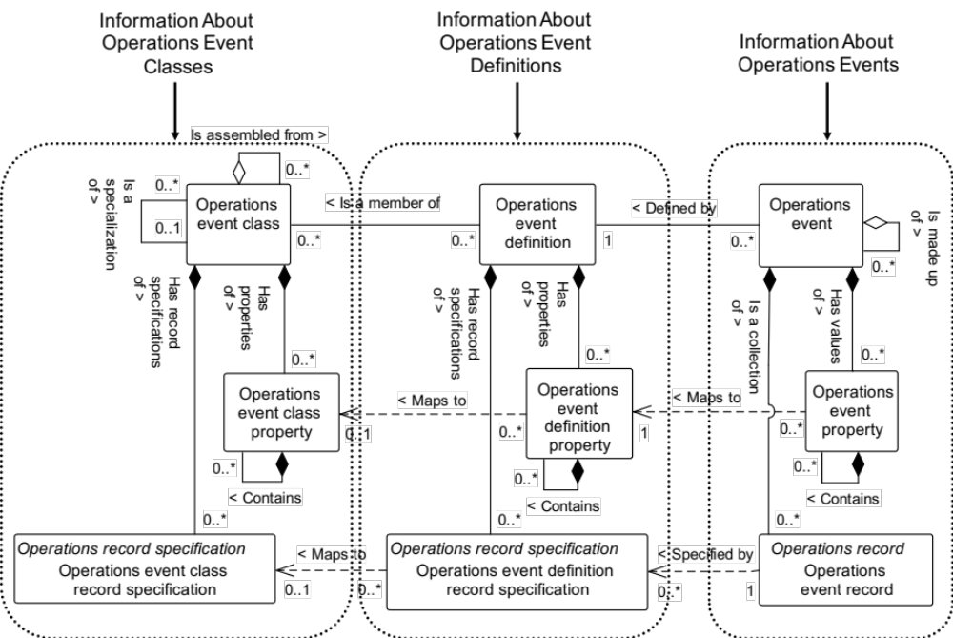
Figure 23 - Object grouping for the operations event model

Operations event class verbs
The base noun criteria in a request provides the ID of the entry and any additional information that refines the scope of the request to a subset of all possible values.
The criteria may also specify additional information that indicates the required information in the associated response is a subset of the possible information to be reported.
In each case the additional information may be an exact match of the attribute, property or record or may be a range of acceptable values to report.
Note: The GET verb typically contains information about operations event classes, or operations event classes and their operations event class properties and operations event class record specifications. The returned information does not contain the operations event definitions associated with the operations event class, but only the IDs of the operations event definitions belonging to the class if known and requested.

Operations event class verb actions
The actions performed on an operations event class objects are defined in Table 25.
Table 25 – Operations event class verb actions
Noun criteria | Verb action on noun
ID’s specified | GET: Shall define a request that the receiver is to return, in a SHOW message, all attributes, properties and record specifications about the specified Operations Event Classes. The ID’s of Operations Event Definitions supporting the Operations Event Class shall also be returned.  PROCESS: Shall define a request that the receiver is to add Operations Event Classes. The ID defines suggested ID’s for the Operations Event Classes. The receiver adds the Operations Event Classes and assigns ID’s. The assigned ID’s shall be returned in the ACKNOWLEDGE message.  CHANGE: The specified attributes of the specified Operations Event Classes shall be changed.  CANCEL: Shall define a request that the receiver is to cancel the specified Operations Event Classes.  SYNC ADD: Shall define a request that the receiver is to add the specified Operations Event Classes with all properties and record specifications.  SYNC CHANGE: The specified attributes of the specified Operations Event Classes shall be changed.  SYNC DELETE: Shall define a request that the receiver is to delete the specified Operations Event Classes.  NOTIFY: Shall define the creation of a new Operations Event Class.

Operations event definition verbs
The base noun criteria in a request provides the ID of the entry and any additional information that refines the scope of the request to a subset of all possible values.
The criteria may also specify additional information that indicates the required information in the associated response is a subset of the possible information to be reported.
In each case the additional information may be an exact match of the attribute, property or record or may be a range of acceptable values to report.
NOTE The GET verb typically contains information about operations event definitions, or operations event definitions and their operations event definition properties and operations event class record specifications. The returned information does not contain the operations event associated with the operations event definition, but only the IDs of the operations events if known and requested.

Operations event definition verb actions
The actions performed on an operations event definition objects are defined in Table 26.
Table 26 – Operations event definition verb actions
Noun criteria | Verb action on noun
ID’s specified | GET: Shall define a request that the receiver is to return, in a SHOW message, all attributes, properties and record specifications about the specified Operations Event Definitions. The ID’s of Operations Events known to be created from the Operations Event Definitions, and the ID’s of the Operations Event Classes the Operations Event Definitions support shall be returned if specified.  PROCESS: Shall define a request that the receiver is to add Operations Event Definitions. The ID defines suggested ID’s for the Operations Event Definitions. The receiver adds the Operations Event Definitions and assigns ID’s. The assigned ID’s shall be returned in the ACKNOWLEDGE message.  CHANGE: The specified attributes of the specified Operations Event Definitions shall be changed.  CANCEL: Shall define a request that the receiver is to cancel the specified Operations Event Definitions.  NOTIFY: Error.  SYNC ADD: Shall define a request that the receiver is to add the specified Operations Event Definitions with all properties and record specifications.  SYNC CHANGE: The specified attributes of the specified Operations Event Definitions shall be changed.  SYNC DELETE: Shall define a request that the receiver is to delete the specified Operations Event Definitions.  NOTIFY: Shall define the creation of a new Operations Event Definition.

Operations event verbs
Operations events are immutable, once created they are published with a NOTIFY verb. After publication, the event shall not be changed. An event can be archived and used in analysis functions but shall never change from the original published information.
NOTE In some implementations, a security has code may be applied to ensure the event information has not changed.
The NOTIFY verb is applied to an Operations Event noun to provide notification of a real world event.

Operations event verb actions
The actions performed on an operations event object are defined in Table 27.
Table 27 – Operations event verb actions
Noun criteria | Verb action on noun
Entire object specified | GET: Error.  PROCESS: Error.  CHANGE: Error.  CANCEL: Error.  SYNC ADD: Error.  SYNC CHANGE: Error.  SYNC DELETE: Error.  NOTIFY: Indicates a newly created Operations Event that contains all of the attributes, properties and records pertaining to the Operations Event. Once published the ID of the event, the attributes, properties and records associated with the Operations Event are to be considered unique. A unique Operations Event noun shall only be published once with the NOTIFY verb.

Operations capability model

Operations capability model elements
The message definitions assume that operations capability information may be accessed from one starting point; an operations capability, as identified by the dotted collection in Figure 24.
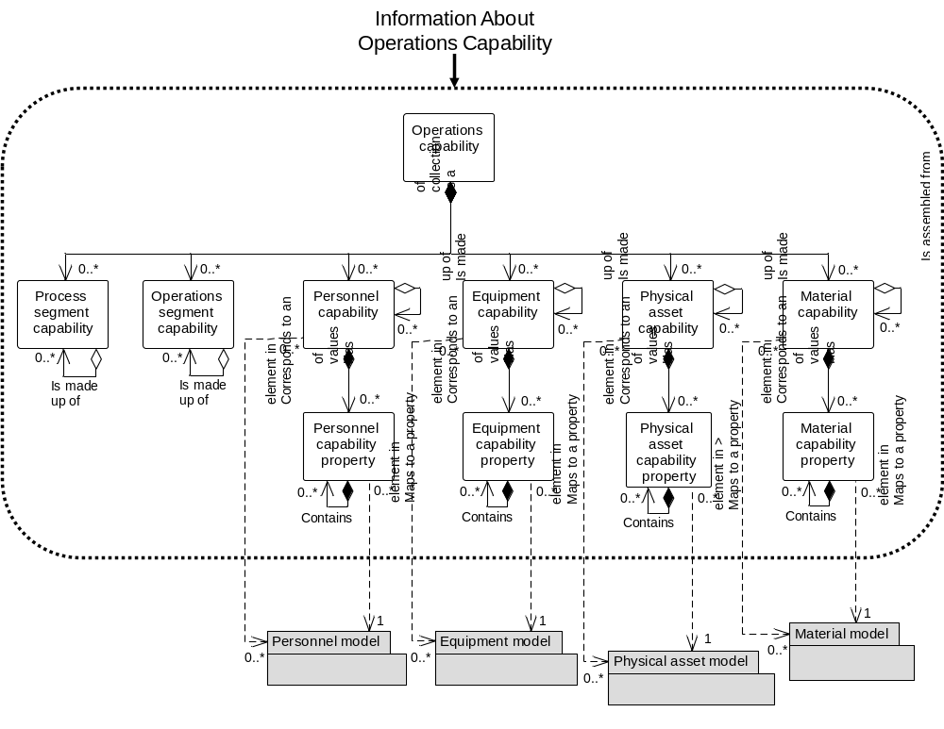
Figure 24 – Object grouping for the Operations capability model

Operations capability verbs
All verbs shall be valid for an operations capability noun.
NOTE 1 The operations capability information is the collection of information about all operations resources for selected timeframes. This is made up of information about equipment, physical assets, material, personnel, and process segments. It describes the names, terms, statuses, and quantities of which the manufacturing control system has knowledge. The presumption is that a Level 3 function is the owner of the operations capability information.
NOTE 2 The operations capability model is hierarchical with operations capabilities containing process segment capabilities and personnel, equipment, and material capability information.
NOTE 3 Operations capability is a snapshot in time of the available, unattainable, or committed capability.
Specifying the information to be returned from a Get may involve values in multiple fields. Each field definition restricts the returned information.

Operations capability verb actions
The actions performed on an operations capability noun are defined in Table 28.
Table 28 – Operations capability verb actions
Operations Capability ID | Verb action on noun
IDs specified | GET: Shall define a request that the receiver is to return, in a SHOW message, all attributes and contained elements of the Operations Capabilities that matches the IDs.  PROCESS: Shall define a request that the receiver is to add new Operations Capabilities. Any assigned IDs are returned in the ACKNOWLEDGE message.  CHANGE: Shall define a request that the receiver is to change specified attributes and contained elements of the Operations Capabilities. A RESPOND message may be used to communicate agreement, disagreement, or changes made to the CHANGE message data.  Example 1 A CHANGE may define an updated Operations Capability due to line slowdown or personnel unavailability.  CANCEL: Shall define a request that the receiver is to cancel the specified attributes and contained elements of the Operations Capabilities. If contained elements IDs are specified, then only the specified contained elements for the specified Operations Capability are to be cancelled, not the Operations Capability.  Example 2 A CANCEL may define a removed process capability due to line shutdown or personnel reassignment.  SYNC ADD: Shall define a request that the receiver is to define the specified attributes and contained elements of Operations Capabilities.  Example 3 A SYNC ADD sent every day may define Operations Capability for the next day.  SYNC CHANGE: Shall define a request that the receiver is to change the specified attributes and contained elements of Operations Capabilities.  Example 4 A SYNC CHANGE may define a new Operations Capability due to line slowdown or personnel unavailability.  SYNC DELETE: Shall define a request that the receiver is to delete the specified attributes and contained elements of Operations Capabilities.  Example 5 A SYNC DELETE may define a removed process capability due to line shutdown or personnel reassignment.  NOTIFY: Shall define the creation of a new Operations Capability.
<not specified> | GET: Shall define a request that the receiver is to return, in a SHOW message, all attributes and contained elements of a Operations Capabilities identified by the information specified in the GET message. See Table 29 for details.  PROCESS: Shall define a request that the receiver is to add new Operations Capabilities. Any assigned IDs are returned in the ACKNOWLEDGE message.  CHANGE: Shall define a request that the receiver is to change specified attributes and contained elements of the Operations Capabilities identified by the information specified in the CHANGE message. See Table 29 for details. A RESPOND message may be used to communicate agreement, disagreement, or changes made to the CHANGE message data.  CANCEL: Shall define a request that the receiver is to cancel the specified attributes and contained elements of the Operations Capabilities identified by the information specified in the CANCEL message. See Table 29 for details. If contained elements IDs are specified, then only the specified contained elements for the specified Operations Capability are to be cancelled, not the Operations Capability.  SYNC ADD: Shall define a request that the receiver is to define the specified attributes and contained elements of Operations Capabilities identified by the information specified in the SYNC message. See Table 29 for details.  SYNC CHANGE: Shall define a request that the receiver is to delete the specified attributes and contained elements of Operations Capabilities identified by the information specified in the SYNC message. See Table 29 for details.  SYNC DELETE: Shall define a request that the receiver is to delete the specified attributes and contained elements of Operations Capabilities identified by the information specified in the SYNC message. See Table 29 for details.  NOTIFY: Error.
Wildcard specified | GET: Shall define a request that the receiver is to return, in a SHOW message, all attributes and contained elements of all Operations Capabilities that match the wildcard.  PROCESS: Error  CHANGE: Shall define a request that the receiver is to change specified attributes and contained elements of the Operations Capabilities that match the wildcard. A RESPOND message may be used to communicate agreement, disagreement, or changes made to the CHANGE message data.  CANCEL: Shall define a request that the receiver is to cancel the specified attributes and contained elements of the Operations Capabilities that match the wildcard. If contained elements IDs are specified, then only the specified contained elements for the specified Operations Capability are to be cancelled, not the Operations Capability.  SYNC ADD: Error.  SYNC CHANGE: Shall define a request that the receiver is to delete the specified attributes and contained elements of Operations Capabilities that match the wildcard.  SYNC DELETE: Shall define a request that the receiver is to delete the specified attributes and contained elements of Operations Capabilities that match the wildcard.  NOTIFY: Error.

Table 29 – Operations capability element definitions for GET verb
Operations capability Element | Returns
Start Time | Specifies operations capability information for times after, and including the start time. If not specified then the responder selects the Start Time.
End Time | Specifies operations capability information for times before, and including, the end time. If not specified then the responder selects the End Time.
Hierarchy Scope | Specifies operations capability information for the specified scope in the role based equipment hierarchal. (e.g. A process cell, work center, production line, area, site, …) If not specified then the responder selects the Hierarchy Scope.
Capability Type | Specifies the type of operations capability information to be returned. If not specified, then the responder selects the Capability Type information returned.
Personnel Capability /  Personnel Class ID | May specify a wildcard or a Personnel Class ID. If included, then it specifies the personnel class(es) for the returned Personnel Capability.
Personnel Capability /  Person ID | May specify a wildcard or a Person ID. If included, then it specifies the person(s) for the returned Personnel Capability.
Equipment Capability /  Equipment Class ID | May specify a wildcard or an Equipment Class ID. If included, then it specifies the equipment class(es) for the returned Equipment Capability.
Equipment Capability /  Equipment ID | May specify a wildcard or an Equipment ID. If included, then it specifies the equipment for the returned Equipment Capability.
Physical Asset Capability /  Physical Asset ID | May specify a wildcard or a Physical Asset ID. If included, then it specifies the Physical Assets for the returned Physical Asset Capability.
Physical Asset Capability /  Physical Asset Class ID | May specify a wildcard or a Physical Asset Class ID. If included, then it specifies the Physical Asset Class(es) for the returned Physical Asset Class Capability.
Material Capability /  Material Class ID | May specify a wildcard or a Material Class ID. If included, then it specifies the material class(es) for the returned Material Capability.
Material Capability /  Material Definition ID | May specify a wildcard or a Material Definition ID. If included, then it specifies the material definitions(s) for the returned Material Capability.
Material Capability /  Material Lot ID | May specify a wildcard or a Material Lot ID. If included, then it specifies the material lot(s) for the returned Material Capability.
Material Capability /  Material SubLot ID | May specify a wildcard or a Material Sublot ID. If included, then it specifies the material sublot(s) for the returned Material Capability.
Process Segment Capability ID | May contain a wildcard or a Process Segment ID. If included, then it specifies that Process Segment Capability should only be returned for the specified process segment.
Process Segment Capability /  Personnel Class ID | May specify a wildcard or a Personnel Class ID. If included, then it specifies the personnel class(es) for the returned Process Segment / Personnel Capability.
Process Segment Capability /  Person ID | May specify a wildcard or a Person ID. If included, then it specifies the person(s) for the returned Process Segment / Personnel Capability.
Process Segment Capability /  Equipment Class ID | May specify a wildcard or an Equipment Class ID. If included, then it specifies the equipment class(es) for the returned Process Segment / Equipment Capability.
Process Segment Capability /  Equipment ID | May specify a wildcard or an Equipment ID. If included, then it specifies the equipment for the returned Equipment Capability.
Process Segment Capability /  Physical Asset Class ID | May specify a wildcard or a Physical Asset Class ID. If included, then it specifies the Physical Asset class(es) for the returned Process Segment / Physical Asset Capability.
Process Segment Capability /  Physical Asset ID | May specify a wildcard or a Physical Asset ID. If included, then it specifies the Physical Asset for the returned Physical Asset Capability.
Process Segment Capability /  Material Class ID | May specify a wildcard or a Material Class ID. If included, then it specifies the material class(es) for the returned Process Segment / Material Capability.
Process Segment Capability /  Material Definition ID | May specify a wildcard or a Material Definition ID. If included, then it specifies the material definitions(s) for the returned Process Segment / Material Capability.
Process Segment Capability /  Material Lot ID | May specify a wildcard or a Material Lot ID. If included, then it specifies the material lot(s) for the returned Process Segment / Material Capability.
Process Segment Capability /  Material Sublot ID | May specify a wildcard or a Material Sublot ID. If included, then it specifies the material sublot(s) for the returned Process Segment / Material Capability.

Operations definition model

Operations definition model elements
The message definitions assume that operations definition information may be accessed from one starting point; an operations definition, as identified by the dotted collection in Figure 25.
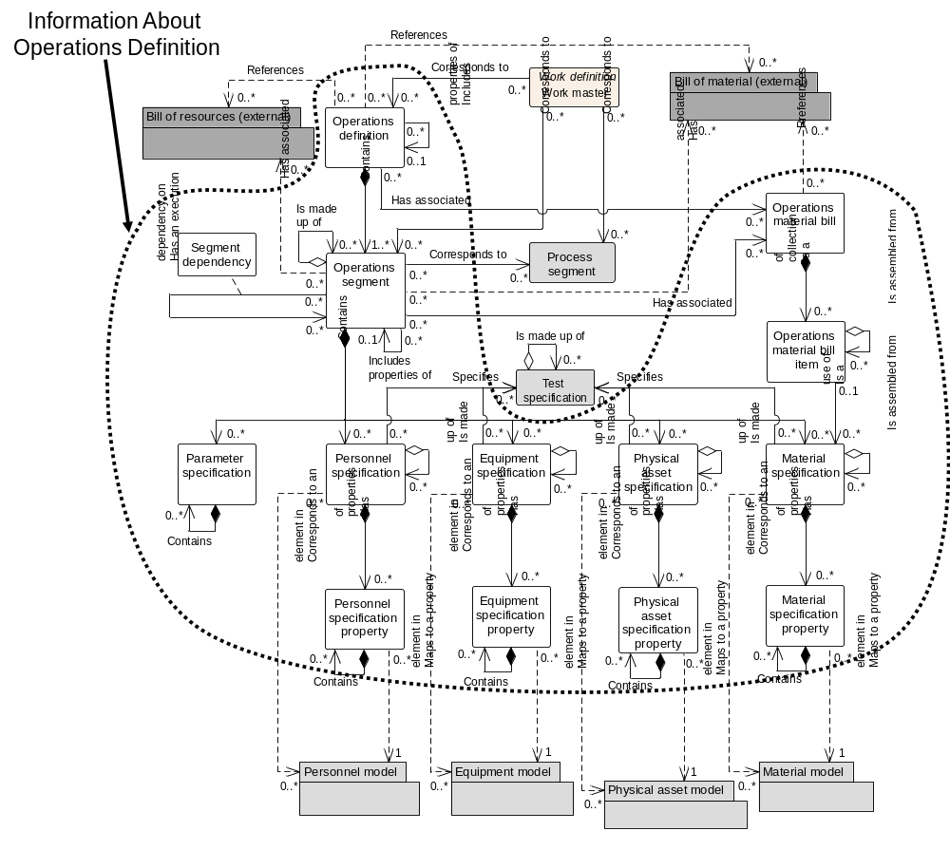
Figure 25 – Object grouping for the operations definition model
NOTE If operations Segments are to be exchanged, such as the exchange of a library of operations segments that are used in many products, then an operations definition should be used as a container with an ID and Version for the operations segments.

Operations definition verbs
All verbs shall be valid for an operations definition noun.
NOTE An operations definition contains a listing of the exchanged information about operations, such as production of a product, or performing a maintenance activity. The information is used in a set of operations segments. An operations definition has a reference to an operations bill of materials, a work definition, and a bill of resources. It contains the operations manufacturing bill and the operations segment definitions.

Operations definition verb actions
The actions performed on an operations definition noun are defined in Table 30.
Table 30 – Operations definition verb actions
Operations Definition ID | Verb action on noun
IDs specified | GET: Shall define a request that the receiver is to return, in a SHOW message, all attributes and contained elements of the Operations Definitions.  PROCESS: Shall define a request that the receiver is to add Operations Definitions. The message defines suggested IDs for the Operations Definitions and values for the attributes and contained elements. The receiver adds the Operations Definitions and assigns IDs. The assigned IDs shall be returned in the ACKNOWLEDGE message.  CHANGE: Shall define a request that the receiver is to change the specified attributes and/or contained elements of the Operations Definitions. A RESPOND message may be used to communicate agreement, disagreement, or changes made to the CHANGE message data.  CANCEL: Shall define a request that the receiver is to cancel the specified Operations Definitions. If contained elements IDs are specified, then only the specified contained elements for the specified Operations Definitions are to be cancelled, not the Operations Definitions.  SYNC ADD: Shall define a request that the receiver is to add the specified Operations Definitions with contained elements.  SYNC CHANGE: Shall define a request that the receiver is to change the specified attributes and/or contained elements of the Operations Definitions.  SYNC DELETE: Shall define a request that the receiver is to delete the specified Operations Definitions.  NOTIFY: Shall define the creation of a new Operations Definition.
<not specified> | GET: Error.  PROCESS: Error.  CHANGE: Error.  CANCEL: Error.  SYNC ADD: Error.  SYNC CHANGE: Error.  SYNC DELETE: Error.  NOTIFY: Error.
Wildcard specified | GET: Shall define a request that the receiver is to return, in a SHOW message, all attributes and contained elements of all Operations Definitions matching the wildcard.  Example To return all Operations Definitions, specify a “*” as the wildcard.  PROCESS: Error.  CHANGE: Shall define a request that the receiver is to change the specified attributes and contained elements of all Operations Definitions matching the wildcard. A RESPOND message may be used to communicate agreement, disagreement, or changes made to the CHANGE message data.  CANCEL: Shall define a request that the receiver is to cancel all Operations Definitions matching the wildcard.  SYNC ADD: Error.  SYNC CHANGE: Shall define a request that the receiver is to change the specified attributes and/or contained elements of all Operations Definitions matching the wildcard.  SYNC DELETE: Shall define a request that the receiver is to delete all Operations Definitions matching the wildcard.  NOTIFY: Error.

Operations schedule model

Operations schedule model elements
The message definitions assume that operations schedule information may be accessed from one starting point; an operations schedule, as identified by the dotted collection in Figure 26.
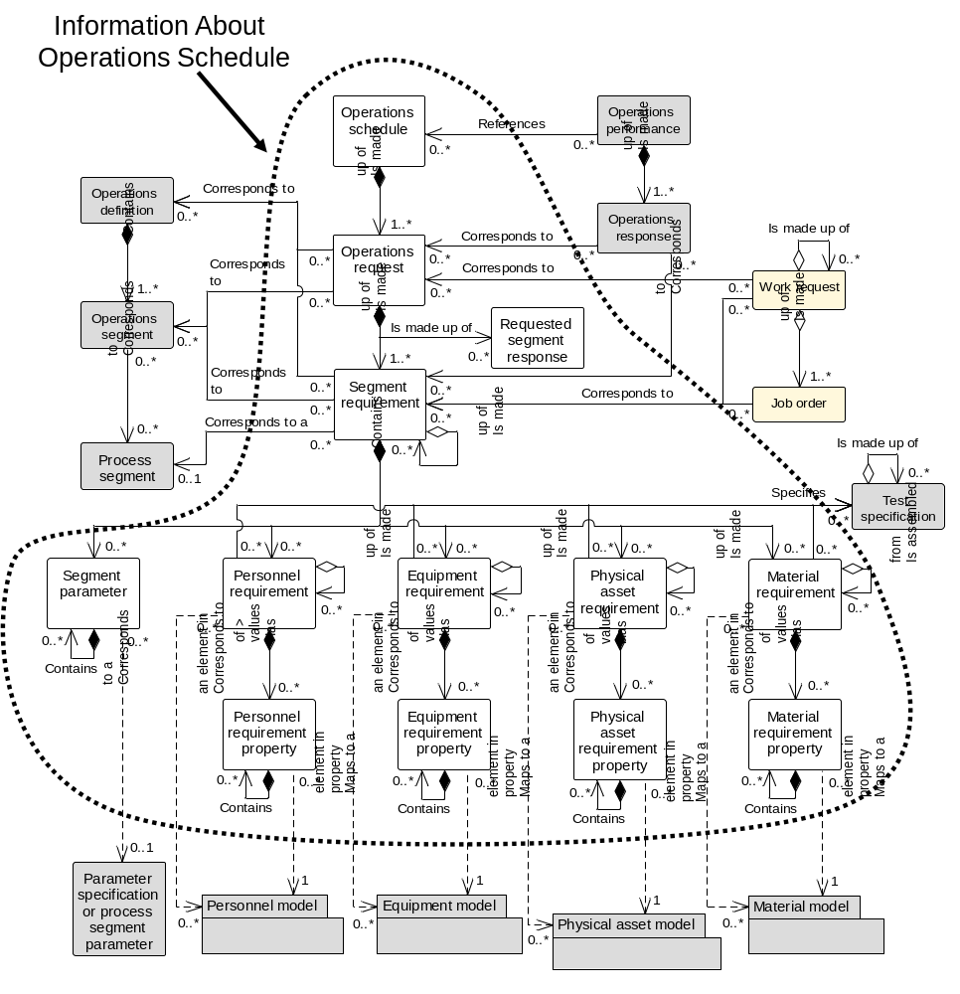
Figure 26 – Object grouping for the operations schedule model

Operations schedule verbs
All verbs shall be valid for an operations schedule noun.
NOTE An operations schedule contains a set of operations requests, each request may specify production of a main product, an inventory operation, a maintenance operation, or a testing operation. The presumption is that a Level 4 function is the provider of the operations schedule information.
Specifying the information to be returned from a GET may involve values in multiple fields. Each field definition restricts the returned information.

Operations schedule verb actions
The actions performed on an operations schedule noun are defined in Table 31.
Table 31 - Operations schedule verb actions
Operations Schedule ID | Verb action on noun
IDs specified | GET: Shall define a request that the receiver is to return, in a SHOW message, all attributes and contained elements of the Operations Schedules that match the IDs.  PROCESS: Shall define a request that the receiver is to add new Operations Schedules. Any assigned IDs shall be returned in the ACKNOWLEDGE message.  CHANGE: Shall define a request that the receiver is to change the specified attributes and contained elements of the Operations Schedules that match the IDs. A RESPOND message may be used to communicate agreement, disagreement, or changes made to the CHANGE message data.  Example 1 A CHANGE may define a changed Operations Schedule due to line slowdown or personnel unavailability.  CANCEL: Shall define a request that the receiver is to cancel the specified attributes and contained elements of the Operations Schedules that match the IDs. If contained elements IDs are specified, then only the specified contained elements for the specified Operations Schedule are to be cancelled, not the Operations Schedule.  Example 2 A CANCEL may define a removed Operations Schedule due to line shutdown or personnel reassignment  SYNC ADD: Shall define a request that the receiver is to add the specified attributes and contained elements of the Operations Schedules.  Example 3 A SYNC ADD sent every day may define Operations Schedules for the next day.  SYNC CHANGE: Shall define a request that the receiver is to change the specified attributes and contained elements of the Operations Schedules that match the IDs.  Example 4 A SYNC CHANGE may change a Operations Schedule due to line slowdown or personnel unavailability.  SYNC DELETE: Shall define a request that the receiver is to delete the specified attributes and contained elements of the Operations Schedules that match the IDs.  Example 5 A SYNC DELETE may define a removed Operations Schedule due to line shutdown or personnel reassignment  NOTIFY: Shall define the creation of a new Operations Schedule.
<not specified> | GET: Shall define a request that the receiver is to return, in a SHOW message, all attributes and contained elements of the Operations Schedules based on the information specified in the GET message. See Table 32 for details.  PROCESS: Shall define a request that the receiver is to add new Operations Schedules. Any assigned IDs shall be returned in the ACKNOWLEDGE message.  CHANGE: Shall define a request that the receiver is to change the specified attributes and contained elements of the Operations Schedules based on the information specified in the CHANGE message. See Table 32 for details. A RESPOND message may be used to communicate agreement, disagreement, or changes made to the CHANGE message data.  CANCEL: Shall define a request that the receiver is to cancel the specified attributes and contained elements of the Operations Schedules based on the information specified in the CANCEL message. See Table 32 for details. If contained elements IDs are specified, then only the specified contained elements for the specified Operations Schedule are to be cancelled, not the Operations Schedule.  SYNC ADD: Shall define a request that the receiver is to add the specified attributes and contained elements of the Operations Schedules based on the information specified in the SYNC message. See Table 32 for details.  SYNC CHANGE: Shall define a request that the receiver is to change the specified attributes and contained elements of the Operations Schedules based on the information specified in the SYNC message. See Table 32 for details.  SYNC DELETE: Shall define a request that the receiver is to delete the specified attributes and contained elements of the Operations Schedules based on the information specified in the SYNC message. See Table 32 for details.  NOTIFY: Error.
Wildcard specified | GET: Shall define a request that the receiver is to return, in a SHOW message, all attributes and contained elements of all Operations Schedules that match the wildcard.  PROCESS: Error  CHANGE: Shall define a request that the receiver is to change the specified attributes and contained elements of the Operations Schedules that match the wildcard. A RESPOND message may be used to communicate agreement, disagreement, or changes made to the CHANGE message data.  CANCEL: Shall define a request that the receiver is to cancel the specified attributes and contained elements of the Operations Schedules that match the wildcard. If contained elements IDs are specified, then only the specified contained elements for the specified Operations Schedule are to be cancelled, not the Operations Schedule.  SYNC ADD: Shall define a request that the receiver is to add the specified attributes and contained elements of the Operations Schedules that match the wildcard.  SYNC CHANGE: Shall define a request that the receiver is to change the specified attributes and contained elements of the Operations Schedules that match the wildcard.  SYNC DELETE: Shall define a request that the receiver is to delete the specified attributes and contained elements of the Operations Schedules that match the wildcard.  NOTIFY: Error.

The meanings of operations schedule elements for a GET verb are defined in Table 32.
Table 32 – Operations schedule element definitions for GET verb
Operations Schedule Element | Returns
Start Time | Specifies the operations schedule information for times after, and including the start time. Should be specified in the GET, otherwise the responder selects the Start Time.
End Time | Specifies the operations schedule information for times before, and including, the end time. If not specified then the responder selects the End Time.
Hierarchy Scope | Specifies the operations schedule information for the specified scope in the role based equipment hierarchy. (e.g. A process cell, work center, production line, area, site, …). If not specified then the responder selects the Hierarchy Scope.
Process Segment /  Work Definition | Specifies one or more process segments and the Work Definition identifying the product, and returns the schedules for the specified products.
Operations Type | Specifies the operations type to be returned. Should be specified in the GET, otherwise the responder selects the Operations Type.

Operations performance model

Operations performance model elements
The message definitions assume that operations performance information may be accessed from one starting point; an operations performance, as identified by the dotted collection in Figure 27.
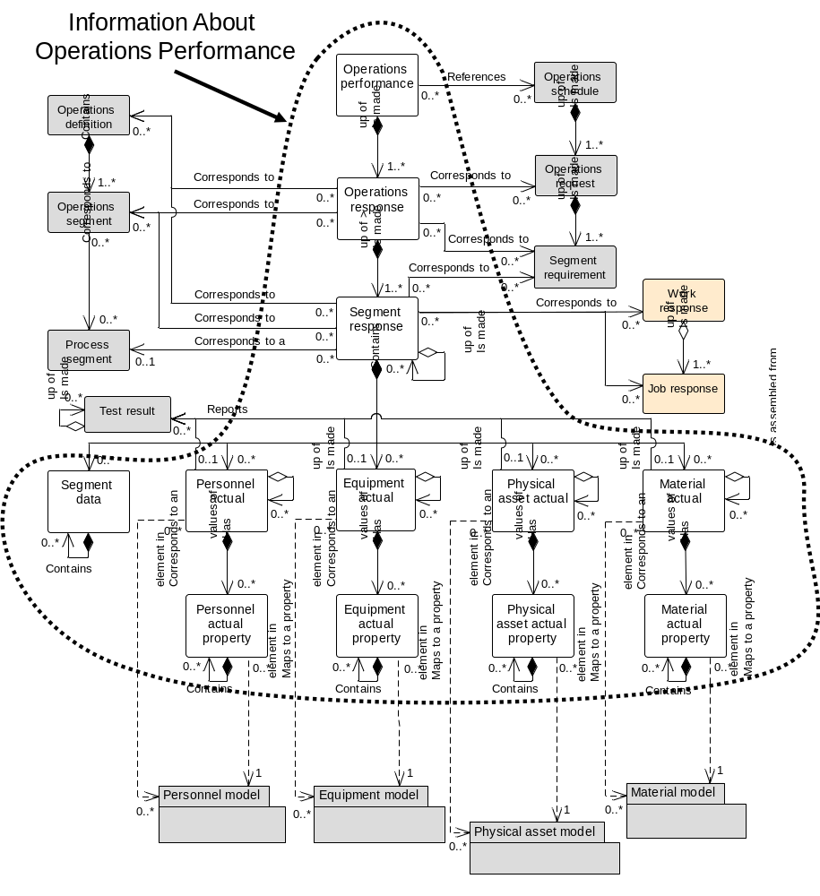
Figure 27 – Object grouping for the operations performance model

Operations performance verbs
All verbs shall be valid for an operations performance noun.
NOTE 1 An operations performance contains a set of operations responses. Operations responses contain the items reported back to the business system, at the end of an operation or during an operation. The presumption is that a Level 3 function is the owner of the operations performance information.
NOTE 2 Operations performance is a snapshot, in time, of operation execution.
Specifying the information to be returned from a GET may involve values in multiple fields. Each field definition restricts the returned information.

Operations performance verb actions
The actions performed on an operation performance noun are defined in Table 33.
Table 33 – Operations Performance verb actions
Operations Performance ID | Verb action on noun
IDs specified | GET: Shall define a request that the receiver is to return, in a SHOW message, all attributes and contained elements of the Operations Performances that match the IDs.  PROCESS: Shall define a request that the receiver is to add New Operations Performances. Any assigned IDs shall be returned in the ACKNOWLEDGE message.  CHANGE: Shall define a request that the receiver is to change the specified attributes and contained elements of Operations Performances that match the IDs. A RESPOND message may be used to communicate agreement, disagreement, or changes made to the CHANGE message data.  Example 1 A CHANGE may define a changed Operations Performance due to late results or recalculation of material use.  CANCEL: Shall define a request that the receiver is to cancel the specified attributes and contained elements of Operations Performances that match the IDs. If contained elements IDs are specified, then only the specified contained elements for the specified Operations Performance are to be cancelled, not the Operations Performance.  Example 2 A CANCEL may define a removed Operations Performances due to incorrectly collected use and production information, or information sent before it was verified.  SYNC ADD: Shall define a request that the receiver is to add the specified attributes and contained elements of Operations Performances.  Example 3 A SYNC ADD sent every day may define Operations Performance for the previous day.  SYNC CHANGE: Shall define a request that the receiver is to change the specified attributes and contained elements of Operations Performances that match the IDs.  Example 4 A SYNC CHANGE may change an Operations Performance due to incorrectly collected use and production information, or information sent before it was verified.  SYNC DELETE: Shall define a request that the receiver is to delete the specified attributes and contained elements of Operations Performances that match the IDs.  NOTIFY: Shall define the creation of a new Operations Performance.
<not specified> | GET: Shall define a request that the receiver is to return, in a SHOW message, all attributes and contained elements of Operations Performances based on the information specified in the GET message. See Table 34 for details.  PROCESS: Shall define a request that the receiver is to add New Operations Performances based on the information specified in the GET message. See Table 34 for details. Any assigned IDs shall be returned in the ACKNOWLEDGE message.  CHANGE: Shall define a request that the receiver is to change the specified attributes and contained elements of Operations Performances based on the information specified in the GET message. See Table 34 for details. A RESPOND message may be used to communicate agreement, disagreement, or changes made to the CHANGE message data.  CANCEL: Shall define a request that the receiver is to cancel the specified attributes and contained elements of Operations Performances based on the information specified in the CANCEL message. See Table 34 for details. If contained elements IDs are specified, then only the specified contained elements for the specified Operations Performance are to be cancelled, not the Operations Performance.  SYNC ADD: Shall define a request that the receiver is to add the specified attributes and contained elements of Operations Performances based on the information specified in the SYNC message. See Table 34 for details.  SYNC CHANGE: Shall define a request that the receiver is to change the specified attributes and contained elements of Operations Performances based on the information specified in the SYNC message. See Table 34 for details.  SYNC DELETE: Shall define a request that the receiver is to delete the specified attributes and contained elements of Operations Performances based on the information specified in the SYNC message. See Table 34 for details.  NOTIFY: Error.
Wildcard specified | GET: Shall define a request that the receiver is to return, in a SHOW message, all attributes and contained elements of all Operations Performances that match the wildcard.  PROCESS: Error.  CHANGE: Shall define a request that the receiver is to change the specified attributes and contained elements of Operations Performances that match the wildcard. A RESPOND message may be used to communicate agreement, disagreement, or changes made to the CHANGE message data.  CANCEL: Shall define a request that the receiver is to cancel the specified attributes and contained elements of Operations Performances that match the wildcard. If contained elements IDs are specified, then only the specified contained elements for the specified Operations Performance are to be cancelled, not the Operations Performance.  SYNC ADD: Error.  SYNC CHANGE: Shall define a request that the receiver is to change the specified attributes and contained elements of Operations Performances that match the wildcard.  SYNC DELETE: Shall define a request that the receiver is to delete the specified attributes and contained elements of Operations Performances that match the wildcard.  NOTIFY: Error.

Table 34 – Operations Performance definitions for GET verb
Operations Performance Element | Returns
Start Time | Specifies operations performance information for times after, and including the start time. Should be specified in the GET, otherwise the responder selects the Start Time.
End Time | Specifies operations performance information for times before, and including, the end time. If not specified then the responder selects the End Time.
Hierarchy Scope | Specifies operations performance information for the specified scope in the role based equipment hierarchy. (e.g. A process cell, work center, production line, area, site, …). If not specified then the responder selects the Hierarchy Scope.
Operations Performance /  Operations Schedule ID | Specifies the operations performance information associated with the specified operations schedule.
Operations Performance /  Operations Response /  Operations Request ID | Specifies the operations performance information associated with the specified operations request.
Operations Performance /  Operations Response /  Operations Definition ID | Specifies the operations performance information associated with the specified operations definition.
Operations Performance /  Operations Response /  Segment Response /  Process Segment ID | Specifies the operations performance information associated with the specified process segment.
Operations Performance /  Operations Response /  Segment Response /  Operations Segment ID | Specifies the operations performance information associated with the specified operations segment.

Resource relationship network model

Resource relationship network model elements
The message definitions assume that resource relationship network information may be accessed from two starting points; a resource relationship network and a resource relationship network type, as identified by the dotted collection in Figure 28.
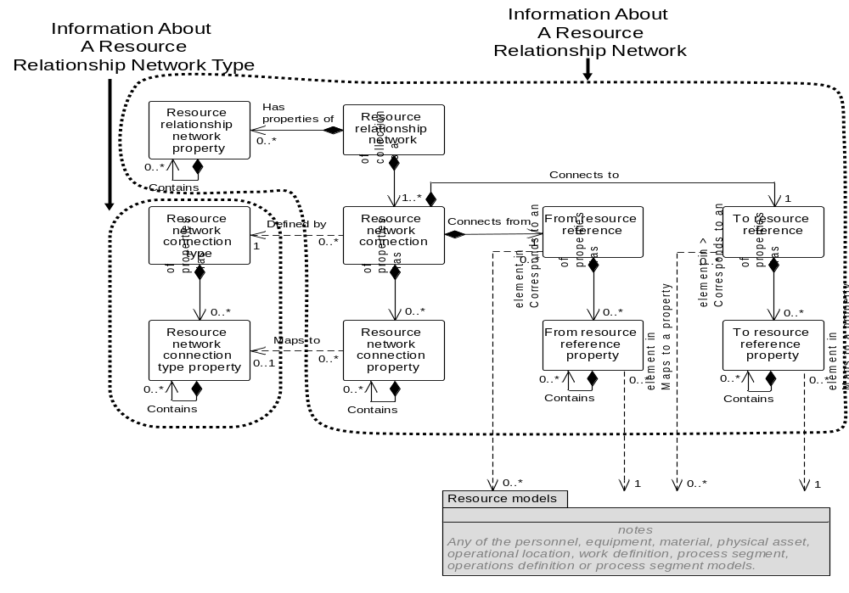
Figure 28 – Object grouping for the resource relationship network model

Resource relationship network verbs
All verbs shall be valid for a Resource Relationship Network noun.

Resource relationship network verb actions
The actions performed on a Resource Relationship Network noun are defined in Table 35.
Table 35 – Resource Relationship Network verb actions
Resource Relationship Network ID | Verb action on noun
IDs specified | GET: Shall define a request that the receiver is to return, in a SHOW message, all attributes and subobjects of Resource Relationship Networks.  PROCESS: Shall define a request that the receiver is to add Resource Relationship Networks. The message defines suggested IDs for the Resource Relationship Networks, values for the attributes and subobjects. The receiver adds the Resource Relationship Networks and assigns IDs. The assigned IDs shall be returned in the ACKNOWLEDGE message.  CHANGE: Shall define a request that the receiver is to change the specified attributes and subobjects of the Resource Relationship Networks. The assumption is the new Resource Relationship Network is the complete network definition and that the previous Resource Relationship Network is canceled and the new Resource Relationship Network is added. A RESPOND message may be used to communicate agreement, disagreement, or changes made to the CHANGE message data.  CANCEL: Shall define a request that the receiver is to cancel the specified Resource Relationship Networks.  SYNC ADD: Shall define a request that the receiver is to add the specified Resource Relationship Networks, attributes and subobjects.  SYNC CHANGE: Shall define a request that the receiver is to change the specified attributes and subobjects of the Resource Relationship Networks. The assumption is the new Resource Relationship Network is the complete network definition and that the previous Resource Relationship Network is deleted and the new Resource Relationship Network is added.  SYNC DELETE: Shall define a request that the receiver is to delete the specified Resource Relationship Networks.  NOTIFY: Shall define the creation of a new Resource Relationship Network.
<not specified> | GET: Error.  PROCESS: Error.  CHANGE: Error.  CANCEL: Error.  SYNC ADD: Error.  SYNC CHANGE: Error.  SYNC DELETE: Error.  NOTIFY: Error.
Wildcard specified | GET: Shall define a request that the receiver is to return, in a SHOW message, all attributes and subobjects about all Resource Relationship Networks identified by the wildcard.  PROCESS: Error.  CHANGE: Error.  CANCEL: Shall define a request that the receiver is to cancel all Resource Relationship Networks matching the wildcard.  SYNC ADD: Error.  SYNC CHANGE: Error.  SYNC DELETE: Shall define a request that the receiver is to delete all Resource Relationship Networks matching the wildcard.  NOTIFY: Error.

Resource relationship connection type verbs
All verbs shall be valid for a Resource Relationship Connection Type noun.

Resource relationship connection type verb actions
The actions performed on a Resource Relationship Connection Type noun are defined in Table 36.
Table 36 – Resource Relationship Connection Type verb actions
Resource Relationship Connection Type ID | Verb action on noun
IDs specified | GET: Shall define a request that the receiver is to return, in a SHOW message, all attributes and subobjects of Resource Relationship Connection Types.  PROCESS: Shall define a request that the receiver is to add Resource Relationship Connection Types. The message defines suggested IDs for the Resource Relationship Connection Types, values for the attributes and subobjects. The receiver adds the Resource Relationship Connection Types and assigns IDs. The assigned IDs shall be returned in the ACKNOWLEDGE message.  CHANGE: Shall define a request that the receiver is to change the specified attributes and subobjects of the Resource Relationship Connection Types. The assumption is the new Resource Relationship Connection Type is the complete type definition and that the previous Resource Relationship Connection Type is canceled and the new Resource Relationship Connection Type is added. A RESPOND message may be used to communicate agreement, disagreement, or changes made to the CHANGE message data.  CANCEL: Shall define a request that the receiver is to cancel the specified Resource Relationship Connection Types.  SYNC ADD: Shall define a request that the receiver is to add the specified Resource Relationship Connection Types, attributes and subobjects.  SYNC CHANGE: Shall define a request that the receiver is to change the specified attributes and subobjects of the Resource Relationship Connection Types. The assumption is the new Resource Relationship Connection Type is the complete type definition and that the previous Resource Relationship Connection Type is deleted and the new Resource Relationship Connection Type is added.  SYNC DELETE: Shall define a request that the receiver is to delete the specified Resource Relationship Connection Types.  NOTIFY: Shall define the creation of a new Resource Relationship Connection Type.
<not specified> | GET: Error.  PROCESS: Error.  CHANGE: Error.  CANCEL: Error.  SYNC ADD: Error.  SYNC CHANGE: Error.  SYNC DELETE: Error.  NOTIFY: Error.
Wildcard specified | GET: Shall define a request that the receiver is to return, in a SHOW message, all attributes and subobjects about all Resource Relationship Connection Types identified by the wildcard.  PROCESS: Error.  CHANGE: Error.  CANCEL: Shall define a request that the receiver is to cancel all Resource Relationship Connection Types matching the wildcard.  SYNC ADD: Error.  SYNC CHANGE: Error.  SYNC DELETE: Shall define a request that the receiver is to delete all Resource Relationship Connection Types matching the wildcard.  NOTIFY: Error.

Work alerts

Work alert model elements
The message definitions assume that Work Alert information may be accessed from two starting points; a Work Alert Definition and a Work Alert, as identified by the dotted collection in Figure 29.
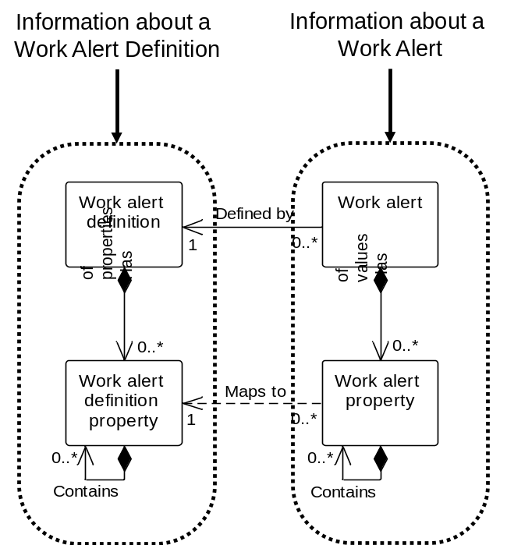
Figure 29 – Object grouping for the work alert model

Work alert definition verbs
All verbs shall be valid for a work alert definition noun.
Specifying the information to be returned from a GET may involve values in multiple fields. Each field definition restricts the returned information.
The additional attributes defined in Table 37 shall be defined for Work Alerts Definitions for purposes of GET transaction support.
Table 37 – Work alert definition additional attributes
Attribute Name | Description
Hierarchy Scope | Identifies where the exchanged information fits within the role based equipment hierarchy.

Work alert definition actions
The actions performed on a work alert definition noun are defined in Table 38. The additional attributes for the GET verb for work alert definition are defined in Table 39.
Table 38 – Work alert definition verb actions
Work Alert Definition ID | Verb action on noun
IDs specified | GET: Shall define a request that the receiver is to return, in a SHOW message, all attributes and contained elements of the Work Alert Definition that matches the IDs.  PROCESS: Shall define a request that the receiver is to add new Work Alert Definitions. Any assigned IDs are returned in the ACKNOWLEDGE message.  CHANGE: Shall define a request that the receiver is to change specified attributes and contained elements of the Work Alert Definitions. A RESPOND message may be used to communicate agreement, disagreement, or changes made to the CHANGE message data.  CANCEL: Shall define a request that the receiver is to cancel the specified attributes and contained elements of the Work Alert Definitions.  SYNC ADD: Shall define a request that the receiver is to define the specified attributes and contained elements of Work Alert Definitions.  SYNC CHANGE: Shall define a request that the receiver is to change the specified attributes and contained elements of Work Alert Definitions.  SYNC DELETE: Shall define a request that the receiver is to delete the specified Work Alert Definitions.  NOTIFY: Shall define the creation of a new Work Alert Definition.
<not specified> | GET: Shall define a request that the receiver is to return, in a SHOW message, all attributes and contained elements of a Work Alert Definitions identified by the information specified in the GET message. See Table 39 for details.  PROCESS: Shall define a request that the receiver is to add new Work Alert Definitions. Any assigned IDs are returned in the ACKNOWLEDGE message.  CHANGE: Shall define a request that the receiver is to change specified attributes and contained elements of the Work Alert Definitions identified by the information specified in the CHANGE message. See Table 39 or details. A RESPOND message may be used to communicate agreement, disagreement, or changes made to the CHANGE message data.  CANCEL: Shall define a request that the receiver is to cancel the specified attributes and contained elements of the Work Alert Definitions identified by the information specified in the CANCEL message. See Table 39 for details.  SYNC ADD: Shall define a request that the receiver is to define the specified attributes and contained elements of Work Alert Definitions identified by the information specified in the SYNC message. See Table 39 for details.  SYNC CHANGE: Shall define a request that the receiver is to delete the specified attributes and contained elements of Work Alert Definitions identified by the information specified in the SYNC message. See Table 39 for details.  SYNC DELETE: Shall define a request that the receiver is to delete the specified attributes and contained elements of Work Alert Definitions identified by the information specified in the SYNC message. See Table 39 for details.  NOTIFY: Error.
Wildcard specified | GET: Shall define a request that the receiver is to return, in a SHOW message, all attributes and contained elements of all Work Alert Definitions that match the wildcard.  PROCESS: Error  CHANGE: Error.  CANCEL: Shall define a request that the receiver is to cancel the specified Work Alert Definitions that match the wildcard.  SYNC ADD: Error.  SYNC CHANGE: Error.  SYNC DELETE: Shall define a request that the receiver is to delete the specified Work Alert Definitions that match the wildcard.  NOTIFY: Error.

Table 39 – Work alert definition element definitions for GET verb
Work Alert Element | Returns
Hierarchy Scope | Specifies work alert definition information for the specified scope in the role based equipment hierarchal. (e.g. A process cell, work center, production line, area, site, …). If not specified then the responder selects the Hierarchy Scope.
Priority | Specifies work alert definition information for the specified priority. If not specified then the responder returns all priority alerts.
Category | Specifies work alert definition information for the specified category. If not specified then the responder returns all category alerts.

Work alert verbs
All verbs shall be valid for a work alert noun.
Specifying the information to be returned from a GET may involve values in multiple fields. Each field definition restricts the returned information.
The additional attributes defined in Table 40 shall be defined for Work Alerts for purposes of GET transaction support. The additional attributes for the GET verb for work alert are defined in Table 42
Table 40 – Work alert definition additional attributes
Attribute Name | Description
Start Time | The starting time for the associated work alert, if applicable.
End Time | The ending time for the associated work schedule, if applicable.
Hierarchy Scope | Identifies where the exchanged information fits within the role based equipment hierarchy.

Work alert verb actions
The actions performed on a work alert noun are defined in Table 41.
Table 41 – Work alert verb actions
Work Alert ID | Verb action on noun
IDs specified | GET: Shall define a request that the receiver is to return, in a SHOW message, all attributes and contained elements of the Work Alert that matches the IDs.  PROCESS: Shall define a request that the receiver is to add new Work Alerts. Any assigned IDs are returned in the ACKNOWLEDGE message.  CHANGE: Shall define a request that the receiver is to change specified attributes and contained elements of the Work Alerts. A RESPOND message may be used to communicate agreement, disagreement, or changes made to the CHANGE message data.  CANCEL: Shall define a request that the receiver is to cancel the specified attributes and contained elements of the Work Alerts.  SYNC ADD: Shall define a request that the receiver is to define the specified attributes and contained elements of Work Alerts.  SYNC CHANGE: Shall define a request that the receiver is to change the specified attributes and contained elements of Work Alerts.  SYNC DELETE: Shall define a request that the receiver is to delete the specified Work Alerts.  NOTIFY: Shall define the creation of a new Work Alert.
<not specified> | GET: Shall define a request that the receiver is to return, in a SHOW message, all attributes and contained elements of a Work Alert identified by the information specified in the GET message. See Table 42 for details.  PROCESS: Shall define a request that the receiver is to add new Work Alerts. Any assigned IDs are returned in the ACKNOWLEDGE message.  CHANGE: Shall define a request that the receiver is to change specified attributes and contained elements of the Work Alerts identified by the information specified in the CHANGE message. See Table 42 or details. A RESPOND message may be used to communicate agreement, disagreement, or changes made to the CHANGE message data.  CANCEL: Shall define a request that the receiver is to cancel the specified attributes and contained elements of the Work Alerts identified by the information specified in the CANCEL message. See Table 42 for details.  SYNC ADD: Shall define a request that the receiver is to define the specified attributes and contained elements of Work Alerts identified by the information specified in the SYNC message. See Table 42 for details.  SYNC CHANGE: Shall define a request that the receiver is to delete the specified attributes and contained elements of Work Alerts identified by the information specified in the SYNC message. See Table 42 for details.  SYNC DELETE: Shall define a request that the receiver is to delete the specified attributes and contained elements of Work Alerts identified by the information specified in the SYNC message. See Table 42 for details.  NOTIFY: Error.
Wildcard specified | GET: Shall define a request that the receiver is to return, in a SHOW message, all attributes and contained elements of all Work Alerts that match the wildcard.  PROCESS: Error  CHANGE: Error.  CANCEL: Shall define a request that the receiver is to cancel the specified Work Alerts that match the wildcard.  SYNC ADD: Error.  SYNC CHANGE: Error.  SYNC DELETE: Shall define a request that the receiver is to delete the specified Work Alerts that match the wildcard.  NOTIFY: Error.

Table 42 – Work alert element definitions for GET verb
Work Alert Element | Returns
Start Time | Specifies work alert information with Timestamps after, and including the start time. If not specified then the responder selects the Start Time.
End Time | Specifies work alert information with Timestamps before, and including, the end time. If not specified then the responder selects the End Time.
Hierarchy Scope | Specifies work alert information for the specified scope in the role based equipment hierarchal. (e.g. A process cell, work center, production line, area, site, …). If not specified then the responder selects the Hierarchy Scope.
Priority | Specifies work alert information for the specified priority. If not specified then the responder returns all priority alerts.
Category | Specifies work alert information for the specified category. If not specified then the responder returns all category alerts.

Work calendar

Work calendar elements
The message definitions assume that Work Calendar information may be accessed from two starting points; a Work Calendar Definition and a Work Calendar, as identified by the dotted collection in Figure 30.
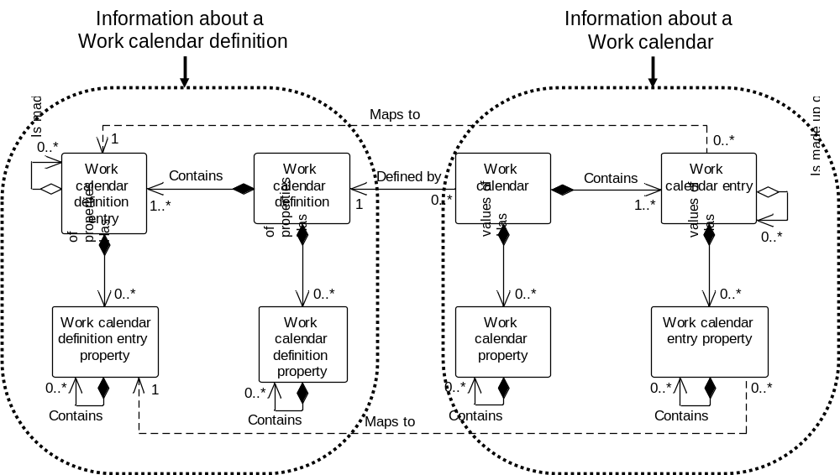
Figure 30 – Object grouping for the work calendar model

Work calendar definition verbs
All verbs shall be valid for a work calendar definition noun.

Work calendar definition actions
The actions performed on a work calendar definition noun are defined in Table 43.
Table 43 – Work calendar definition verb actions
Work Calendar Definition ID | Verb action on noun
IDs specified | GET: Shall define a request that the receiver is to return, in a SHOW message, all attributes and contained elements of the Work Calendar Definition that matches the IDs.  PROCESS: Shall define a request that the receiver is to add new Work Calendar Definitions. Any assigned IDs are returned in the ACKNOWLEDGE message.  CHANGE: Shall define a request that the receiver is to change specified attributes and contained elements of the Work Calendar Definitions. A RESPOND message may be used to communicate agreement, disagreement, or changes made to the CHANGE message data.  CANCEL: Shall define a request that the receiver is to cancel the specified attributes and contained elements of the Work Calendar Definitions.  SYNC ADD: Shall define a request that the receiver is to define the specified attributes and contained elements of Work Calendar Definitions.  SYNC CHANGE: Shall define a request that the receiver is to change the specified attributes and contained elements of Work Calendar Definitions.  SYNC DELETE: Shall define a request that the receiver is to delete the specified Work Calendar Definitions.  NOTIFY: Shall define the creation of a new Work Calendar Definition.
<not specified> | GET: Error.  PROCESS: Shall define a request that the receiver is to add new Work Calendar Definitions. Any assigned IDs are returned in the ACKNOWLEDGE message..  CHANGE: Error.  CANCEL: Error.  SYNC ADD: Error.  SYNC CHANGE: Error.  SYNC DELETE: Error.  NOTIFY: Error.
Wildcard specified | GET: Shall define a request that the receiver is to return, in a SHOW message, all attributes and contained elements of all Work Calendar Definitions that match the wildcard.  PROCESS: Error  CHANGE: Error.  CANCEL: Shall define a request that the receiver is to cancel the specified Work Calendar Definitions that match the wildcard.  SYNC ADD: Error.  SYNC CHANGE: Error.  SYNC DELETE: Shall define a request that the receiver is to delete the specified Work Calendar Definitions that match the wildcard.  NOTIFY: Error.

Work calendar verbs
All verbs shall be valid for a work calendar noun.

Work calendar actions
The actions performed on a work calendar noun are defined in Table 44.
Table 44 – Work calendar verb actions
Work Calendar ID | Verb action on noun
IDs specified | GET: Shall define a request that the receiver is to return, in a SHOW message, all attributes and contained elements of the Work Calendar that matches the IDs.  PROCESS: Shall define a request that the receiver is to add new Work Calendar. Any assigned IDs are returned in the ACKNOWLEDGE message.  CHANGE: Shall define a request that the receiver is to change specified attributes and contained elements of the Work Calendar. A RESPOND message may be used to communicate agreement, disagreement, or changes made to the CHANGE message data.  CANCEL: Shall define a request that the receiver is to cancel the specified attributes and contained elements of the Work Calendars.  SYNC ADD: Shall define a request that the receiver is to define the specified attributes and contained elements of Work Calendars.  SYNC CHANGE: Shall define a request that the receiver is to change the specified attributes and contained elements of Work Calendars.  SYNC DELETE: Shall define a request that the receiver is to delete the specified Work Calendar.  NOTIFY: Shall define the creation of a new Work Calendar.
<not specified> | GET: Error.  PROCESS: Shall define a request that the receiver is to add new Work Calendar. Any assigned IDs are returned in the ACKNOWLEDGE message.  CHANGE: Error.  CANCEL: Error.  SYNC ADD: Error.  SYNC CHANGE: Error.  SYNC DELETE: Error.  NOTIFY: Error.
Wildcard specified | GET: Shall define a request that the receiver is to return, in a SHOW message, all attributes and contained elements of all Work Calendars that match the wildcard.  PROCESS: Error  CHANGE: Error.  CANCEL: Shall define a request that the receiver is to cancel the specified Work Calendars that match the wildcard.  SYNC ADD: Error.  SYNC CHANGE: Error.  SYNC DELETE: Shall define a request that the receiver is to delete the specified Work Calendar that match the wildcard.  NOTIFY: Error.

Work capability model

Work capability model elements
The message definitions assume that Work Capability information may be accessed from one starting point; a Work Capability, as identified by the dotted collection in Figure 31.
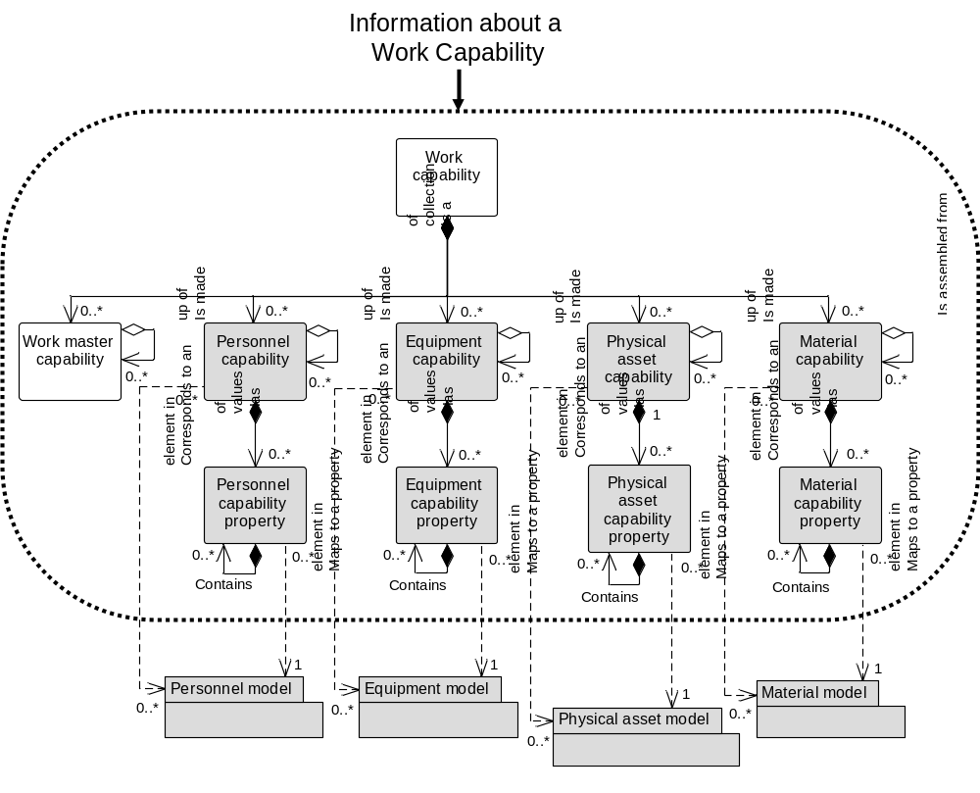
Figure 31 – Object grouping for the work capability model

Work capability verbs
All verbs shall be valid for a work capability noun.
NOTE Work capability is a snapshot in time of the available, unattainable, or committed capability.
Specifying the information to be returned from a Get may involve values in multiple fields. Each field definition restricts the returned information.

Work capability verb actions
The actions performed on a work capability noun are defined in Table 45. The additional attributes for the GET verb for work capability are defined in Table 46.
Table 45 – Work capability verb actions
Work Capability ID | Verb action on noun
IDs specified | GET: Shall define a request that the receiver is to return, in a SHOW message, all attributes and contained elements of the Work Capabilities that matches the IDs.  PROCESS: Shall define a request that the receiver is to add new Work Capabilities. Any assigned IDs are returned in the ACKNOWLEDGE message.  CHANGE: Shall define a request that the receiver is to change specified attributes and contained elements of the Work Capabilities. The assumption is the new Work Capability is the complete type definition and that the previous Work Capability is cancelled and the new Work Capability is added. A RESPOND message may be used to communicate agreement, disagreement, or changes made to the CHANGE message data.  CANCEL: Shall define a request that the receiver is to cancel the specified attributes and contained elements of the Work Capabilities. If contained elements IDs are specified, then only the specified contained elements for the specified Work Capability are to be cancelled, not the Work Capability.  SYNC ADD: Shall define a request that the receiver is to define the specified attributes and contained elements of Work Capabilities.  SYNC CHANGE: Shall define a request that the receiver is to change the specified attributes and contained elements of Work Capabilities. The assumption is the new Work Capability is the complete type definition and that the previous Work Capability is deleted and the new Work Capability is added.  SYNC DELETE: Shall define a request that the receiver is to delete the specified attributes and contained elements of Work Capabilities.  NOTIFY: Shall define the creation of a new Work Capabilities.
<not specified> | GET: Shall define a request that the receiver is to return, in a SHOW message, all attributes and contained elements of a Work Capabilities identified by the information specified in the GET message. See Table 46 for details.  PROCESS: Shall define a request that the receiver is to add new Work Capabilities. Any assigned IDs are returned in the ACKNOWLEDGE message.  CHANGE: Shall define a request that the receiver is to change specified attributes and contained elements of the Work Capabilities identified by the information specified in the CHANGE message. See Table 46 for details. A RESPOND message may be used to communicate agreement, disagreement, or changes made to the CHANGE message data.  CANCEL: Shall define a request that the receiver is to cancel the specified attributes and contained elements of the Work Capabilities identified by the information specified in the CANCEL message. See Table 46 for details. If contained elements IDs are specified, then only the specified contained elements for the specified Work Capability are to be cancelled, not the Work Capability.  SYNC ADD: Shall define a request that the receiver is to define the specified attributes and contained elements of Work Capabilities identified by the information specified in the SYNC message. See Table 46 for details.  SYNC CHANGE: Shall define a request that the receiver is to delete the specified attributes and contained elements of Work Capabilities identified by the information specified in the SYNC message. See Table 46 for details.  SYNC DELETE: Shall define a request that the receiver is to delete the specified attributes and contained elements of Work Capabilities identified by the information specified in the SYNC message. See Table 46 for details.  NOTIFY: Error.
Wildcard specified | GET: Shall define a request that the receiver is to return, in a SHOW message, all attributes and contained elements of all Work Capabilities that match the wildcard.  PROCESS: Error  CHANGE: Shall define a request that the receiver is to change specified attributes and contained elements of the Work Capabilities that match the wildcard. A RESPOND message may be used to communicate agreement, disagreement, or changes made to the CHANGE message data.  CANCEL: Shall define a request that the receiver is to cancel the specified attributes and contained elements of the Work Capabilities that match the wildcard. If contained elements IDs are specified, then only the specified contained elements for the specified Work Capability are to be cancelled, not the Work Capability.  SYNC ADD: Error.  SYNC CHANGE: Shall define a request that the receiver is to delete the specified attributes and contained elements of Work Capabilities that match the wildcard.  SYNC DELETE: Shall define a request that the receiver is to delete the specified attributes and contained elements of Work Capabilities that match the wildcard.  NOTIFY: Error.

Table 46 – Work capability element definitions for GET verb
Work capability Element | Returns
Start Time | Specifies work capability information for times after, and including the start time. If not specified then the responder selects the Start Time.
End Time | Specifies work capability information for times before, and including, the end time. If not specified then the responder selects the End Time.
Hierarchy Scope | Specifies work capability information for the specified scope in the role based equipment hierarchal. (e.g. A process cell, work center, production line, area, site, …) If not specified then the responder selects the Hierarchy Scope.
Capability Type | Specifies the type of work capability information to be returned. If not specified, then the responder selects the Capability Type information returned.
Personnel Capability /  Personnel Class ID | May specify a wildcard or a Personnel Class ID. If included, then it specifies the personnel class(es) for the returned Personnel Capability.
Personnel Capability /  Person ID | May specify a wildcard or a Person ID. If included, then it specifies the person(s) for the returned Personnel Capability.
Equipment Capability /  Equipment Class ID | May specify a wildcard or an Equipment Class ID. If included, then it specifies the equipment class(es) for the returned Equipment Capability.
Equipment Capability /  Equipment ID | May specify a wildcard or an Equipment ID. If included, then it specifies the equipment for the returned Equipment Capability.
Physical Asset Capability /  Physical Asset ID | May specify a wildcard or a Physical Asset ID. If included, then it specifies the Physical Assets for the returned Physical Asset Capability.
Physical Asset Capability /  Physical Asset Class ID | May specify a wildcard or a Physical Asset Class ID. If included, then it specifies the Physical Asset Class(es) for the returned Physical Asset Class Capability.
Material Capability /  Material Class ID | May specify a wildcard or a Material Class ID. If included, then it specifies the material class(es) for the returned Material Capability.
Material Capability /  Material Definition ID | May specify a wildcard or a Material Definition ID. If included, then it specifies the material definitions(s) for the returned Material Capability.
Material Capability /  Material Lot ID | May specify a wildcard or a Material Lot ID. If included, then it specifies the material lot(s) for the returned Material Capability.
Material Capability /  Material SubLot ID | May specify a wildcard or a Material Sublot ID. If included, then it specifies the material sublot(s) for the returned Material Capability.
Work Master Capability ID | May contain a wildcard or a Work Master ID. If included, then it specifies that Work Master Capability should only be returned for the specified process segment.
Work Master Capability / Personnel Capability /  Personnel Class ID | May specify a wildcard or a Work Master ID. If included, then it specifies the personnel class(es) for the returned Work Master / Personnel Capability.
Work Master Capability / Personnel Capability /  Person ID | May specify a wildcard or a Person ID. If included, then it specifies the person(s) for the returned Work Master / Personnel Capability.
Work Master Capability / Equipment Capability /  Equipment Class ID | May specify a wildcard or an Equipment Class ID. If included, then it specifies the equipment class(es) for the returned Work Master / Equipment Capability.
Work Master Capability /  Equipment Capability /  Equipment ID | May specify a wildcard or an Equipment ID. If included, then it specifies the equipment for the returned Equipment Capability.
Work Master Capability /  Physical Asset Capability /  Physical Asset Class ID | May specify a wildcard or a Physical Asset Class ID. If included, then it specifies the Physical Asset class(es) for the returned Work Master / Physical Asset Capability.
Work Master Capability /  Physical Asset Capability /  Physical Asset ID | May specify a wildcard or a Physical Asset ID. If included, then it specifies the Physical Asset for the returned Physical Asset Capability.
Work Master Capability / Material Capability /  Material Class ID | May specify a wildcard or a Material Class ID. If included, then it specifies the material class(es) for the returned Work Master / Material Capability.
Work Master Capability / Material Capability /  Material Definition ID | May specify a wildcard or a Material Definition ID. If included, then it specifies the material definitions(s) for the returned Work Master / Material Capability.
Work Master Capability / Material Capability /  Material Lot ID | May specify a wildcard or a Material Lot ID. If included, then it specifies the material lot(s) for the returned Work Master / Material Capability.
Work Master Capability / Material Capability /  Material Lot ID | May specify a wildcard or a Material Sublot ID. If included, then it specifies the material sublot(s) for the returned Work Master / Material Capability.

Work definition model

Work definition model elements
The message definitions assume that Work Definition information may be accessed from two starting points; a Work Master and a Work Directive, as identified by the dotted collection in Figure 32.
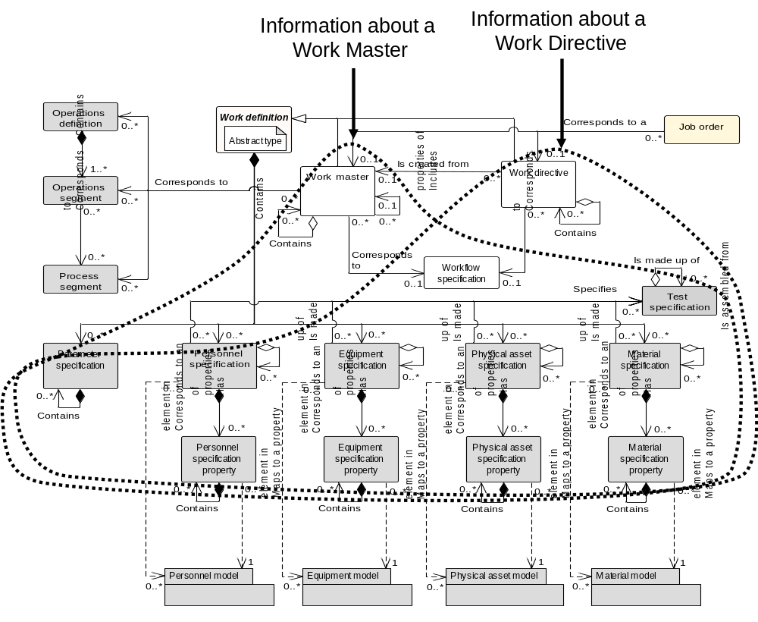
Figure 32 – Object grouping for the work definition model

Work master verbs
All verbs shall be valid for a Work Master noun.

Work master verb actions
The actions performed on a Work Master noun are defined in Table 47.
Table 47 – Work master verb actions
Work Master ID | Verb action on noun
IDs specified | GET: Shall define a request that the receiver is to return, in a SHOW message, all attributes and subobjects of Work Masters.  PROCESS: Shall define a request that the receiver is to add Work Masters. The message defines suggested IDs for the Work Masters, values for the attributes and subobjects. The receiver adds the Work Masters and assigns IDs. The assigned IDs shall be returned in the ACKNOWLEDGE message.  CHANGE: Shall define a request that the receiver is to change the specified attributes and subobjects of the Work Masters. The assumption is the new Work Master is the complete type definition and that the previous Work Master is canceled and the new Work Master is added. A RESPOND message may be used to communicate agreement, disagreement, or changes made to the CHANGE message data.  CANCEL: Shall define a request that the receiver is to cancel the specified Work Masters.  SYNC ADD: Shall define a request that the receiver is to add the specified Work Masters, attributes and subobjects.  SYNC CHANGE: Shall define a request that the receiver is to change the specified attributes and subobjects of the Work Masters. The assumption is the new Work Master is the complete type definition and that the previous Work Master is deleted and the new Work Master is added.  SYNC DELETE: Shall define a request that the receiver is to delete the specified Work Masters.  NOTIFY: Shall define the creation of a new Work Master.
<not specified> | GET: Error.  PROCESS: Error.  CHANGE: Error.  CANCEL: Error.  SYNC ADD: Error.  SYNC CHANGE: Error.  SYNC DELETE: Error.  NOTIFY: Error.
Wildcard specified | GET: Shall define a request that the receiver is to return, in a SHOW message, all attributes and subobjects about all Work Masters identified by the wildcard.  PROCESS: Error.  CHANGE: Error.  CANCEL: Shall define a request that the receiver is to cancel all Work Masters matching the wildcard.  SYNC ADD: Error.  SYNC CHANGE: Error.  SYNC DELETE: Shall define a request that the receiver is to delete all Work Masters matching the wildcard.  NOTIFY: Error.

Work directive verbs
All verbs shall be valid for a Work Directive noun.

Work directive verb actions
The actions performed on a Work Directive noun are defined in Table 48.
Table 48 – Work directive verb actions
Work Directive ID | Verb action on noun
IDs specified | GET: Shall define a request that the receiver is to return, in a SHOW message, all attributes and subobjects of Work Directives.  PROCESS: Shall define a request that the receiver is to add Work Directives. The message defines suggested IDs for the Work Directives, values for the attributes and subobjects. The receiver adds the Work Directives and assigns IDs. The assigned IDs shall be returned in the ACKNOWLEDGE message.  CHANGE: Shall define a request that the receiver is to change the specified attributes and subobjects of the Work Directives. The assumption is the new Work Directive is the complete type definition and that the previous Work Directive is canceled and the new Work Directive is added. A RESPOND message may be used to communicate agreement, disagreement, or changes made to the CHANGE message data.  CANCEL: Shall define a request that the receiver is to cancel the specified Work Directives.  SYNC ADD: Shall define a request that the receiver is to add the specified Work Directives, attributes and subobjects.  SYNC CHANGE: Shall define a request that the receiver is to change the specified attributes and subobjects of the Work Directives. The assumption is the new Work Directive is the complete type definition and that the previous Work Directive is deleted and the new Work Directive is added.  SYNC DELETE: Shall define a request that the receiver is to delete the specified Work Directives.  NOTIFY: Shall define the creation of a new Work Directive.
<not specified> | GET: Error.  PROCESS: Error.  CHANGE: Error.  CANCEL: Error.  SYNC ADD: Error.  SYNC CHANGE: Error.  SYNC DELETE: Error.  NOTIFY: Error.
Wildcard specified | GET: Shall define a request that the receiver is to return, in a SHOW message, all attributes and subobjects about all Work Directives identified by the wildcard.  PROCESS: Error.  CHANGE: Error.  CANCEL: Shall define a request that the receiver is to cancel all Work Directives matching the wildcard.  SYNC ADD: Error.  SYNC CHANGE: Error.  SYNC DELETE: Shall define a request that the receiver is to delete all Work Directives matching the wildcard.  NOTIFY: Error.

Work record

Work record elements
The message definitions assume that work record information may be accessed from one starting point, a Work Record, as identified by the dotted collection in Figure 33.
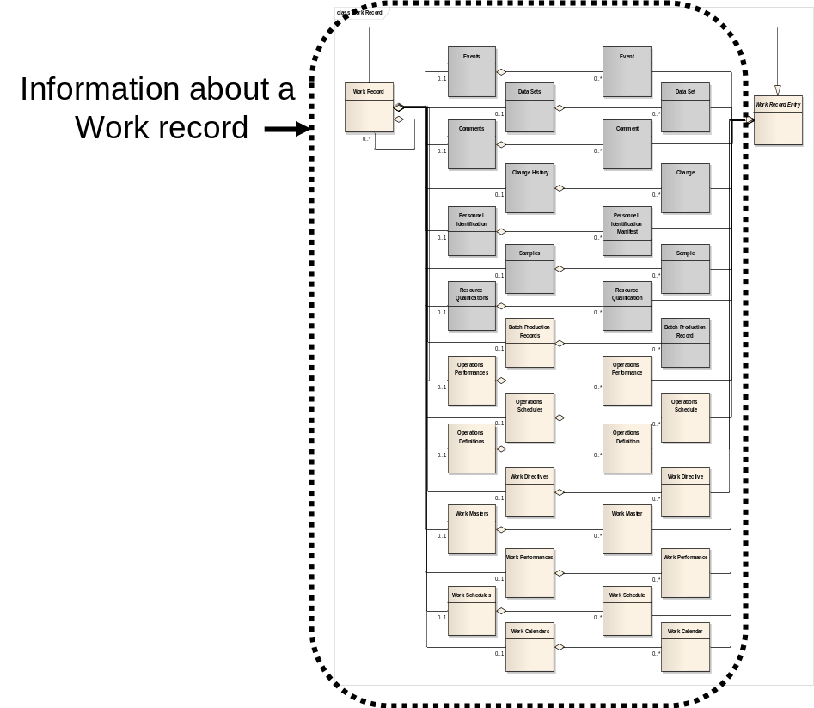
Figure 33 – Object grouping for the work record model

Work record verbs
All verbs shall be valid for a work record noun.

Work record verb actions
The actions performed on a work record noun are defined in Table 49.
Table 49 – Work record verb actions
Work Record ID | Verb action on noun
IDs specified | GET: Shall define a request that the receiver is to return, in a SHOW message, all attributes and contained elements of the work record that match the IDs.  PROCESS: Shall define a request that the receiver is to add new work records. Any assigned IDs shall be returned in the ACKNOWLEDGE message.  CHANGE: Shall define a request that the receiver is to change the specified attributes and contained elements of work records that match the IDs. A RESPOND message may be used to communicate agreement, disagreement, or changes made to the CHANGE message data.  CANCEL: Shall define a request that the receiver is to cancel the specified attributes and contained elements of work records that match the IDs. If contained elements IDs are specified, then only the specified contained elements for the specified work record are to be cancelled, not the work record.  SYNC ADD: Shall define a request that the receiver is to add the specified attributes and contained elements of work record.  SYNC CHANGE: Shall define a request that the receiver is to change the specified attributes and contained elements of work records that match the IDs.  SYNC DELETE: Shall define a request that the receiver is to delete the specified attributes and contained elements of work records that match the IDs.  NOTIFY: Shall define the creation of a new Work Record.
<not specified> | GET: Error.  PROCESS: Shall define a request that the receiver is to add new work records based on the information specified in the GET message.  CHANGE: Error.  CANCEL: Error.  SYNC ADD: Error.  SYNC CHANGE: Error.  SYNC DELETE: Error.  NOTIFY: Error.
Wildcard specified | GET: Error.  PROCESS: Error  CHANGE: Error.  CANCEL: Error.  SYNC ADD: Error.  SYNC CHANGE: Error.  SYNC DELETE: Error  NOTIFY: Error.

Work schedule model

Work schedule elements
The message definitions assume that Work Schedule information may be accessed from two starting points; a Work Schedule and a Job List, as identified by the dotted collections in Figure 34.
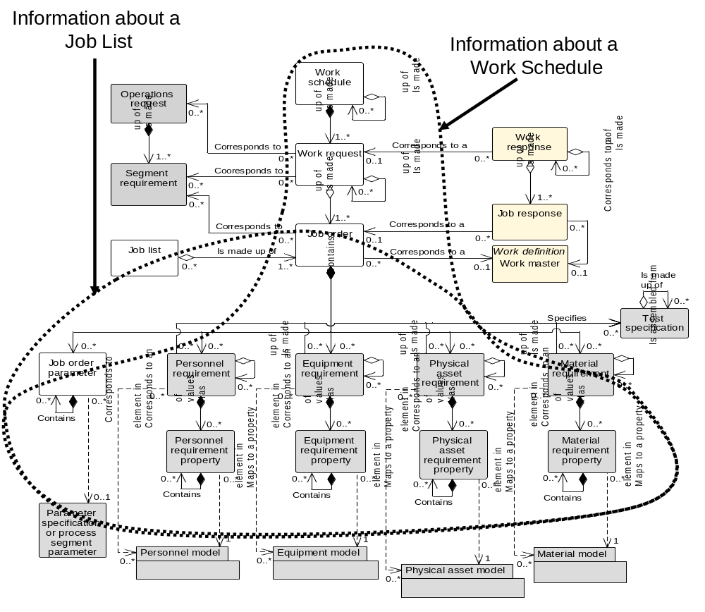
Figure 34 – Object grouping for the work schedule model

Work schedule verbs
All verbs shall be valid for a Work Schedule noun.

Work schedule verb actions
The actions performed on a Work Schedule noun are defined in Table 50.
Table 50 – Work Schedule verb actions
Work Schedule ID | Verb action on noun
IDs specified | GET: Shall define a request that the receiver is to return, in a SHOW message, all attributes and subobjects of a Work Schedule. See Table 52 for additional selection criteria.  PROCESS: Shall define a request that the receiver is to add Work Schedules. The message defines suggested IDs for the Work Schedules, values for the attributes and subobjects. The receiver adds the Work Schedules and assigns IDs. The assigned IDs shall be returned in the ACKNOWLEDGE message.  CHANGE: Shall define a request that the receiver is to change the specified attributes and subobjects of the Work Schedules. The assumption is the new Work Schedule is the complete type definition and that the previous Work Schedule is canceled and the new Work Schedule is added. .A RESPOND message may be used to communicate agreement, disagreement, or changes made to the CHANGE message data.  CANCEL: Shall define a request that the receiver is to cancel the specified Work Schedules.  SYNC ADD: Shall define a request that the receiver is to add the specified Work Schedules, attributes and subobjects.  SYNC CHANGE: Shall define a request that the receiver is to change the specified attributes and subobjects of the Work Schedules. The assumption is the new Work Schedule is the complete type definition and that the previous Work Schedule is deleted and the new Work Schedule is added.  SYNC DELETE: Shall define a request that the receiver is to delete the specified Work Schedules.  NOTIFY: Shall define the creation of a new Work Schedule.
<not specified> | GET: Error.  PROCESS: Error.  CHANGE: Error.  CANCEL: Error.  SYNC ADD: Error.  SYNC CHANGE: Error.  SYNC DELETE: Error.  NOTIFY: Error.
Wildcard specified | GET: Shall define a request that the receiver is to return, in a SHOW message, all attributes and subobjects about all Work Schedules identified by the wildcard. See Table 52 for additional selection criteria.  PROCESS: Error.  CHANGE: Error.  CANCEL: Shall define a request that the receiver is to cancel all Work Schedules matching the wildcard.  SYNC ADD: Error.  SYNC CHANGE: Error.  SYNC DELETE: Shall define a request that the receiver is to delete all Work Schedules matching the wildcard.  NOTIFY: Error.

Job list verbs
All verbs shall be valid for a Job List noun.

Job list verb actions
The actions performed on a Job List noun are defined in Table 51.
Table 51 – Job List verb actions
Job List ID | Verb action on noun
IDs specified | GET: Shall define a request that the receiver is to return, in a SHOW message, all attributes and subobjects of a Job List. See Table 52 for additional selection criteria.  PROCESS: Shall define a request that the receiver is to add Job Lists. The message defines suggested IDs for the Job Lists, values for the attributes and subobjects. The receiver adds the Job Lists and assigns IDs. The assigned IDs shall be returned in the ACKNOWLEDGE message.  CHANGE: Shall define a request that the receiver is to change the specified attributes and subobjects of the Job Lists. The assumption is the new Job List is the complete type definition and that the previous Job List is cancelled and the new Job List is added. A RESPOND message may be used to communicate agreement, disagreement, or changes made to the CHANGE message data.  CANCEL: Shall define a request that the receiver is to cancel the specified Job Lists.  SYNC ADD: Shall define a request that the receiver is to add the specified Job Lists, attributes and subobjects.  SYNC CHANGE: Shall define a request that the receiver is to change the specified attributes and subobjects of the Job Lists. The assumption is the new Job List is the complete type definition and that the previous Job List is cancelled and the new Job List is added.  SYNC DELETE: Shall define a request that the receiver is to delete the specified Job Lists.  NOTIFY: Shall define the creation of a new Job List.
<not specified> | GET: Error.  PROCESS: Error.  CHANGE: Error.  CANCEL: Error.  SYNC ADD: Error.  SYNC CHANGE: Error.  SYNC DELETE: Error.  NOTIFY: Error.
Wildcard specified | GET: Shall define a request that the receiver is to return, in a SHOW message, all attributes and subobjects about all Job Lists identified by the wildcard. See Table 52 for additional selection criteria.  PROCESS: Error.  CHANGE: Error.  CANCEL: Shall define a request that the receiver is to cancel all Job Lists matching the wildcard.  SYNC ADD: Error.  SYNC CHANGE: Error.  SYNC DELETE: Shall define a request that the receiver is to delete all Job Lists matching the wildcard.  NOTIFY: Error.

Table 52 – Work Schedule and Job List element definitions for GET verb
Work Alert Element | Returns
Work Type | Specifies either the Work Schedule or Job List information with Work Types that match the specified work type. If not specified then the responder selects the Work Types.
Start Time | Specifies either Work Schedule or Job List information with Start Times after, and including the start time. If not specified then the responder selects the Start Time.
End Time | Specifies either Work Schedule or Job List information with End Times before, and including, the end time. If not specified then the responder selects the End Time.
Hierarchy Scope | Specifies either the Work Schedule or Job List information with Start Times for the specified scope in the role based equipment hierarchal. (e.g. A process cell, work center, production line, area, site, …). If not specified then the responder selects the Hierarchy Scope.

Work performance model

Work performance elements
The message definitions assume that Work Performance information may be accessed from three starting points; a Work Performance, a Job Response List, and a Job Response as identified by the dotted collections in Figure 35.
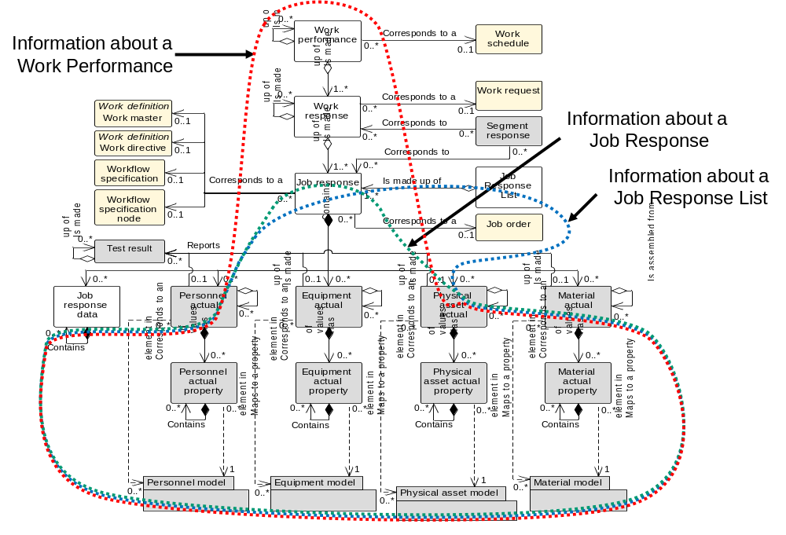
Figure 35 – Object grouping for the work performance model

Work performance verbs
All verbs shall be valid for a Work Performance noun.

Work performance verb actions
The actions performed on a Work Performance noun are defined in Table 53. The additional attributes for the GET verb for Work Performance are defined in Table 54.
Table 53 – Work performance verb actions
Work Performance ID | Verb action on noun
IDs specified | GET: Shall define a request that the receiver is to return, in a SHOW message, all attributes and subobjects of a Work Performance. See Table 58 for additional selection criteria.  PROCESS: Shall define a request that the receiver is to add Work Performances. The message defines suggested IDs for the Work Performances, values for the attributes and subobjects. The receiver adds the Work Performances and assigns IDs. The assigned IDs shall be returned in the ACKNOWLEDGE message.  CHANGE: Shall define a request that the receiver is to change the specified attributes and subobjects of the Work Performances. The assumption is the new Work Performance is the complete type definition and that the previous Work Performance is cancelled and the new Work Performance is added. A RESPOND message may be used to communicate agreement, disagreement, or changes made to the CHANGE message data.  CANCEL: Shall define a request that the receiver is to cancel the specified Work Performances.  SYNC ADD: Shall define a request that the receiver is to add the specified Work Performances, attributes and subobjects.  SYNC CHANGE: Shall define a request that the receiver is to change the specified attributes and subobjects of the Work Performances. The assumption is the new Work Performance is the complete type definition and that the previous Work Performance is deleted and the new Work Performance is added.  SYNC DELETE: Shall define a request that the receiver is to delete the specified Work Performances.  NOTIFY: Shall define the creation of a new Work Performance.
<not specified> | GET: Error.  PROCESS: Error.  CHANGE: Error.  CANCEL: Error.  SYNC ADD: Error.  SYNC CHANGE: Error.  SYNC DELETE: Error.  NOTIFY: Error.
Wildcard specified | GET: Shall define a request that the receiver is to return, in a SHOW message, all attributes and subobjects about all Work Performances identified by the wildcard. See Table 58 for additional selection criteria.  PROCESS: Error.  CHANGE: Error.  CANCEL: Shall define a request that the receiver is to cancel all Work Performances matching the wildcard.  SYNC ADD: Error.  SYNC CHANGE: Error.  SYNC DELETE: Shall define a request that the receiver is to delete all Work Performances matching the wildcard.  NOTIFY: Error.

Table 54 – Work performance element definitions for GET verb
Work Performance Element | Returns
Work Type | Specifies Work Performance information with Work Types that match the specified work type. If not specified then the responder selects the Work Types.
Start Time | Specifies Work Performance information with Start Times after, and including the start time. If not specified then the responder selects the Start Time.
End Time | Specifies Work Performance information with End Times before, and including, the end time. If not specified then the responder selects the End Time.
Hierarchy Scope | Specifies Work Performance information with Start Times for the specified scope in the role based equipment hierarchal. (e.g. A process cell, work center, production line, area, site, …). If not specified then the responder selects the Hierarchy Scope.

Job response verbs
All verbs shall be valid for a Job Response noun.

Job response verb actions
The actions performed on a Job Response noun are defined in Table 55. The additional attributes for the GET verb for Job Response are defined in Table 56.
Table 55 – Job response verb actions
Job Response ID | Verb action on noun
IDs specified | GET: Shall define a request that the receiver is to return, in a SHOW message, all attributes and subobjects of a Job Response. See Table 58 for additional selection criteria.  PROCESS: Shall define a request that the receiver is to add Job Responses. The message defines suggested IDs for the Job Responses, values for the attributes and subobjects. The receiver adds the Job Responses and assigns IDs. The assigned IDs shall be returned in the ACKNOWLEDGE message.  CHANGE: Shall define a request that the receiver is to change the specified attributes and subobjects of the Job Responses. The assumption is the new Job Response is the complete type definition and that the previous Job Response is cancelled and the new Job Response is added. A RESPOND message may be used to communicate agreement, disagreement, or changes made to the CHANGE message data.  CANCEL: Shall define a request that the receiver is to cancel the specified Job Responses.  SYNC ADD: Shall define a request that the receiver is to add the specified Job Responses, attributes and subobjects.  SYNC CHANGE: Shall define a request that the receiver is to change the specified attributes and subobjects of the Job Responses. The assumption is the new Job Response is the complete type definition and that the previous Job Response is deleted and the new Job Response is added.  SYNC DELETE: Shall define a request that the receiver is to delete the specified Job Responses.  NOTIFY: Shall define the creation of a new Job Response.
<not specified> | GET: Error.  PROCESS: Error.  CHANGE: Error.  CANCEL: Error.  SYNC ADD: Error.  SYNC CHANGE: Error.  SYNC DELETE: Error.  NOTIFY: Error.
Wildcard specified | GET: Shall define a request that the receiver is to return, in a SHOW message, all attributes and subobjects about all Job Responses identified by the wildcard. See Table 58 for additional selection criteria.  PROCESS: Error.  CHANGE: Error.  CANCEL: Shall define a request that the receiver is to cancel all Job Responses matching the wildcard.  SYNC ADD: Error.  SYNC CHANGE: Error.  SYNC DELETE: Shall define a request that the receiver is to delete all Job Responses matching the wildcard.  NOTIFY: Error.

Table 56 – Job response element definitions for GET verb
Work Performance Element | Returns
Work Type | Specifies Job Response information with Work Types that match the specified work type. If not specified then the responder selects the Work Types.
Start Time | Specifies Job Response information with Start Times after, and including the start time. If not specified then the responder selects the Start Time.
End Time | Specifies either Job Response information with End Times before, and including, the end time. If not specified then the responder selects the End Time.
Hierarchy Scope | Specifies Job Response information with Start Times for the specified scope in the role based equipment hierarchal. (e.g. A process cell, work center, production line, area, site, …). If not specified then the responder selects the Hierarchy Scope.

Job response list verbs
All verbs shall be valid for a Job Response List noun.

Job response list verb actions
The actions performed on a Job Response List noun are defined in Table 57. The additional attributes for the GET verb for Job Response List are defined in Table 58.
Table 57 – Job response list verb actions
Job Response List ID | Verb action on noun
IDs specified | GET: Shall define a request that the receiver is to return, in a SHOW message, all attributes and subobjects of a Job Response List. See Table 58 for additional selection criteria.  PROCESS: Shall define a request that the receiver is to add Job Responses. The message defines suggested IDs for the Job Responses, values for the attributes and subobjects. The receiver adds the Job Responses and assigns IDs. The assigned IDs shall be returned in the ACKNOWLEDGE message.  CHANGE: Shall define a request that the receiver is to change the specified attributes and subobjects of the Job Responses. The assumption is the new Job Response is the complete type definition and that the previous Job Response is cancelled and the new Job Response is added. A RESPOND message may be used to communicate agreement, disagreement, or changes made to the CHANGE message data.  CANCEL: Shall define a request that the receiver is to cancel the specified Job Responses.  SYNC ADD: Shall define a request that the receiver is to add the specified Job Responses, attributes and subobjects.  SYNC CHANGE: Shall define a request that the receiver is to change the specified attributes and subobjects of the Job Responses. The assumption is the new Job Response is the complete type definition and that the previous Job Response is deleted and the new Job Response is added.  SYNC DELETE: Shall define a request that the receiver is to delete the specified Job Responses.  NOTIFY: Shall define the creation of a new Job Response.
<not specified> | GET: Error.  PROCESS: Error.  CHANGE: Error.  CANCEL: Error.  SYNC ADD: Error.  SYNC CHANGE: Error.  SYNC DELETE: Error.  NOTIFY: Error.
Wildcard specified | GET: Shall define a request that the receiver is to return, in a SHOW message, all attributes and subobjects about all Job Responses identified by the wildcard. See Table 58 for additional selection criteria.  PROCESS: Error.  CHANGE: Error.  CANCEL: Shall define a request that the receiver is to cancel all Job Responses matching the wildcard.  SYNC ADD: Error.  SYNC CHANGE: Error.  SYNC DELETE: Shall define a request that the receiver is to delete all Job Responses matching the wildcard.  NOTIFY: Error.

Table 58 – Job response list element definitions for GET verb
Job Response List Element | Returns
Work Type | Specifies Job Response List information with Work Types that match the specified work type. If not specified then the responder selects the Work Types.
Start Time | Specifies Job Response List information with Start Times after, and including the start time. If not specified then the responder selects the Start Time.
End Time | Specifies either Job Response List information with End Times before, and including, the end time. If not specified then the responder selects the End Time.
Hierarchy Scope | Specifies Job Response List information with Start Times for the specified scope in the role based equipment hierarchal. (e.g. A process cell, work center, production line, area, site, …). If not specified then the responder selects the Hierarchy Scope.

Workflow specification model

Workflow specification elements
The message definitions assume that Workflow Specification information may be accessed from two starting points; a Workflow Specification and a Workflow Specification Type, as identified by the dotted collection in Figure 36.
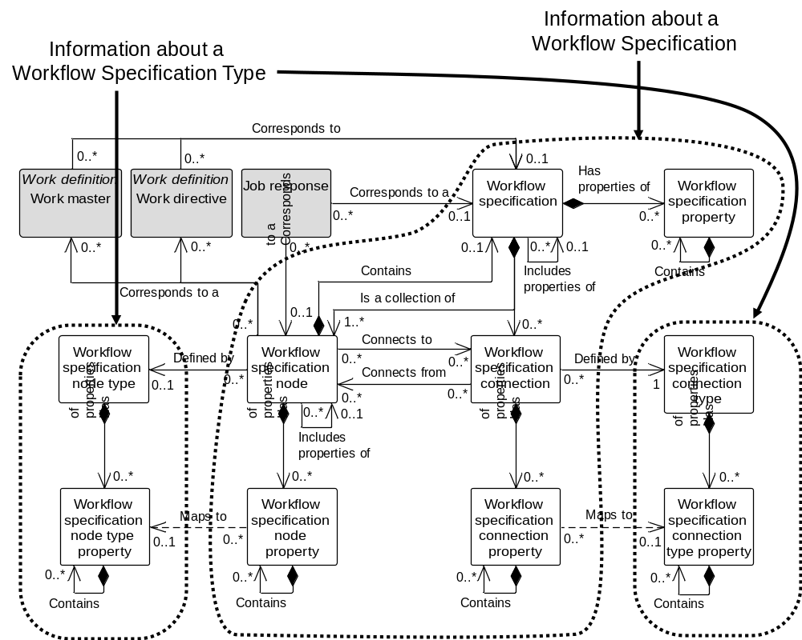
Figure 36 – Object grouping for the workflow specification model

Workflow specification verbs
All verbs shall be valid for a Workflow Specification noun.

Workflow specification verb actions
The actions performed on a Workflow Specification noun are defined in Table 59.
Table 59 – Workflow Specification verb actions
Workflow Specification ID | Verb action on noun
IDs specified | GET: Shall define a request that the receiver is to return, in a SHOW message, all attributes and subobjects of Workflow Specification.  PROCESS: Shall define a request that the receiver is to add Workflow Specification. The message defines suggested IDs for the Workflow Specification, values for the attributes and subobjects. The receiver adds the Workflow Specification and assigns IDs. The assigned IDs shall be returned in the ACKNOWLEDGE message.  CHANGE: Shall define a request that the receiver is to change the specified attributes and subobjects of the Workflow Specification. The assumption is the new Workflow Specification is the complete definition and that the previous Workflow Specification is canceled and the new Workflow Specification is added. A RESPOND message may be used to communicate agreement, disagreement, or changes made to the CHANGE message data.  CANCEL: Shall define a request that the receiver is to cancel the specified Workflow Specifications.  SYNC ADD: Shall define a request that the receiver is to add the specified Workflow Specifications, attributes and subobjects.  SYNC CHANGE: Shall define a request that the receiver is to change the specified attributes and subobjects of the Workflow Specifications. The assumption is the new Workflow Specification is the complete definition and that the previous Workflow Specification is deleted and the new Workflow Specification is added  SYNC DELETE: Shall define a request that the receiver is to delete the specified Workflow Specifications.  NOTIFY: Shall define the creation of a new Workflow Specification.
<not specified> | GET: Error.  PROCESS: Error.  CHANGE: Error.  CANCEL: Error.  SYNC ADD: Error.  SYNC CHANGE: Error.  SYNC DELETE: Error.  NOTIFY: Error.
Wildcard specified | GET: Shall define a request that the receiver is to return, in a SHOW message, all attributes and subobjects about all Workflow Specifications identified by the wildcard.  PROCESS: Error.  CHANGE: Error.  CANCEL: Shall define a request that the receiver is to cancel all Workflow Specifications matching the wildcard.  SYNC ADD: Error.  SYNC CHANGE: Error.  SYNC DELETE: Shall define a request that the receiver is to delete all Workflow Specifications matching the wildcard.  NOTIFY: Error.

Workflow specification type
A Workflow Specification Type shall be defined as a collection of Workflow Specification Node Types and Workflow Specification Connection Types, with an attribute of ID, for purposes of supporting transactions.

Workflow specification type verbs
All verbs shall be valid for a Workflow Specification Type noun. A Workflow Specification Type is a combination of Workflow Specification Node Types and Workflow Specification Connection Types.

Workflow specification type verb actions
The actions performed on a Workflow Specification Type noun are defined in Table 60.
Table 60 – Workflow Specification Type verb actions
Workflow Specification Type ID | Verb action on noun
IDs specified | GET: Shall define a request that the receiver is to return, in a SHOW message, all attributes and subobjects of a Workflow Specification Type.  PROCESS: Shall define a request that the receiver is to add Workflow Specification Type. The message defines suggested IDs for the Workflow Specification Type, values for the attributes and subobjects. The receiver adds the Workflow Specification Type and assigns IDs. The assigned IDs shall be returned in the ACKNOWLEDGE message.  CHANGE: Shall define a request that the receiver is to change the specified attributes and subobjects of the Workflow Specification Type. The assumption is the new Workflow Specification Type is the complete definition and that the previous Workflow Specification Type is canceled and the new Workflow Specification Type is added. A RESPOND message may be used to communicate agreement, disagreement, or changes made to the CHANGE message data.  CANCEL: Shall define a request that the receiver is to cancel the specified Workflow Specification Type.  SYNC ADD: Shall define a request that the receiver is to add the specified Workflow Specification Type, attributes and subobjects.  SYNC CHANGE: Shall define a request that the receiver is to change the specified attributes and subobjects of the Workflow Specification Types. The assumption is the new Workflow Specification Type is the complete definition and that the previous Workflow Specification Type is deleted and the new Workflow Specification Type is added  SYNC DELETE: Shall define a request that the receiver is to delete the specified Workflow Specification Types.  NOTIFY: Shall define the creation of a new Workflow Specification Type.
<not specified> | GET: Error.  PROCESS: Error.  CHANGE: Error.  CANCEL: Error.  SYNC ADD: Error.  SYNC CHANGE: Error.  SYNC DELETE: Error.  NOTIFY: Error.
Wildcard specified | GET: Shall define a request that the receiver is to return, in a SHOW message, all attributes and subobjects about all Workflow Specification Types identified by the wildcard.  PROCESS: Error.  CHANGE: Error.  CANCEL: Shall define a request that the receiver is to cancel all Workflow Specification Types matching the wildcard.  SYNC ADD: Error.  SYNC CHANGE: Error.  SYNC DELETE: Shall define a request that the receiver is to delete all Workflow Specification Types matching the wildcard.  NOTIFY: Error.

Transaction Profile
A transaction profile contains a definition of the verb and noun combinations supported by an application. The transaction profile provides a method for applications to query another application to determine the verb-noun combinations it supports. A transaction profile is itself a noun. Applications supporting this standard shall support use of the GET and SHOW verbs with transaction profiles. The objects for a transaction profile exchange are identified by the dotted collection in Figure 37.
NOTE The transaction profile information can also be exchanged at application setup time. The mechanism for accomplishing the exchange at setup time is not defined in this part.
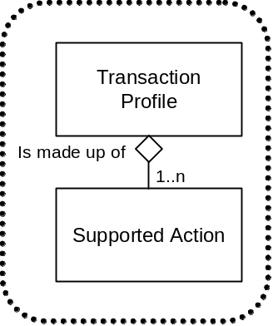
Figure 37 – Transaction profile model
A transaction profile is a container object. A transaction profile is made up of 1 or more supported actions. Each supported action documents a single verb-noun combination supported by an application. Table 61 lists the attributes of a Transaction Profile.
Table 61 – Attributes of Transaction Profile
Attribute Name | Description | Examples
ID | A unique identification of a transaction profile. | 77262
Description | Optional description of the transaction profile. | From Ajax

Table 62 lists the attributes of a supported action.
Table 62 – Attributes of Supported Action
Attribute Name | Description | Examples
ID | A unique identification of a supported action. | 77262
Verb | Identifies the verb in the verb-noun action.  Valid values are: GET, PROCESS, CHANGE, CANCEL, SYNC ADD, SYNC CHANGE, SYNC DELETE, and NOTIFY. | PROCESS  SYNC ADD
Noun | Identifies the noun in the verb-noun action. | MATERIAL LOT  OPERATIONS SCHEDULE
Information User | Indicates if the application can act as an information user.  NOTE 1 This is defined for only GET, NOTIFY and SYNC messages. | TRUE  FALSE
Information Provider | Indicates if the application can act as an information provider.  NOTE 2 This is defined for only GET, NOTIFY and SYNC messages | TRUE  FALSE
Information Sender | Indicates if the application can act as an information Sender.  NOTE 3 This is defined for PROCESS, CHANGE, and CANCEL messages. | TRUE  FALSE
Information Receiver | Indicates if the application can act as an information Receiver.  NOTE 4 This is defined for only PROCESS, CHANGE, and CANCEL messages | TRUE  FALSE
Object Wildcards Supported | Indicates if wildcards are supported for object identification. | TRUE  FALSE
Property Wildcards Supported | Indicates if wildcards are supported for property identification.  NOTE 5 Wildcard properties are not defined for all verb-noun combinations. | TRUE  FALSE

The GET verb shall be valid for a transaction profile noun.
Table 63 defines the action for each verb.
Table 63 – Transaction Profile verb actions
Verb | Action on Object(s) Specified
GET | Shall define a request that the receiver is to return, in a SHOW message, all supported verb/noun combinations and the attributes used to define the combinations.
PROCESS | Error
CHANGE | Error
CANCEL | Error
SYNC ADD | Error
SYNC CHANGE | Error
SYNC DELETE | Error
NOTIFY | Error

Completeness, compliance and conformance

Completeness
The number of transactions supported, as defined in Table 64 shall determine the degree of completeness of a specification or application.

Compliance
Any assessment of the degree of compliance of a specification shall be qualified by the following:
- the use of the terminology defined in this part;
- the use of the protocol for each supported transaction;
- a statement of the degree to which they then conform partially or totally to definitions and transaction names.
In the event of partial compliance, areas of non-compliance shall be explicitly identified.

Conformance
Any assessment of the degree of conformance of an application shall be qualified by the following:
- documentation of the transactions, as listed in Table 8 through Table 34,
- documentation of the transaction rules conformed to.
In the event of partial conformance, areas of non-conformance shall be explicitly identified.
Suppliers of applications shall use Table 64 or an equivalent to document their supported transactions.
Suppliers of applications shall document if the application can perform the role of the information user, if the application can perform the role of the information provider, if the application can perform the role of information sender, and if the application can perform the role of information receiver.
Suppliers shall document their support for wildcards in the appropriate transactions.
Table 64 – Supported verb-noun actions
Verb  Noun | GET, SHOW | PROCESS, ACKNOWLEDGE | CHANGE, RESPOND | CANCEL | SYNC ADD | SYNC CHANGE | SYNC DELETE | NOTIFY
Hierarchy Scope
Personnel Class
Person
Qualification Test
Equipment Class
Equipment
Capability Test
Physical Asset Class
Physical Asset
Physical Asset Test
Material Class
Material Definition
Material Lot
Material Sublot
Material Test
Operational Location Class
Operational Location
Process Segment
Operations Event Class
Operations Event Definition
Operations Event
Operations Capability
Operations Definition
Operations Schedule
Operations Performance
Resource Relationship Network
Work Definition
Work Specification
Work Schedule
Work Performance
Work Capability
Work Alerts
Work Calendar Definition
Work Calendar
Work Record
Job List
Job Response
Transaction Profile

NOTE 1 ISA-95.00.02 Clause 5 defines how to document conformance for the specific objects and attributes supported.
NOTE 2 The bands in Table 64 indicate related sets of nouns. It is likely that applications that support one noun in a set will support the other nouns in the set.
Example Table 65 is an example of a hypothetical vendor offering that supports exchanges about material information. The example application can act as user or provider of the data for PUSH and PULL transactions but only as a user (subscriber) for PUBLISH transactions.
Table 65 – Vendor conformance example
Verb  Noun | GET, SHOW | PROCESS,  ACKN OWLEDGE | CHANGE, RESPOND | CANCEL | SYNC ADD | SYNC CHANGE | SYNC DELETE
Material Class | User, Provider,  Object wildcard,  Property wildcard | Sender, Receiver | Sender, Receiver,  Object wildcard,  Property wildcard | Sender, Receiver,  Object wildcard,  Property wildcard | User | User | User
Material Definition | User, Provider,  Object wildcard,  Property wildcard | Sender, Receiver | Sender, Receiver,  Object wildcard,  Property wildcard | Sender, Receiver,  Object wildcard,  Property wildcard | User | User | User
Material Lot | User, Provider,  Object wildcard,  Property wildcard | Sender, Receiver | Sender, Receiver,  Object wildcard,  Property wildcard | Sender, Receiver,  Object wildcard,  Property wildcard | User | User | User
Material Sublot | User, Provider,  Object wildcard,  Property wildcard | Sender, Receiver | Sender, Receiver,  Object wildcard,  Property wildcard | Sender, Receiver,  Object wildcard,  Property wildcard | User | User | User
Material Test | User, Provider,  Object wildcard,  Property wildcard | Sender, Receiver | Sender, Receiver,  Object wildcard,  Property wildcard | Sender, Receiver,  Object wildcard,  Property wildcard | User | User | User
Transaction Profile | Provider
- – (Informative) Transaction models and business scenario examples
  - Coordinating activities
Figure 38 shows a typical set of correlated transactions to coordinate activities for production planning & scheduling and manufacturing operations that may be implemented using various transactions defined in this part of the standard.
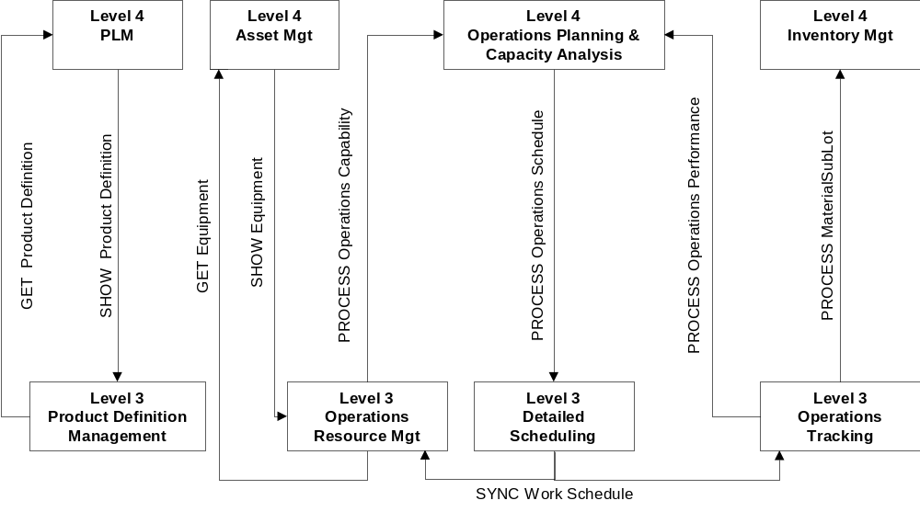
Figure 38 – Coordinating planning and operations processes
Business process assumptions:
- Master product definition information is contained in a Level 4 PLM (Product Lifecycle Management) application.
- Level 3 Production Definition Management obtains current routing / recipe information from the PLM application by using a Get Production Definition / Show Production Definition transaction set.
- Master equipment information is contained in a Level 4 Asset Management application.
- Level 3 Production Resource Management obtains equipment information from the asset management application using a Get Equipment / Show Equipment transactions set.
- A level 4 application manages Production Planning and Capacity Analysis activities.
- Level 3 Production Resource Management manages production capability information.
- Level 3 Production Resource Management pushes production capability information to the Level 4 Production Planning and Capacity Analysis application.
- The level 4 Production Planning and Capacity Analysis application pushes the production schedule information to Level 3 Detailed Scheduling using a Process Production Schedule transaction.
- Level 3 Production Tracking pushes production performance information (material produced and resources used) to Production Planning and Capacity Analysis using a Process Production Performance transaction and pushes material sublot information to a Level 4 Inventory Management application using a Process Material Sublot transaction.
- The Level 3 detailed scheduling application publishes work schedules that are used in Level 3 resource management and tracking applications.
  - Usage scenarios
The following sections define typical usage scenarios that could be implemented using the transactions defined in this part of the standard. The scenarios are based on the coordinating processes model of Clause B.1. The scenarios combine a set of transactions.
ERP (Enterprise Resource Planning) represents a typical Level 4 business system in these scenarios. MOM (Manufacturing Operations Management) represents a typical Level 3 manufacturing system. The arrows indicate a message between the applications.
  - Operations schedule and operations performance
    - Push Model
Scenario assumptions:
- ERP pushes an operations schedule to MOM for processing when schedules are released.
- MOM pushes an operations performance to ERP for processing as work is completed.
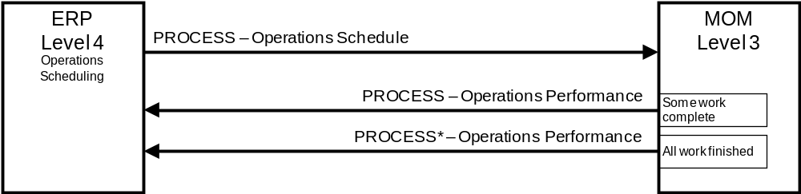
Figure 39 – Push model; operations schedule and operations performance
* The last PROCESS operations performance message contains a flag to indicate that the message is the final operations performance for the associated operations schedule.
    - Pull model
Scenario assumptions:
- MOM requests operations schedules from ERP on a regular schedule.
- ERP requests operations performance from MOM on a regular schedule.
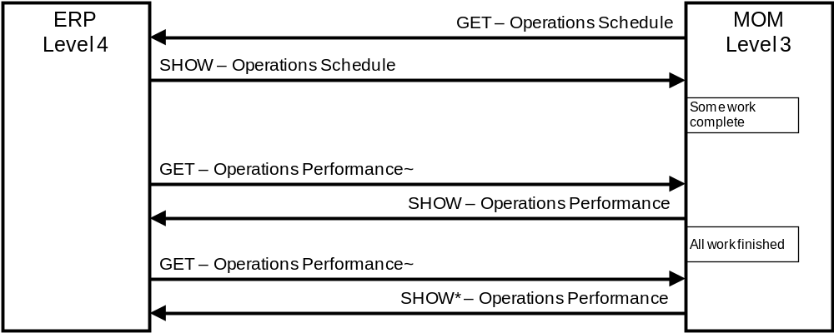
Figure 40 – Pull model; operations schedule and operations performance
~ The GET operations performance message contains an identification of an operations schedule (Operations Performance / Operations Schedule ID)
* The last SHOW operations performance message contains a flag to indicate that the message is the final operations performance for the associated operations schedule.
    - Publish model
      - Data synchronization example
Scenario assumptions:
- MOM subscribes to operations schedules.
- ERP subscribes to operations performances.
- ERP publishes operations schedule.
- MOM publishes initial operations performance with a SYNC ADD message.
- MOM publishes subsequent operations performances for the schedule with SYNC CHANGE messages.
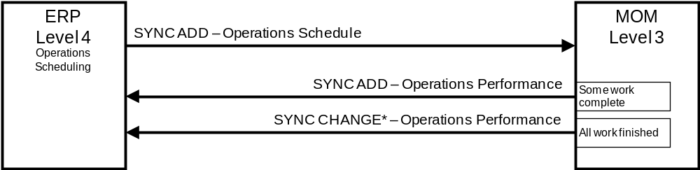
Figure 41 – Publish Model; operations schedule and operations performance
* The last SYNC CHANGE message contains a flag to indicate that the message is the final operations performance for the associated operations schedule.
      - Event notification example
Scenario assumptions for an EDA implementation:
- Detailed scheduling, execution management and data collection subscribe to work scheduling.
- Detailed scheduling publishes an event ‘Work Scheduled’
- Execution Management publishes a ‘Resources Acquired’ event when resources are available and work has started.
- Data collection logs all the events for subsequent analysis activities.
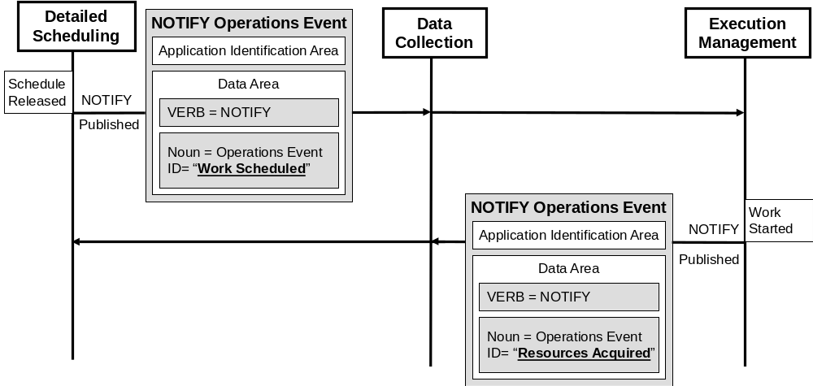
Figure 42 - Publish notifications of Work Scheduling Operations Events
  - Operations schedule changes
    - Push model
Scenario assumptions:
- ERP sends operations schedule to MOM for processing.
- MOM sends operations performance to ERP for processing.
- ERP makes change to schedule and sends to MOM for processing.
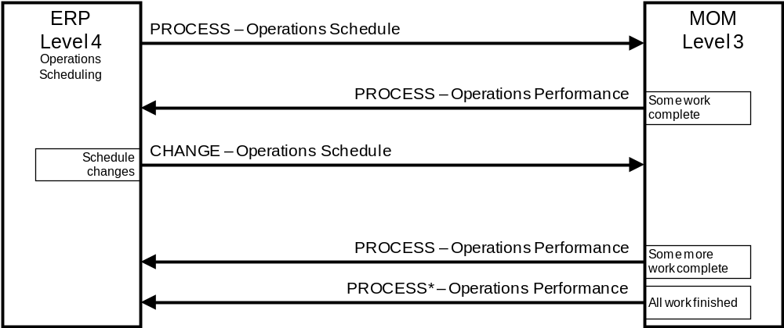
Figure 43 – Push Model; Operations schedule changes
* The last PROCESS operations performance message contains a flag to indicate that the message is the final operations performance for the associated operations schedule.
    - Publish model
Scenario assumptions:
- MOM subscribes to operations schedules.
- ERP subscribes to operations performances.
- ERP publishes operations schedule.
- MOM publishes initial operations performance with a SYNC ADD message.
- ERP changes schedule and republishes with SYNC CHANGE.
- MOM publishes subsequent operations performances for the schedule with SYNC CHANGE messages.
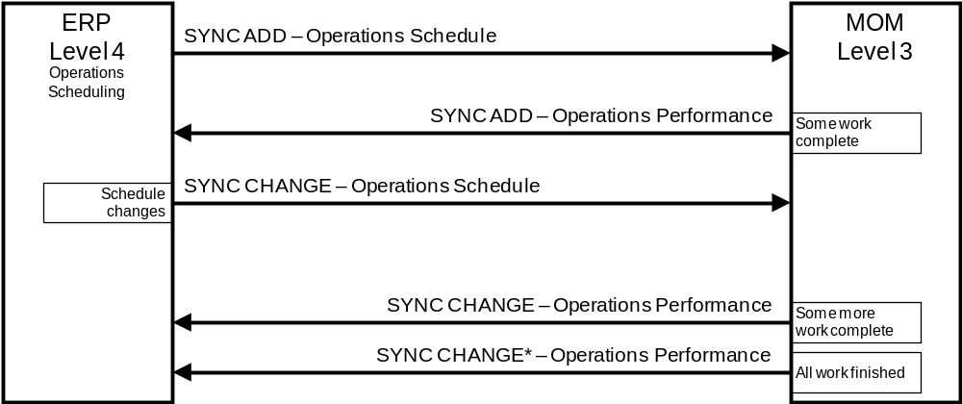
Figure 44 – Publish model: v schedule changes
* The last SYNC CHANGE message contains a flag to indicate that the message is the final operations performance for the associated operations schedule.
  - Operations schedule cancelled
    - Push model
Scenario assumptions:
- ERP sends operations schedule to MOM for processing.
- ERP cancels schedule before actual operations start, and sends CANCEL of schedule to MOM.
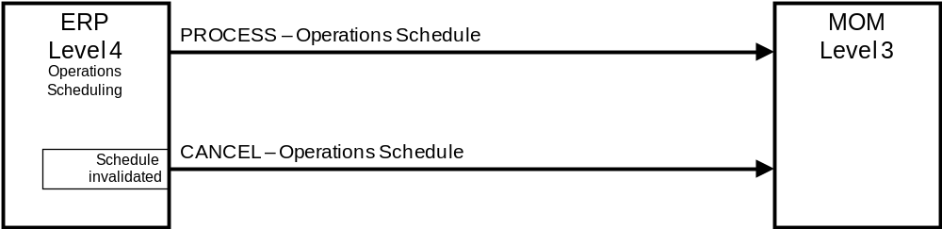
Figure 45 – Push model; operations schedule cancelled
    - Push and pull model
Scenario assumptions:
- MOM requests operations schedule from ERP.
- ERP cancels schedule before actual operations start, and sends CANCEL of schedule to MOM.
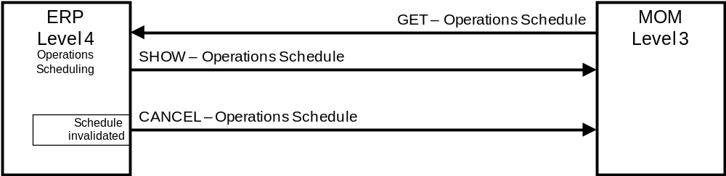
Figure 46 – Push and pull model; schedule cancelled
  - Daily operations performance
    - Push model
Scenario assumptions:
- MOM sends daily operations performance to ERP
- The scope of the operations performance (which production lines, etc…) and timing of the publication (daily, weekly, time published) is not defined in a message. It is determined to in an out-of-band agreement.
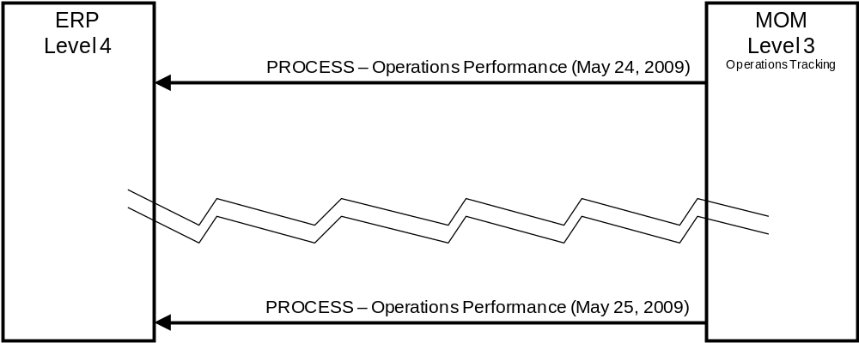
Figure 47 – Push model; daily operations performance
    - Pull model
Scenario assumptions:
- ERP requests operations performance from MOM on a daily schedule
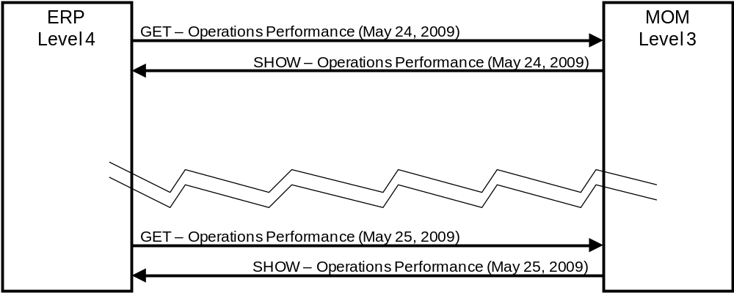
Figure 48 – Pull model; daily operations performance
    - Publish model
Scenario assumptions:
- ERP subscribes to daily operations performance from MOM
- MOM publishes daily operations performance
- Scope of operations performance (which production lines, etc…) and timing of the publication (daily, weekly, time published) is not defined in a message. It is determined to in an out-of-band agreement.
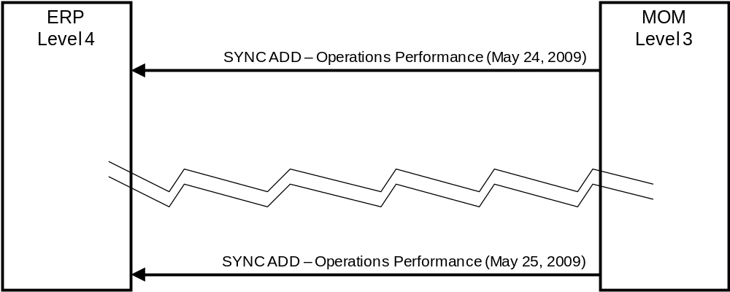
Figure 49 – Publish model; daily operations schedule
  - Operations schedule based on operations capability
    - Pull and push model
Scenario assumptions:
- ERP requests operations capability for the planning period.
- MOM responds with an operations capability to ERP.
- ERP sends operations schedule to MOM for processing.
- MOM sends operations performance to ERP reflecting partial order completion.
- MOM sends operations performance to ERP reflecting partial order completion.
- MOM sends operations performance to ERP reflecting completion of order.
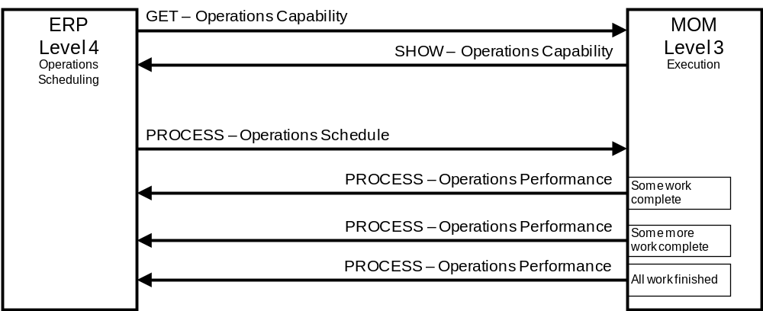
Figure 50 – Pull and push model; operations capability and operations schedule
    - Publish and push model
Scenario assumptions:
- 1. ERP subscribes to operations capability.
- 2. MOM subscribes to operations schedules.
- 3. MOM publishes operations capability on a regular schedule, e.g. every 2 days,
- 4. ERP generates an operations schedule and publishes it.
- 5. MOM sends operations performance to ERP reflecting partial order completion.
- 6. MOM sends operations performance to ERP reflecting partial order completion.
- 7. MOM sends operations performance to ERP reflecting completion of order.
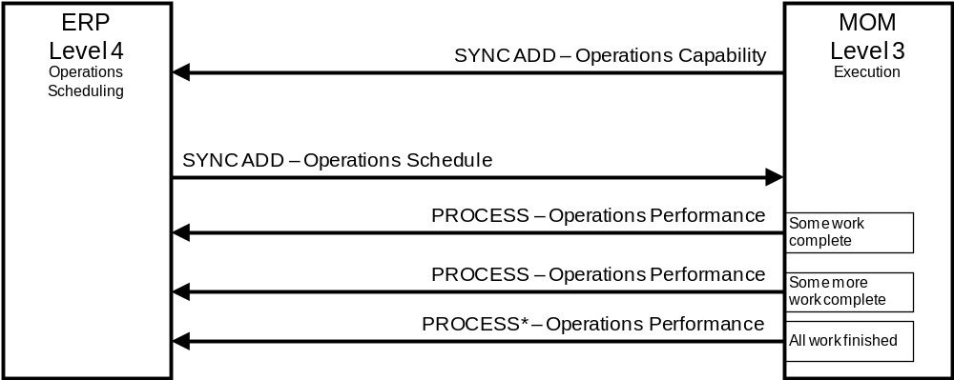
Figure 51 – Publish and push model; operations capability and operations schedule
* The last PROCESS message contains a flag to indicate that the message is the final operations performance for the associated operations schedule.
  - Operations schedule changes
    - Push and pull model
Scenario assumptions:
- ERP sends operations schedule to MOM for processing.
- MOM sends operations performance to ERP for processing.
- ERP requests operations capability from MOM.
- MOM responds with an operations capability to ERP.
- ERP makes change to the operations schedule and sends to MOM for processing.
- MOM sends operations performance to ERP reflecting partial order completion.
- MOM sends operations performance to ERP reflecting completion of order.
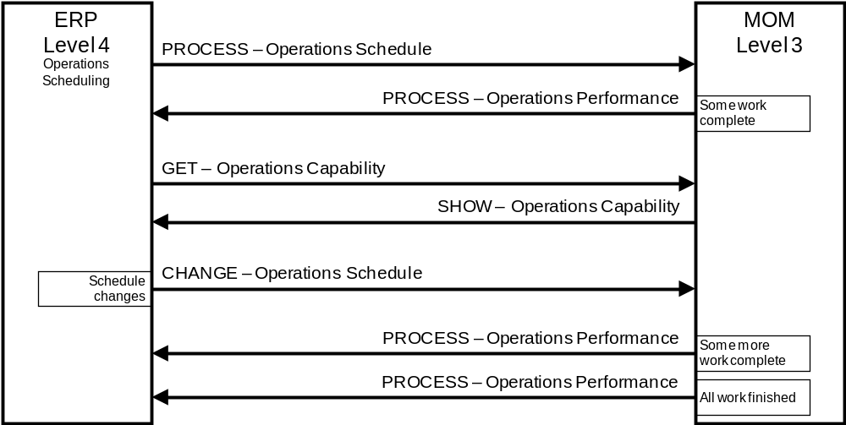
Figure 52 – Push and pull model; schedule changes
    - Publish model
Scenario assumptions:
- MOM subscribes to operations schedules.
- ERP subscribes to operations performances.
- ERP publishes operations schedule.
- MOM publishes initial operations performance with a SYNC ADD message.
- ERP changes the schedule based on initial work done and republished with a SYNC CHANGE.
- MOM publishes subsequent operations performances for the schedule with SYNC CHANGE messages.
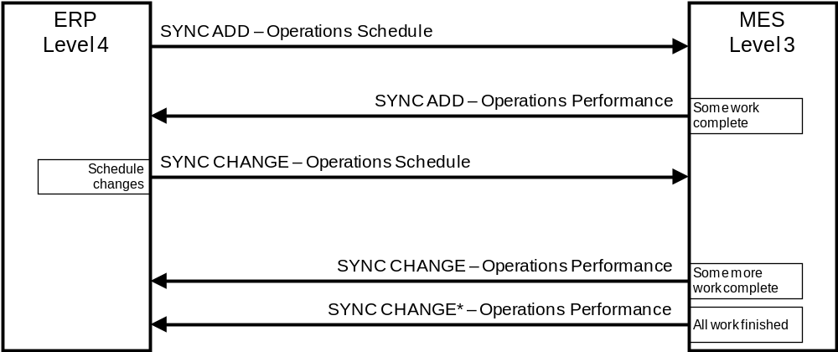
Figure 53 – Publish model; schedule changes after capability changes
* The last SYNC CHANGE message contains a flag to indicate that the message is the final operations performance for the associated operations schedule.
  - Material quantity changed
    - Push model
Scenario assumptions:
- Consumable material arrives at the facility and is entered into the ERP.
- ERP sends material lot information to MOM for processing.
- MOM sends quantity changes in material lot to ERP as material is consumed.
- ERP sends CANCEL when material lot is no longer available.
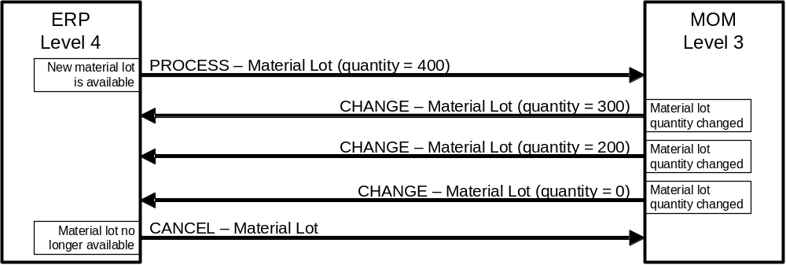
Figure 54 – Push model; material lot added, material lot quantity changed
    - Publish and push model
Scenario assumptions:
- ERP publishes material lot information; MOM subscribes.
- MOM sends quantity changes in material lot to ERP.
- ERP sends SYNC DELETE when material lot is no longer available.
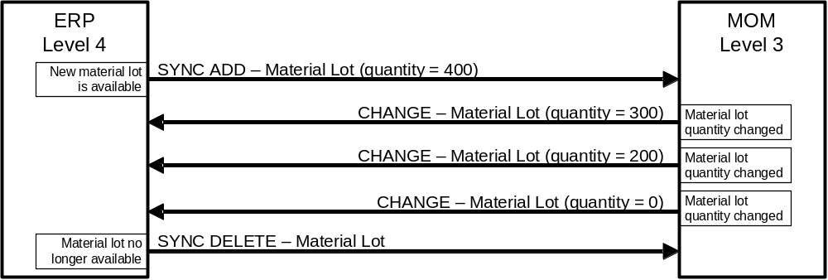
Figure 55 – Publish and push model; material quantity changes
    - Push and pull model
Scenario assumptions:
- MOM periodically requests material lot information for new material lots from ERP.
- ERP responds with information on new material lots. (There may be multiple material lots in a single SHOW message.)
- MOM pushes quantity changes in material lots to ERP.
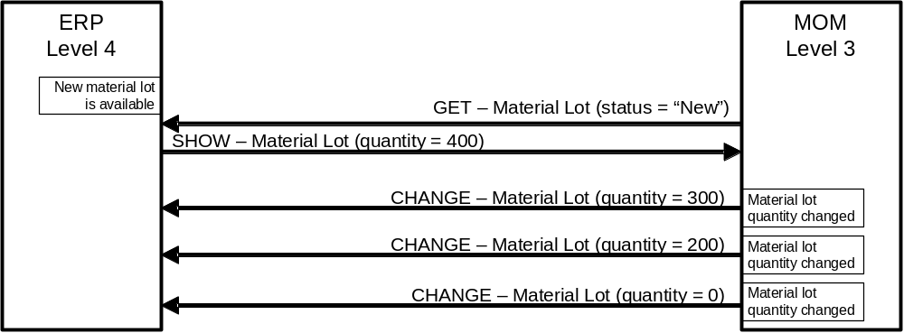
Figure 56 – Push and pull model; material quantity changes

- – (Informative) Questions on the use of transactions
B.1 Different systems will have different IDs for the same objects. The GET verb and others use IDs to identify the object. Which ID is used and how does any translation occur?
On a project basis there must be an agreement on which system’s ID to use. The translation can occur on either side or in a middleware system.
This gets even more interesting when there are more than two systems. In that situation it may be beneficial to designate a system as the repository of the mapping information, and to allow exchanging of the alternate names as properties of the object.
For example, if there is a maintenance system, production system, and business system which all have knowledge of the same object, but each have different IDs, then one system can maintain properties of “Maintenance ID”, “Production ID”, and “Business ID”. The GET verb can be used with a specified property name to return the global ID and each mapping.
B.2 Are these database or message transactions?
This technical specification defines message transactions between cooperating systems, and not database transactions. It is unfortunate that the term “transaction” is used to mean different things in different contexts.
B.3 How are rollbacks handled?
The owner of the data would handle any rollbacks. Each transaction may have a CONFIRM set, and the receiver of the response would be responsible for determining what action to take.
B.4 Why should CONFIRM be used in a SYNC?
Typically CONFIRM is not used with SYNC, but in some situations this may be required and the transaction definition allows its use. It may be required when the information is a critical piece of information that must be shared with a limited number of subscribers.
However, it should be used with care because:
- If many clients are subscribed, the publisher may be overwhelmed by the CONFIRM messages;
- Unless linked to the subscribe mechanism, the publisher will not be able to know if any client failed to confirm the SYNC;
- Even if a publisher detects that one client failed to properly process the SYNC message (either sent a CONFIRM error message or sent nothing) there may not be much it can do.
B.5 How would you handle a two phase commit?
Several Part 5 transactions could be part of a larger business transaction that are collectively either all completed, or all rolled back. The two phase commit is a form of this in which a set of transactions are encapsulated in a larger transaction. If no errors are received from the set of transactions, then they are all committed, and the larger transaction completes. If errors occurred, then none of them are committed and the transactions are rolled back. Two phase commit is usually an element of the implementation architecture and there are several standards that refer to these.
B.6 Why would you use confirmation on a GET message, when a SHOW is the standard response?
A confirmation is not required, but if there were an error on the request this would provide an indication of the error. This is normally expected when a GET is sent for objects that are not understood by the receiving application. A GET that returns no objects in the SHOW would not normally be considered an error.
B.7 Why doesn’t the standard support a general query mechanism on the GET message?
The transaction definitions were not intended to provide a complete query mechanism for remote data, such as SQL or XML Query access, but only as a mechanism to share data between loosely coupled systems with different internal data storage structures. If complete query capability is needed, then the transactions can be used to create local databases and local query mechanisms can be used.
B.8 How were the nouns determined?
The nouns were identified as those objects that were not composites of another object. For example, Equipment was used as a noun, but the equipment properties are composite objects within the equipment and they were not made nouns. This decision was made in order to limit the number of messages so that it would be easier to build and verify complying applications.
B.9 Is CONFIRM allowed for any verb?
The CONFIRM response is permitted for any message but is not recommended for NOTIFY or SYNC verbs. The purpose of the NOTIFY and SYNC are to disassociate the senders from the receivers. There may be zero, one, or many subscribers to the NOTIFY or SYNC messages, without the publisher having knowledge of how many, if any, subscribers there are. A good design practice is to not use the CONFIRM option in NOTIFY and SYNC messages.
A CONFIRM may be used with PROCESS or CHANGE messages. These have specific response messages of ACKNOWLEDGE and RESPOND that contain modified data, however the CONFIRM message contains any specific error messages.
B.10 How would you acknowledge on a NOTIFY, if it was needed?
Any acknowledgment or response expected by an application is notified to the information provider as a separate event notification. The acknowledgment may be from any publisher but typically is an application that processed the original event. The application level specification may define that only those events that meet specific criteria (publisher, event content, time period ...) are acceptable acknowledgments / responses.
In the scenario presented in Figure 57 the initial Operations Event Definition of ‘Work Scheduled’ has the Acknowledgment attribute set to ‘Work Accepted’. Application A publishes the event and then listens for publications of the acknowledgment. Application X upon receiving the ‘Work Scheduled’ notification and verifying the schedule, publishes ‘Work Accepted’ in a separate notification that is received by Application A.
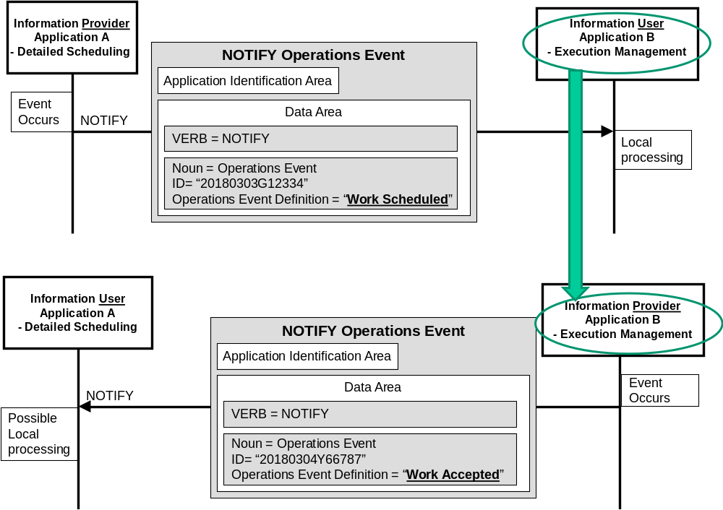
Figure 57 - Implementation of Notify transactions that requires a response
By definition, an application that publishes a NOTIFY transaction is acting in the role of information provider for that event notification. Also by definition, an application that consumes a NOTIFY transaction is acting in the role of information user. An application can simultaneously be an information provider for one set of event notifications and an information user for a separate set of event notifications. This is depicted in Figure 15 above.

- – (Informative) Bibliography and References
OAGIS - (Open Applications Group Integration Specification) – see www.openapplications.org
OASIS PPS (Production Planning and Scheduling) Part 1: Core Elements – see http://docs.oasis-open.org/pps/v1.0/pps-core-elements-1.0.html
OASIS PPS (Production Planning and Scheduling) Part 2: Transaction Messages – see http://docs.oasis-open.org/pps/v1.0/pps-transaction-messages-1.0.html
OASIS PPS (Production Planning and Scheduling) Part 3: Profile Specifications – see http://docs.oasis-open.org/pps/v1.0/pps-profile-specifications-1.0.html
ISO/IEC 9945-2:2003 Information technology – Portable Operating System Interface (POSIX) – Part 2: System Interfaces

- – (Informative) Patterns for Verbs
  - Patterns
The following tables define the general pattern that was applied to create the rules used to define the requirements for verbs when applied to specific nouns.
The same general pattern could be applied to other nouns and/or objects not defined in this standard, but those specifications are outside the scope of this part of the standard.
  - Actions for GET verb
There is a general pattern for the GET verb in which a noun (one or more objects) is included with either an object identifier for the primary object, an identifier of an associated property, and/or a value for the property which is defined in Table 66. The specific rules for the GET verb for a specific noun are described within each noun’s clause. When the nouns include other associated elements, such as limiting parameters, then the verb actions are described within each noun’s clause.
Table 66 – GET message with object ID is specified
Access specification for attributes of objects that make up the noun |  | Action for GET verb
Noun has properties | Property ID is not specified | Defines a request that the receiver is to return, in a SHOW message, all attributes about the specified objects, all properties and their attributes, and ID or IDs of the associated objects with the specified object.
Noun has properties | Property IDs are specified | Defines a request that the receiver is to return, in a SHOW message, all attributes about the specified objects, all of the specified properties, and ID or IDs of the associated objects with the specified object.
Noun has properties | Property IDs and value are specified | Defines a request that the receiver is to return, in a SHOW message, all attributes about the specified objects where the specified property object value matches the specified property value, all of the specified properties, and ID or IDs of the associated objects with the specified object.
Noun has no properties but has contained elements |  | Defines a request that the receiver is to return, in a SHOW message, all attributes and contained elements of the specified object, IDs of the objects associated with the specified objects.

Table 67 – GET message with wildcard in object ID
Access specification for attributes of objects that make up the noun |  | Action for GET verb
Noun has properties | Property ID is not specified | Defines a request that the receiver is to return, in a SHOW message, all attributes and properties about the objects that match the object wildcard, all of the specified properties, and ID or IDs of the associated objects with the objects.
Noun has properties | Wildcard is specified as Property ID | Defines a request that the receiver is to return, in a SHOW message, all attributes of the objects that match the object wildcard, and for each object return all properties that match the property wildcards, and ID or IDs of the associated objects with the objects.
Noun has no properties but has contained elements |  | Defines a request that the receiver is to return, in a SHOW message, all attributes and contained elements of all objects identified by the object wildcard, IDs of the objects associated with the objects.

Table 68 – GET message with no object ID specified
Access specification for attributes of objects that make up the noun | Action for GET verb
<null> | Defines a request that the receiver is to return, in a SHOW message, all attributes and contained elements of all objects.

  - Actions for PROCESS verb
The general pattern for the actions taken on a PROCESS message when an Object ID is specified are defined in Table 69.
Table 69 – PROCESS message with Object ID specified
Access specification for attributes of objects that make up the noun |  | Action for PROCESS verb
Noun has properties | Property ID is not specified | Defines a request that the receiver is to add the specified objects. The message defines suggested IDs for the specified objects. The receiver adds the specified objects and assigns IDs. The assigned IDs are returned in the ACKNOWLEDGE message.
Noun has properties | Property IDs are specified | Defines a request that the receiver is to add the specified objects. The message defines suggested IDs for the specified objects and properties. The receiver adds the specified objects and properties and assigns IDs. The assigned IDs are returned in the ACKNOWLEDGE message.
Noun has properties | Property IDs and value are specified | Defines a request that the receiver is to add the specified objects. The message defines suggested IDs for the specified objects and properties, and values for the properties. The receiver adds the specified objects and properties and assigns IDs. The assigned IDs are returned in the ACKNOWLEDGE message.
Noun has no properties but has contained elements |  | Defines a request that the receiver is to add the specified objects. The message defines suggested IDs for the specified objects, values for the attributes and IDs of the object associated with the specified objects. The receiver adds the specified objects and assigns IDs. The assigned IDs are returned in the ACKNOWLEDGE message.

The general pattern for actions taken on a PROCESS message when no Object ID is specified are defined in Table 70.
Table 70 – PROCESS message with no object ID
Access specification for attributes of objects that make up the noun |  | Action for PROCESS verb
Noun has properties | Property ID is not specified | Error for identified resource objects. Not an error for objects that may be identified by time specifications (Capability, Schedule, Performance).
Noun has properties | Wildcard is specified as Property ID | Error for identified resource objects. Not an error for objects that may be identified by time specifications (Capability, Schedule, Performance).
Noun has no properties but has contained elements |  | Error for identified resource objects. Not an error for objects that may be identified by time specifications (Capability, Schedule, Performance).

  - Actions for CHANGE message
The general pattern for actions taken on a CHANGE message when the Object ID is specified is defined in Table 71.
Table 71 – CHANGE message with object ID
Access specification for attributes of objects that make up the noun |  | Action for CHANGE verb
Noun has properties | Property ID is not specified | The specified attributes of the specified object is to be changed.
Noun has properties | Property IDs are specified | The specified properties and attributes of the specified object is to be changed.
Noun has properties | Property IDs and value are specified | Defines a request that the receiver is to change the values of the specified properties for the specified objects to the specified values. A RESPOND message may be used to communicate agreement, disagreement, or changes made to the CHANGE message data.
Noun has no properties but has contained elements |  | Defines a request that the receiver is to change the specified attributes and contained elements of the specified objects, and IDs of objects associated with the specified objects. A RESPOND message may be used to communicate agreement, disagreement, or changes made to the CHANGE message data.

The general pattern for actions taken on a CHANGE message when the Object ID is a wildcard is defined in Table 72.
Table 72 – CHANGE message with wildcard object ID
Access specification for attributes of objects that make up the noun |  | Action for CHANGE verb
Noun has properties | Property ID is not specified | Defines a request that the defined attributes for all objects matching the wildcard are to be changed to the specified values. A RESPOND message may be used to communicate agreement, disagreement, or changes made to the CHANGE message data.
Noun has properties | Wildcard is specified as Property ID | Defines a request that the defined attributes for all objects matching the wildcard and all properties matching the wildcard property ID are to be changed to the specified values. A RESPOND message may be used to communicate agreement, disagreement, or changes made to the CHANGE message data.
Noun has no properties but no contained elements |  | Defines a request that the receiver is to change the specified attributes and contained elements of all objects matching the object wildcard, and IDs of objects associated with the objects. A RESPOND message may be used to communicate agreement, disagreement, or changes made to the CHANGE message data.

  - Actions for CANCEL message
The general pattern for actions taken on a CANCEL message when the Object ID is specified is defined in Table 73.
Table 73 – CANCEL message with object ID
Access specification for attributes of objects that make up the noun |  | Action for CANCEL verb
Noun has properties | Property ID is not specified | Defines a request that the receiver is to cancel the specified objects.
Noun has properties | Property IDs are specified | Defines a request that the receiver is to cancel the specified properties for the specified objects.
Noun has properties | Property IDs and value are specified | Defines a request that the receiver is to cancel the specified properties of the specified objects that have the specified property value.
Noun has no properties but has contained elements |  | Defines a request that the receiver is to cancel the specified objects. If contained elements IDs are specified, then only the specified contained elements for the specified objects are to be cancelled, not the specified objects.

The general pattern for actions taken on a CHANGE message when the Object ID is a wildcard is defined in Table 74.
Table 74 – CANCEL message with wildcard in object ID
Access specification for attributes of objects that make up the noun |  | Action for CANCEL verb
Noun has properties | Property ID is not specified | Error for identified resource objects. Not an error for objects that may be identified by time specifications (Capability, Schedule, Performance).
Noun has properties | Wildcard is specified as Property ID | Defines a request that the receiver is to cancel all properties matching the property wildcard of all objects that match the object wildcard.
Noun has no properties but has contained elements |  | Defines a request that the receiver is to cancel all objects matching the object wildcard.

  - Actions for SYNC message
The general pattern for actions taken on a SYNC message when the Object ID is specified is defined in Table 75. A sync message may be a SYNC ADD to define new information, SYNC CHANGE to change existing information, and SYNC DELETE to delete information.
Table 75 – SYNC message with object ID
Access specification for attributes of objects that make up the noun |  | Action for SYNC verb
Noun has properties | Property ID is not specified | Defines a request that the receiver is to add (SYNC ADD), delete (SYNC DELETE) or change (SYNC CHANGE) the specified objects.
Noun has properties | Property IDs are specified | Defines a request that the receiver is to add, change, or delete the specified objects and list of the specified properties.
Noun has properties | Property IDs and value are specified | Defines a request that the receiver is to add, change, or cancel the specified objects, list of properties and property values.
Noun has no properties but has contained elements |  | Defines a request that the receiver is to add, change, or delete the specified attributes and contained elements of the specified objects and IDs of objects associated with the specified objects.
The general pattern for actions taken on a SYNC message when the Object ID contains a wildcard specification is defined in Table 76.
Table 76 – SYNC message with wildcard in object ID
Access specification for attributes of objects that make up the noun |  | Action for SYNC verb
Noun has properties | Property ID is not specified | SYNC ADD: Error  SYNC DELETE: Defines a request that the receiver is to delete all objects matching the object wildcard.  SYNC CHANGE: Defines a request that the receiver is to change all object attributes for all objects matching the object wildcard
Noun has properties | Wildcard is specified as Property ID | SYNC ADD: Error  SYNC DELETE: Defines a request that the receiver is to delete all object properties matching the property wildcard for all objects matching the object wildcard.  SYNC CHANGE: Defines a request that the receiver is to change all object properties matching the property wildcard for all objects matching the object wildcard.
Noun has no properties but has contained elements |  | SYNC ADD: Error  SYNC DELETE: Defines a request that the receiver is to delete all objects matching the wildcard ID.  SYNC CHANGE: Defines a request that the receiver is to change the specified attributes and contained elements of the specified objects and IDs of objects associated with the specified objects.

  - Pattern for usage of NOTIFY verb
The NOTIFY verb is distinguished from all other verbs in that it does not define a request for the information user to perform any action. The information user decides on what actions, if any, will be performed upon receipt of the message.
Each NOTIFY message is considered unique. Only a fully constructed noun should be published with the NOTIFY verb. If the same event or data creation must be sent again, such as on a different subscription channel or forwarded to other systems, then a new NOTIFY message should be created, in order to preserve the integrity of an Event Driven Architecture (EDA).

- – (Informative) General rules for identifying nouns from object models
  - Patterns
The following sections define the general pattern that was applied to define nouns based on the UML models defined in this standard.
The same general pattern could be applied to other nouns and/or objects not defined in this standard, but those specifications are outside the scope of this part.
  - Hierarchical Object Model
Object models that follow a hierarchical structure have a single top object that contains a composite of other objects.
Examples of hierarchical object models are Process Segments, Operations Definitions, Operations Schedules, and Operations Performance.
When the top level object is a composite, and the child objects are only relevant in the context of the top level object, then a NOUN is identified with the top level object. If the child objects are also composite objects, then they are included as the top level NOUN.
The name of the NOUN is the same as the name of the top level object.
This rule is based on the assumption that exchanging the child objects would not be effective, because they require the context of the parent object.
For example, exchanging just a Segment Requirement without the context of the Operations Request and the context of the Operations Schedule does not have sufficient information to handle or process the Segment Requirement.
Figure 58 illustrates the composite relationships within the Operations Schedule. Because all objects in the model are in the composite hierarchy, except for associations to objects in other models (process or product segment), there is only one NOUN defined for this model.
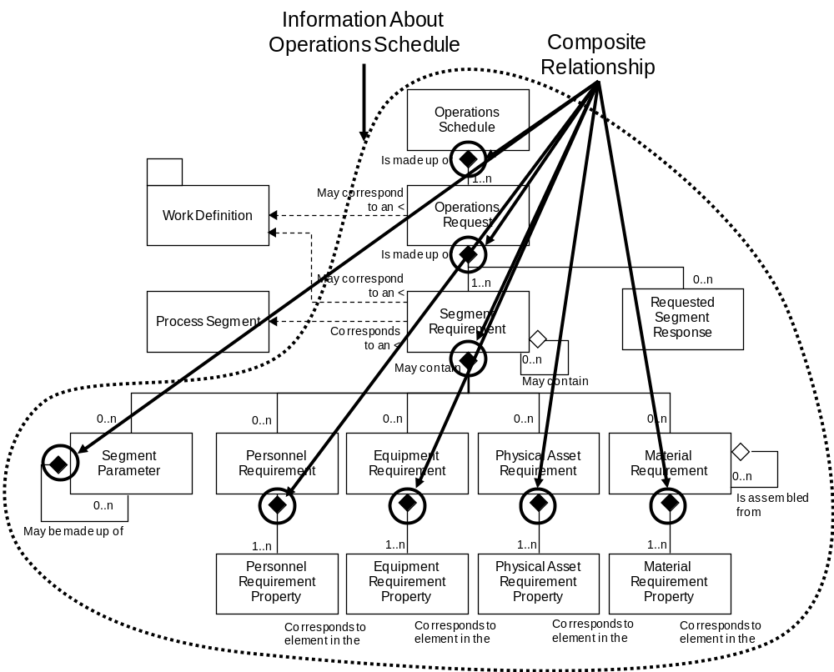
Figure 58 – Object model with composite relationships
  - Non-hierarchical Object Model
Object models that do not have a hierarchical structure will generally have multiple NOUNS defined. Examples of non-hierarchical object models are Personnel, Material and Equipment.
Within non-hierarchical object models there may be sub-models that have composite relationships. In this case the same rule is applied to the composite object as for a hierarchical object model previously defined and the NOUN corresponds to the parent object.
In cases where a child object, such as Material Sublot, may have sufficient context to be exchanged separately, then the child object is also defined as a NOUN.
Objects which are associated with an association between other objects were defined part of one of the objects of the association. Examples of these are Qualification test Result, Equipment Capability Test Results, and Material Test Results. In these cases a decision based on expected business case use patterns was made on which NOUN to include the object in. For example, the expected business uses for the test results were that the test results would be more commonly exchanged with the property value rather than associated with the test specification.
The name of the NOUN is the name of the object.
Figure 59 illustrates the case where there are composite relationships and associated objects in the object model. In this situation a noun is defined for each object that stands alone or contains other objects in a composite relationship, and 5 separate nouns are defined for Material Classes, Material Definitions, Material Lots, Material Sublots, and Material Test Specifications. An associated object, such as a Material Test Result, is placed in the Material Lot and Material Sublot nouns based on the expected use of the object.
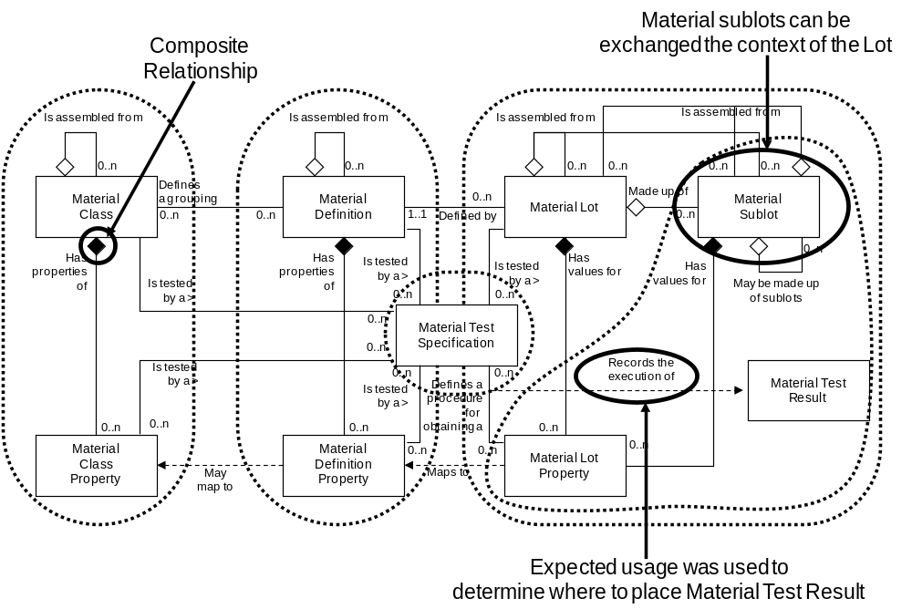
Figure 59 – Example of multiple composite objects

